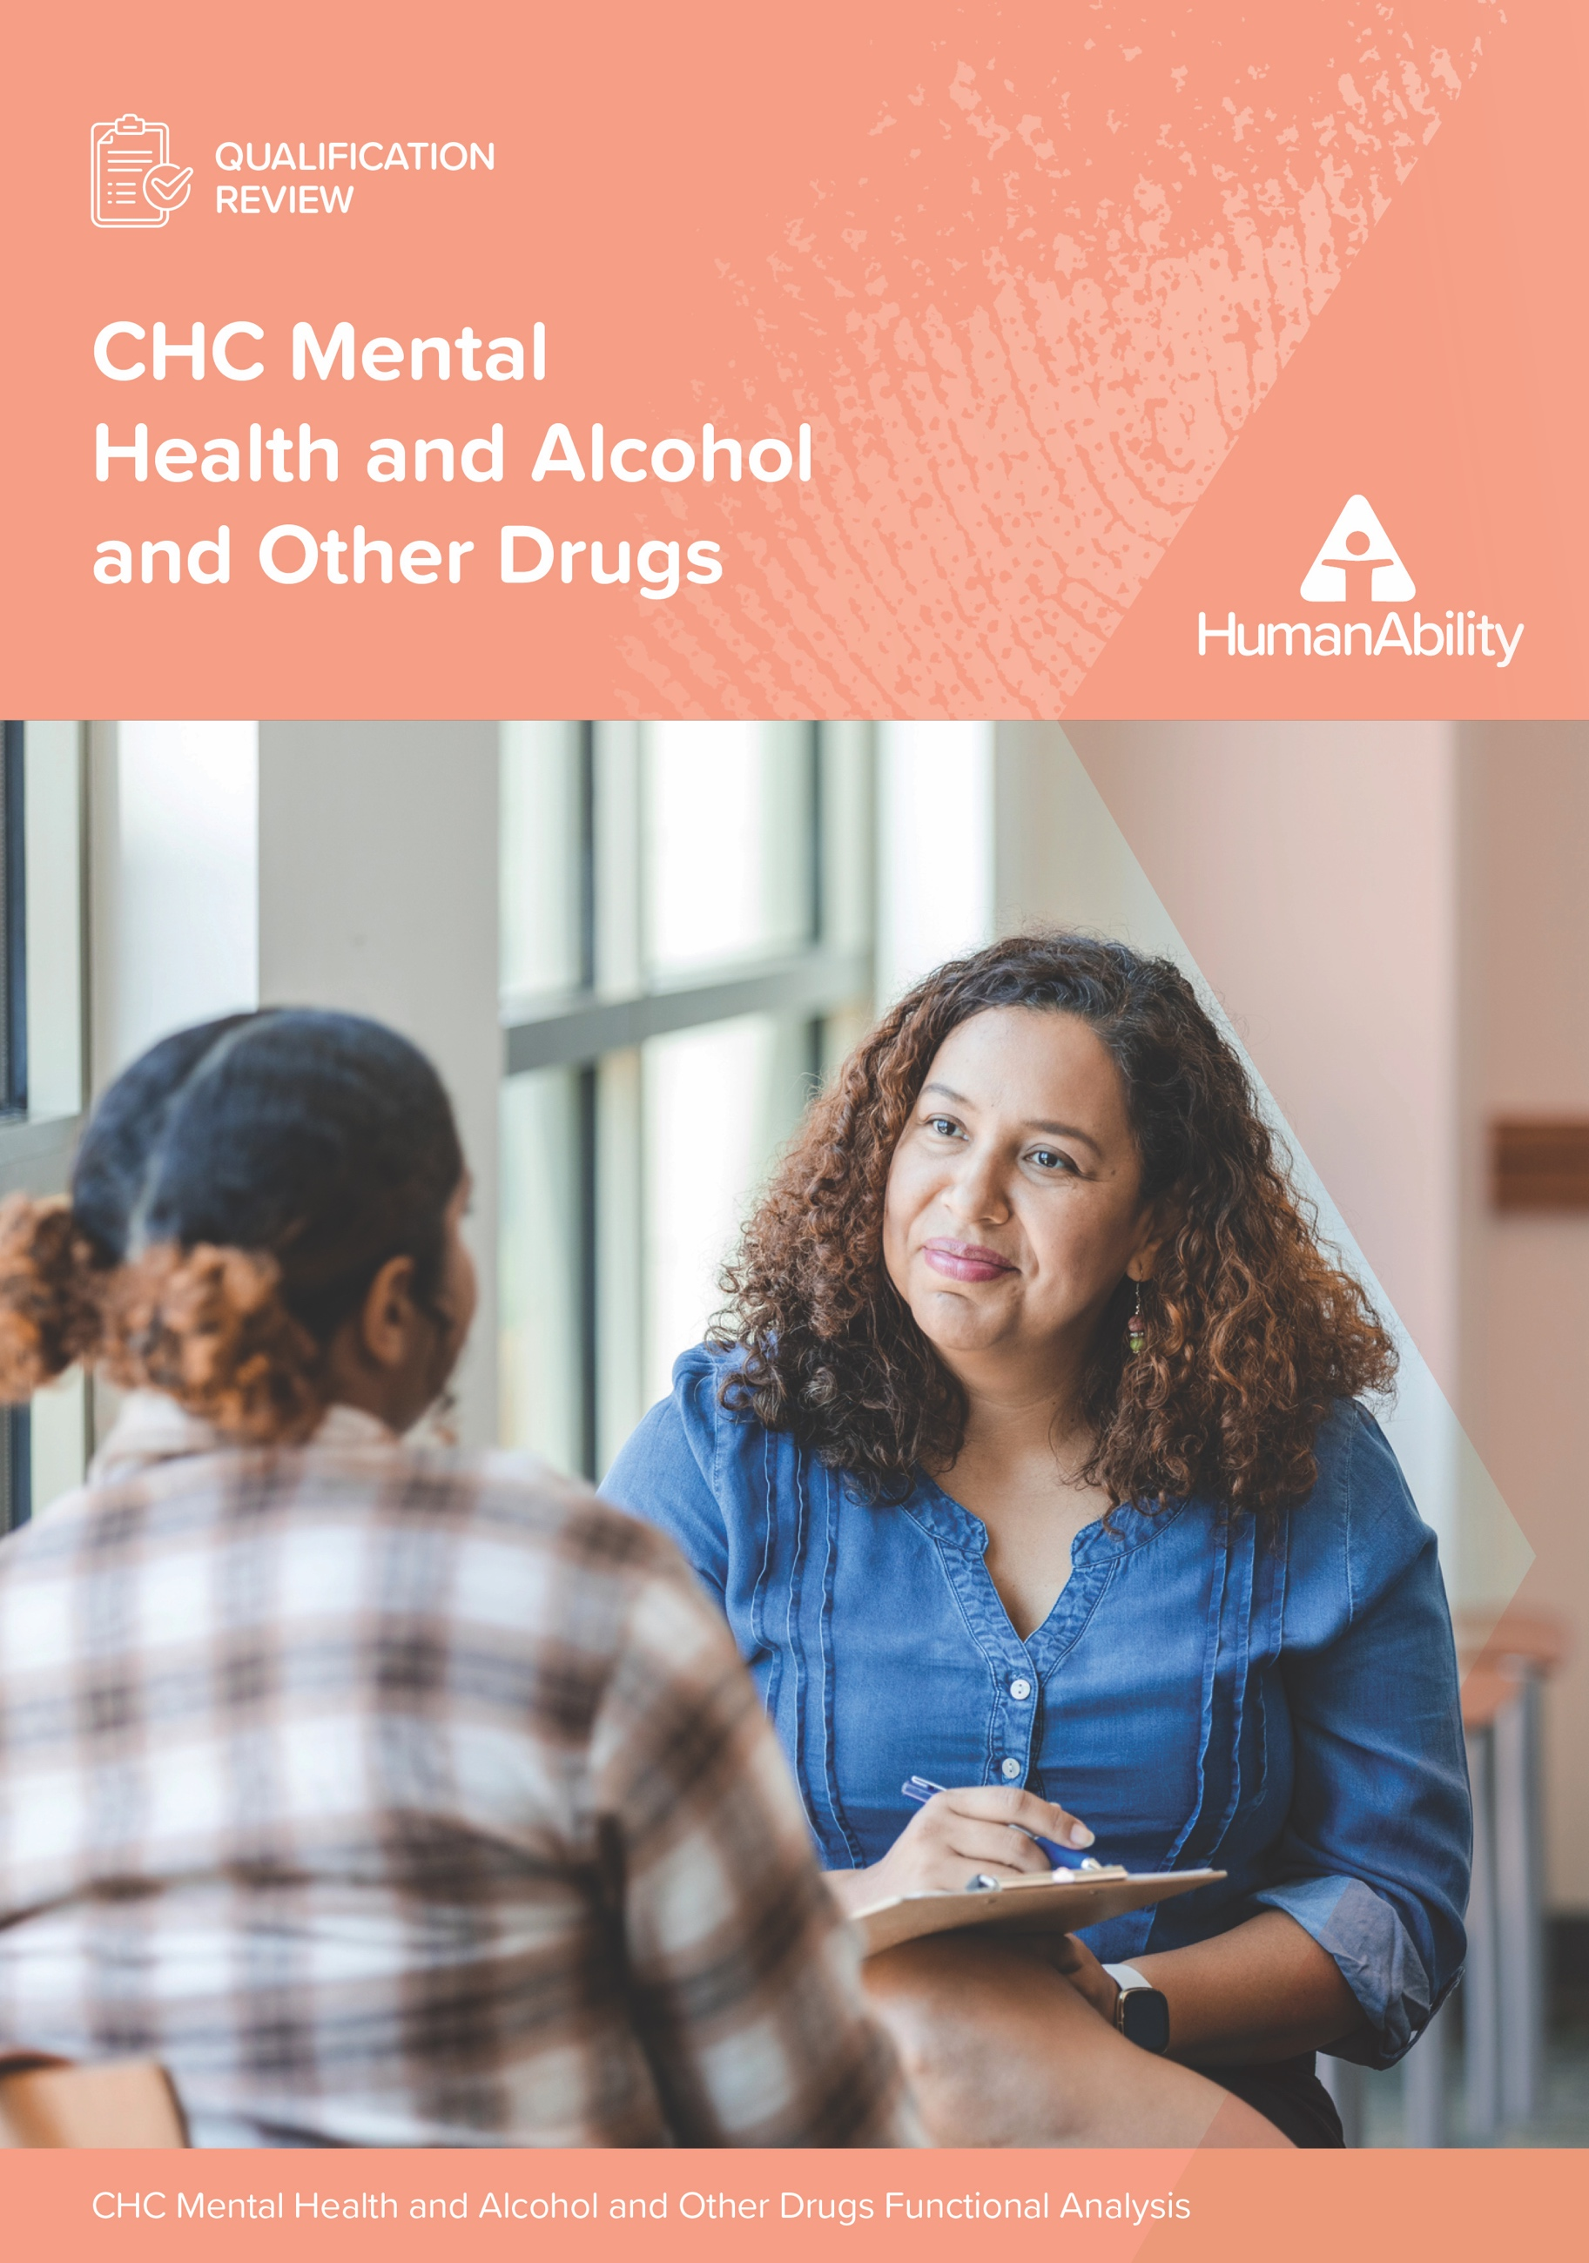

# 



Contents

Section One: Purpose, Methodology, Executive Summary 4

1.1 Executive Summary 5

1.2 Purpose of a Functional Analysis 6

1.3 Purpose of this report 6

Intended audience and application of this report 7

Project overview 7

Project Scope 7

1.4 Methodology 9

Position descriptions and job advertisements 10

Legislative Requirements 11

Cross-project research 11

Stakeholder interviews 11

Consultation with Registered Training Organisations (RTOs) 12

Section Two: Overview of Desktop Analysis 13

2.1 Industry overview 14

Sectors and services 14

Key job titles and roles 15

2.2 Analysis of Position Descriptions and Job Advertisements 18

2.3 Training and educational pathways 20

Enrolments and completions 21

Registered Training Organisations 24

Pathways 24

2.4 Workforce demographics 24

Training and qualifications 24

Workforce composition 25

2.5 Industry demand and growth areas 27

2.6 Licensing and regulatory requirements 28

Section Three: Overview of Interviews and Workshop Outcomes 29

3.1 Current workforce requirements 30

Training gaps and needs 31

Emerging workforce needs 31

Recommendations for qualification redevelopment 32

3.2 Career Pathways 32

3.3 Emerging trends 34

3.4 Regional and Remote Challenges 35

3.5 Training gaps 36

3.6 Specialised skills and niche roles 36

3.7 Technology and digital competencies 36

3.8 Sector challenges 37

Section Four: Mapping to Qualifications 38

4.1 Functions and Subfunctions analysis 39

4.2 Analysis of required skills and knowledge mapped to existing training package components 39

Skill Sets: 41

Completion Trends: 42

Placement Hours: 42

Emerging Trends: 42

4.3 Vocational placement hours 42

4.4 Qualification Packaging Rules and Units 43

Section Five: Recommendations and next steps 44

5.1: Recommendations for qualification enhancements 45

Key priorities for qualification redevelopment 45

Recommendations for changes to Qualifications, Skill Sets and Units of Competency 46

5.2 Next steps 64

Appendices 64

Appendix 1: Training Package Components 65

Appendix 2: Organisations interviewed 67

Appendix 3: List of Services and Sectors 69

Mental Health Services 70

Alcohol and Other Drugs (AOD) Services 70

Family and Domestic Violence Support 70

Youth Services 71

Indigenous and Culturally Specific Services 71

Homelessness and Housing Support 71

Education and Prevention Programs 71

Employment and Vocational Support 71

Specialist Services 71

Advocacy and Systemic Reform 72

Appendix 4: Job Advertisements 72

Appendix 5: Enrolment and Completion data 77

Appendix 6: Registered Training Organisations 82

Appendix 7: Key job roles, functions and sub functions 83

Appendix 8: Workforce Skills Aligned to Existing Training Package Components 95

Appendix 9: Placement Hours 98

Qualifications and skill sets with core units that have mandatory placement hours 99

Appendix 10: Qualification Packaging Rules and Units 100

# Section One: Purpose, Methodology, Executive Summary

## 1.1 Executive Summary

The Functional Analysis Report for the mental health and alcohol and other drugs sectors provides an updated and comprehensive examination of workforce needs, qualification requirements, and training gaps to ensure alignment with current and emerging industry demands. This report supports the redevelopment of qualifications and training products under the *CHC Community Services Training Package* to better meet the complexities of the sectors’ evolving roles, functions, and workforce requirements.

This analysis encompasses 5 qualifications, 7 skill sets, and associated units of competency, including the certificate IV and diploma levels in mental health, alcohol and other drugs, and mental health peer work. It identifies gaps in the current training structure and provides recommendations to ensure these qualifications remain relevant and accessible across diverse service settings, from urban centres to remote regions. The review focuses on aligning qualifications with emerging trends, workforce needs, and regulatory requirements while addressing gaps in competencies not currently reflected in the existing training products.

The functional analysis involved:

* **Desktop research**: Reviewing job descriptions, organisational structures, and legislative requirements to identify skills and competency gaps.
* **Stakeholder engagement**: Conducting interviews and workshops with employers, educators, workers, and policy makers across metropolitan, regional, and remote areas.
* **Workforce data analysis**: Analysing enrolment, completion, and RTO delivery data to highlight trends in training uptake and areas of concern.
* **Cross-project insights**: Incorporating findings from related projects and national strategies, including the *National Mental Health Workforce Strategy 2022-2032*.

The main issues raised during functional analysis interviews and desktop analysis included:

* **Workforce skills needs:**
* Strong demand for trauma-informed care, dual-diagnosis capabilities, and culturally competent practice.
* Increased focus on integrating lived experience and peer work models, which require tailored training approaches.
* **Qualification gaps:**
* Limited opportunities and resources for industry to host vocational placements for learners hinders real-world skill application.
* Current training products lack emphasis on emerging skills like social prescribing and harm minimisation.
* **Regional and remote challenges:**
* Unequal access to training pathways exacerbates workforce shortages.
* Retention of skilled workers in these areas remains a critical issue.
* **Training product limitations:**
* Units of competency are outdated and need to better reflect modern service delivery and regulatory changes.
* Principles of cultural safety and trauma-informed care are inconsistently applied.

The recommendations in this report are provisional and subject to further refinement based on upcoming consultations with RTOs. This critical next phase will ensure that proposed changes to qualifications and training products are practical, deliverable, and aligned with the needs of training providers and learners. Final recommendations will be shaped by the outcomes of these consultations, ensuring a balanced approach to industry relevance and implementation feasibility.

Provisional recommendations include:

* Increasing vocational placement hours and enhancing accessibility in rural and remote regions.
* Updating units of competency to reflect industry best practices and emerging skill requirements.
* Introducing clearer pathways and specialisations to meet diverse career needs.
* Strengthening training in key areas, such as trauma-informed care, motivational interviewing, and group facilitation.
* Developing professional development workshops for trainers and assessors to ensure effective delivery of updated qualifications.

The next phase of this qualification review involves consulting widely with RTOs and stakeholders to refine these recommendations. Once validated, the updated qualifications and skill sets will be finalised and rolled out to ensure the mental health and alcohol and other dugs workforce is well-equipped to meet the complex needs of clients and communities. This will help foster a resilient, capable workforce that is ready to adapt to the challenges of these interconnected sectors.

## 1.2 Purpose of a Functional Analysis

This functional analysis examines the roles, responsibilities, and skills required in the mental health and alcohol and other drugs sectors. It aims to align training programs and qualifications with current and emerging industry needs, providing a foundation for redeveloping qualifications to better prepare workers for the challenges and opportunities in these sectors.

The functional analysis focused on identifying key tasks, exploring industry trends, and highlighting essential competencies required for effective job performance. Particular attention was given to integrating practices such as trauma-informed care, cultural safety, and peer-led approaches, reflecting the evolving demands of the workforce.

By aligning training products with industry needs, this functional analysis supports the development of a skilled and sustainable workforce capable of meeting the complex and interconnected challenges faced by clients and communities. The findings from this activity will directly inform the redevelopment of qualifications, skill sets, and units of competency to enhance their relevance, accessibility, and impact.

## 1.3 Purpose of this report

The purpose of this report is to summarise the analysis that links roles, functions, and skills required for mental health and alcohol and other drugs sector workers with the *CHC Community Services Training Package*.

### Intended audience and application of this report

This report is prepared to report the findings of this functional analysis and to inform the subsequent redevelopment of the training package components within the scope of this review project. It will also be used to inform internal and external stakeholders of HumanAbility in analysing the skills development needs of this industry.

### Project overview

The primary objective of this project is to review the suite of Mental Health and Alcohol and Other Drugs qualifications, skill sets and associated units of competency within the *CHC Community Services Training Package*, with an aim of restructuring and redesigning these components to address current and future skill needs of these industry sectors. These components have been evaluated to:

* ensure that they are aligned with current industry needs and regulatory requirements
* facilitate clear and sustainable career pathways and specialisations to support existing and future growth in the industry
* enhance the relevance and applicability of training products, thereby increasing the industry's capacity to meet growing demand and evolving challenges
* determine skills and knowledge gaps not currently included in training products (internal training performed by employers).

### Project Scope

This functional analysis informs the review of 50 separate training package components, comprising 5 qualifications, 7 skill sets and 38 units of competency. These include:

#### Qualifications

* [CHC43315 Certificate IV in Mental Health](https://training.gov.au/Training/Details/CHC43315)
* [CHC43515 Certificate IV in Mental Health Peer Work](https://training.gov.au/Training/Details/CHC43515)
* [CHC43215 Certificate IV in Alcohol and Other Drugs](https://training.gov.au/Training/Details/CHC43215)
* [CHC53215 Diploma of Alcohol and Other Drugs](https://training.gov.au/Training/Details/CHC53215)
* [CHC53315 Diploma of Mental Health](https://training.gov.au/Training/Details/CHC53315)

#### Skill sets

* [CHCSS00092 Alcohol and Other Drugs Co-existing Needs Skill Set](https://aus01.safelinks.protection.outlook.com/?url=https%3A%2F%2Ftraining.gov.au%2Ftraining%2Fdetails%2FCHCSS00092%2Fskillsetdetails&data=05%7C02%7Ckate.declercq%40humanability.com.au%7C56297e558a8949f5922a08dcfe1b481b%7C970f60a909fa47bbbd6455acf3f6729f%7C0%7C0%7C638664640375405405%7CUnknown%7CTWFpbGZsb3d8eyJFbXB0eU1hcGkiOnRydWUsIlYiOiIwLjAuMDAwMCIsIlAiOiJXaW4zMiIsIkFOIjoiTWFpbCIsIldUIjoyfQ%3D%3D%7C0%7C%7C%7C&sdata=h%2FxnIt5wxqFKUjPXosGVu%2Bw0W0ch04uN7cn2ZUOaot4%3D&reserved=0)
* [CHCSS00093 Alcohol and Other Drugs Skill Set](https://aus01.safelinks.protection.outlook.com/?url=https%3A%2F%2Ftraining.gov.au%2Ftraining%2Fdetails%2FCHCSS00093%2Fskillsetdetails&data=05%7C02%7Ckate.declercq%40humanability.com.au%7C56297e558a8949f5922a08dcfe1b481b%7C970f60a909fa47bbbd6455acf3f6729f%7C0%7C0%7C638664640375421828%7CUnknown%7CTWFpbGZsb3d8eyJFbXB0eU1hcGkiOnRydWUsIlYiOiIwLjAuMDAwMCIsIlAiOiJXaW4zMiIsIkFOIjoiTWFpbCIsIldUIjoyfQ%3D%3D%7C0%7C%7C%7C&sdata=Wms5%2Fi2BGxgYYZH2XNQQ5nZadNc0ms%2BgYOe3NW92%2BaQ%3D&reserved=0)
* [CHCSS00102 Mental Health Co-existing Needs Skill Set](https://aus01.safelinks.protection.outlook.com/?url=https%3A%2F%2Ftraining.gov.au%2Ftraining%2Fdetails%2FCHCSS00102%2Fskillsetdetails&data=05%7C02%7Ckate.declercq%40humanability.com.au%7C56297e558a8949f5922a08dcfe1b481b%7C970f60a909fa47bbbd6455acf3f6729f%7C0%7C0%7C638664640375370630%7CUnknown%7CTWFpbGZsb3d8eyJFbXB0eU1hcGkiOnRydWUsIlYiOiIwLjAuMDAwMCIsIlAiOiJXaW4zMiIsIkFOIjoiTWFpbCIsIldUIjoyfQ%3D%3D%7C0%7C%7C%7C&sdata=m40U9CFQcGV5LB2d86TwW17iEJYluDK3hrHIxM%2F29Yo%3D&reserved=0)
* [CHCSS00103 Mental Health Peer Work Skill Set](https://aus01.safelinks.protection.outlook.com/?url=https%3A%2F%2Ftraining.gov.au%2Ftraining%2Fdetails%2FCHCSS00103%2Fskillsetdetails&data=05%7C02%7Ckate.declercq%40humanability.com.au%7C56297e558a8949f5922a08dcfe1b481b%7C970f60a909fa47bbbd6455acf3f6729f%7C0%7C0%7C638664640375388887%7CUnknown%7CTWFpbGZsb3d8eyJFbXB0eU1hcGkiOnRydWUsIlYiOiIwLjAuMDAwMCIsIlAiOiJXaW4zMiIsIkFOIjoiTWFpbCIsIldUIjoyfQ%3D%3D%7C0%7C%7C%7C&sdata=VeuQSk6x3Xn7cpOWHPErOmsILlk9SupXcm%2FYpxFxV50%3D&reserved=0)
* [CHCSS00112 Suicide Bereavement Support Skill Set](https://training.gov.au/training/details/CHCSS00112/skillsetdetails)
* [CHCSS00113 Crisis Support Skill Set](https://aus01.safelinks.protection.outlook.com/?url=https%3A%2F%2Ftraining.gov.au%2Ftraining%2Fdetails%2FCHCSS00113%2Fskillsetdetails&data=05%7C02%7Ckate.declercq%40humanability.com.au%7C56297e558a8949f5922a08dcfe1b481b%7C970f60a909fa47bbbd6455acf3f6729f%7C0%7C0%7C638664640375437854%7CUnknown%7CTWFpbGZsb3d8eyJFbXB0eU1hcGkiOnRydWUsIlYiOiIwLjAuMDAwMCIsIlAiOiJXaW4zMiIsIkFOIjoiTWFpbCIsIldUIjoyfQ%3D%3D%7C0%7C%7C%7C&sdata=MOCMYz66rxJe85X8eXmPigyIPukGIOymA4S1%2BZM55M4%3D&reserved=0)
* [CHCSS00138 Mental Health Assistance](https://aus01.safelinks.protection.outlook.com/?url=https%3A%2F%2Ftraining.gov.au%2Ftraining%2Fdetails%2FCHCSS00138%2Fskillsetdetails&data=05%7C02%7Ckate.declercq%40humanability.com.au%7C56297e558a8949f5922a08dcfe1b481b%7C970f60a909fa47bbbd6455acf3f6729f%7C0%7C0%7C638664640375352305%7CUnknown%7CTWFpbGZsb3d8eyJFbXB0eU1hcGkiOnRydWUsIlYiOiIwLjAuMDAwMCIsIlAiOiJXaW4zMiIsIkFOIjoiTWFpbCIsIldUIjoyfQ%3D%3D%7C0%7C%7C%7C&sdata=VMzCLbPxB%2FABIyXahr14dVpKaCXgxpKsGKPcqmAH6tA%3D&reserved=0)

*Refer Appendix 1.*

## 1.4 Methodology

This research aimed to provide insights into the workforce skills requirements, job role structures, and organisation of roles within the mental health and alcohol and other drugs (AOD) sectors. By reviewing position descriptions and organisational structures, common qualifications and skills in demand within these sectors were identified. This analysis highlights trends in job responsibilities and structural frameworks, supporting future workforce planning and the development of updated training qualifications for these industries.

The research included:

* review of position descriptions for roles related to mental health and AOD sectors sourced from publicly accessible job advertisements
* analysing workforce skills requirements as outlined in these job advertisements
* examining organisational structures found on company websites and industry publications
* identifying emerging trends in the skills market and highlighting potential gaps in the current workforce
* analysis of National Centre for Vocational Education Research (NCVER) data relating to enrolments and completions of relevant qualifications and skill sets
* number of Registered Training Organisations (RTOs) with the relevant qualifications on their scope of registration
* vocational placement hours for units included in this review
* qualification packaging rules
* relevant frameworks and legislative requirements.

### Position descriptions and job advertisements

From October to December 2024, a detailed review of 33 job advertisements was conducted to capture a snapshot of the roles and skill requirements within the mental health and alcohol and other drugs sectors during this period. These advertisements were sourced from a range of platforms, including:

* online job-seeking agencies, such as Seek, Indeed, CareerOne and Jora
* state government careers websites
* company-specific websites representing diverse organisational contexts.

This targeted review aimed to identify roles, responsibilities, skills, qualifications, and career pathways relevant to the workforce. It was particularly focused on emerging trends within the industry. The findings contribute to an understanding of industry demands, recognising that this dataset reflects only a defined period and therefore offers a momentary view of the job market.

The analysis covered:

* **Key roles and responsibilities:** Understanding the expectations for workers across various job functions within these sectors.
* **Skills and knowledge requirements:** Detailing the qualifications, certifications, and interpersonal competencies deemed essential by employers.
* **Preferred and required qualifications:** Highlighting trends in employer preferences for formal education, such as certificates or diplomas.
* **Emerging trends:** Observing shifts in job postings that might indicate new areas of demand or evolving industry priorities.
* **Career pathways:** Exploring potential progression opportunities within the workforce based on the roles and qualifications advertised.

### Legislative Requirements

Key legislative factors affecting both the industry sectors and the delivery of training and skilling programs were considered at this initial phase of this review. These include workplace health and safety, mandatory reporting, privacy, and licensing requirements, such as Working with Children Checks, NDIS Worker Screening Checks, and First Aid certifications. The analysis also takes into account state-specific legal and ethical requirements, including those related to cultural safety and trauma-informed care. Additionally, this review incorporates guidance from national strategies, such as the National Mental Health Workforce Strategy 2022-2032, and insights from the Productivity Commission's reports on co-existing conditions and psychosocial supports. These frameworks provide critical alignment for addressing workforce development and sector needs in the mental health and alcohol and other drugs industries.

### Cross-project research

Data gathered in the following concurrent HumanAbility projects informed this analysis:

* 25-004 Community Services Qualification Review
* 25-007 Case Management Review

### Stakeholder interviews

To identify the current and emerging skill needs of the industry, HumanAbility conducted a series of employer and other stakeholder interviews. These interviews provided valuable insights into the mental health and alcohol and other drugs workforce and the practical roles, functions, and skill requirements of the sectors from an industry perspective. Employers discussed current roles, daily tasks, career pathways, and the specific challenges and competencies prioritised in different work environments, such as residential services, advocacy groups and clinical practices.

The findings from these interviews helped to clarify employer expectations and workforce needs, contributing to the definition of functions and sub-functions of mental health support workers, alcohol and other drugs support workers and related roles. This information will also inform workforce development and training activities, ensuring alignment with industry priorities. Ultimately, the data has shaped recommendations for qualifications and other training package components to better support mental health, peer work, and alcohol and other drugs roles within the sector.

### Consultation with Registered Training Organisations (RTOs)

While this report includes input from a broad range of stakeholders, consultation with RTOs is a critical next step in the review process. This phase will focus on gathering insights from training providers regarding the practicality, deliverability, and relevance of current qualifications and proposed changes. Their feedback will play a pivotal role in refining the qualifications and ensuring their successful implementation

*Refer Appendix 2.*

# Section Two: Overview of Desktop Analysis

## 2.1 Industry overview

The mental health and alcohol and other drugs sectors address a wide range of community needs through diverse services and settings. These include residential rehabilitation centres, sobering-up units, community-based counselling services, outreach programs, and hospital-to-home transition programs. Specialist services also cater to specific populations, such as Aboriginal and Torres Strait Islander people and communities, and address comorbid conditions through integrated care. Providers in remote and regional areas face unique challenges, often requiring culturally tailored and flexible approaches to ensure appropriate and accessible care.

The workforce in these sectors comprises a variety of roles, from entry-level support workers and peer workers to specialised clinicians, case managers, and counsellors. Increasingly, organisations are integrating peer work and lived experience-led models into therapeutic, advocacy, and leadership roles, recognising their unique value in fostering trust and connection. Workers require a mix of technical and interpersonal skills, such as trauma-informed care, motivational interviewing, cultural competency, dual-diagnosis capability, and system navigation. Practical responsibilities, like assisting clients with appointments, navigating complex systems such as Centrelink and housing services, and facilitating group discussions or yarning circles, are also central to the role.

Emerging trends in the sector highlight a shift towards holistic and wraparound care models that address the complex interplay between mental health, substance use, and social determinants of health. Social prescribing has gained prominence as a way to connect clients with community support systems, tackling broader societal issues such as homelessness and corrections. These trends underscore the critical role the mental health and alcohol and other drugs sectors play in addressing the interconnected nature of health and social challenges.

### Sectors and services

The mental health and alcohol and other drugs sectors within the community services field include numerous services and differing work environments in which roles are performed, and training products are utilised.

*Refer Appendix 3.*

* **Mental Health Services**
* **Alcohol and Other Drugs (AOD) Services**
* **Education and Prevention Programs**
* **Youth Services**
* **Homelessness and Housing Support**
* **Indigenous and Culturally Specific Services**
* **Employment and Vocational Support**
* **Family and Domestic Violence Support**
* **Specialist Services**
* **Advocacy and Systemic Reform**

The breadth of services and sectors encompassed within the mental health and alcohol and other drugs sectors highlights the diverse range of roles and opportunities available within this workforce. These roles span community outreach, psychosocial support, peer work, residential care, harm reduction, education, advocacy, and employment services, among others. Many services target specific populations, such as youth, Aboriginal and Torres Strait Islander peoples, culturally and linguistically diverse communities, and those facing housing instability or justice system involvement. Other services engage with a diverse range of individuals from multicultural communities.

This diversity presents significant opportunities for the workforce to specialise or transition across various roles and sectors. However, it also underscores a challenge: the existing qualifications that address the skills of this sector must address the competency requirements for an extensive variety of job types and service contexts. This qualification review must ensure that these credentials remain adaptable and relevant while meeting the specific skill demands of diverse roles, such as trauma-informed care, cultural competency, and dual diagnosis treatment. Addressing these aspects will be critical to supporting a well-prepared and sustainable workforce.

### Key job titles and roles

The following list of job titles reflect the variety of roles available within the mental health and alcohol and other drugs sectors, ranging from direct client support to specialist clinical and advocacy positions. This list focusses on roles that relate to the qualifications and skill sets reviewed in this project and are generally undertaken by people with a vocational education, skill set or no formal qualification in this field.

|  |  |
| --- | --- |
| **Mental Health** | |
| Mental health recovery worker | Supports individuals with severe mental illness in recovery and rehabilitation |
| Mental health support worker | Assists clients with psychosocial disabilities in achieving daily living and personal goals |
| Peer support worker/ Peer wellbeing navigator | Provides peer support and guidance for mental health recovery |
| Mental health case manager | Coordinates care and support for mental health clients |
| Psychosocial support worker | Provides tailored psychosocial support for mental health recovery |
| Social and emotional wellbeing worker | Provides holistic support, often in Aboriginal and/or Torres Strait Islander people and communities, integrating mental health, emotional resilience, cultural identity, and community wellbeing. |
| Aboriginal community liaison officer | Bridges service delivery to Aboriginal communities |
| Mental health outreach worker | Delivers mental health services directly in the community |
| Lived experience workforce lead | Coordinates and lead peer workforce initiatives |
| Cultural support worker | Provides culturally tailored support services |
| **Alcohol and Other Drugs (AOD)** | |
| AOD support worker | Provides assistance for individuals with substance use disorders |
| AOD case manager | Coordinates treatment plans and monitor progress for clients with AOD challenges |
| Needle exchange program coordinator (or harm reduction coordinator) | Oversees harm reduction efforts through needle exchange services |
| Sobering up unit support worker | Provides a safe space for individuals recovering from intoxication |
| Residential rehabilitation worker (or residential support worker) | Supports individuals in recovery-focused residential settings |
| AOD counsellor (alcohol and other drug counsellor) | Provides specialised support and interventions for individuals with alcohol and other drug-related challenges |
| **Combined Roles (Mental Health and AOD)** | |
| Dual diagnosis clinician/specialist | Addresses co-occurring mental health and substance use disorders |
| Community AOD and mental health worker | Provides holistic care for individuals with both AOD and mental health challenges |
| Social prescribing link worker (or social connection worker) | Connects clients with non-clinical resources to improve overall wellbeing |
| Counsellor | Provides therapeutic and emotional support |
| **Broader or Related Roles** | |
| Community mental health worker | Supports clients in community settings to achieve mental health goals |
| Family support worker (AOD and gambling) | Provides support to families impacted by AOD and gambling |
| Youth meantl health worker | Supports young people with mental health needs |
| Forensic AOD and meantl health worker | Works with clients involved in the justice system to address AOD and mental health challenges |
| Policy and advocacy specialist (lived experience) | Advocates for systemic change using lived experience insights |
| Volunteer coordinator | Manages peer and volunteer staff |
| **Lived Experience and Peer Roles** | |
| Peer worker (peer support worker) | Provides peer-based advocacy and support |
| Cultural support worker (Aboriginal community liaison officer) | Bridges service delivery to Aboriginal communities |
| Peer wellbeing navigator (lived experience educator) | Mentors and educate others using personal recovery experience |
| **Specialised/Leadership Roles** | |
| Training and development coordinator (lived experience) | Designs and implement training programs for peer workers |
| Peer workforce coordinator | Oversees and support the peer workforce within an organisation |
| Harm reduction coordinator (harm reduction officer) | Oversees harm reduction initiatives |
| Harm reduction specialist (needle and syringe program worker) | Provides support through needle exchange programs |
| Family support worker (family and carer support worker) | Supports families impacted by mental health or substance use |
| **Administrative and Supportive Roles** | |
| Intake and assessment worker (intake and assessment officer) | Assesses and coordinate client intake |
| Administration coordinator (client services coordinator) | Manages service-related administrative tasks |

## 2.2 Analysis of Position Descriptions and Job Advertisements

A range of job advertisements and position descriptions were reviewed to support this project, providing a comprehensive understanding of the diverse roles and responsibilities in the mental health and alcohol and other drugs sectors. These roles include mental health support workers, AOD counsellors, peer support navigators, and others, each requiring distinct capabilities such as facilitating psychosocial recovery, implementing harm-reduction strategies, and providing case management support. The analysis revealed a consistent demand for technical expertise combined with strong interpersonal and cultural competence, underscoring the importance of holistic care in addressing client needs.

In addition, industry advertisements have highlighted the critical need for dual-diagnosis skills, particularly the ability to manage co-occurring mental health and substance use issues. Skills such as trauma-informed care, motivational interviewing, and understanding of systemic and structural challenges like homelessness, justice systems, and cultural contexts were commonly mentioned. The focus on trauma-informed care aligns with the industry's emphasis on creating safe, empowering environments for clients.

Specifically, key skills emphasised in the job advertisements included:

* Crisis intervention and de-escalation techniques – Effectively managing volatile or challenging situations to ensure safety.
* Case management and recovery planning – Supporting individuals to identify and achieve goals through structured planning and ongoing monitoring.
* Trauma-informed care – Providing support in a way that recognises and minimises re-traumatisation.
* Cultural competence – Particularly regarding Aboriginal and Torres Strait Islander people and communities and other culturally and linguistically diverse groups.
* Interpersonal and communication skills – Demonstrated ability to liaise with clients, families, and external service providers effectively.
* Group facilitation – Leading or co-facilitating group therapy sessions, workshops, or peer-led discussions.
* Harm minimisation – Knowledge and application of harm-reduction strategies, especially in alcohol and other drugs contexts.
* Organisational and administrative skills – Maintaining accurate records, scheduling appointments, and ensuring compliance with reporting requirements.
* Digital proficiency – Familiarity with using case management systems and data collection software.
* Medication assistance – Supporting clients in managing and administering prescribed medications safely.
* Empathy and understanding – Compassionate support for individuals experiencing mental health challenges or recovery journeys.
* Professional boundaries and ethics – Adhering to clear boundaries and ethical practices in all professional interactions.
* Problem-solving and resilience – Managing stress and uncertainty while providing support in demanding situations.
* Lived experience – Leveraging personal experience in mental health recovery or AOD contexts to provide peer support and foster hope.
* Independent living skill development – Assisting clients with personal care, financial management, and daily living tasks to enhance independence.
* Advocacy and community linkages – Helping clients navigate systems and connect with community resources.

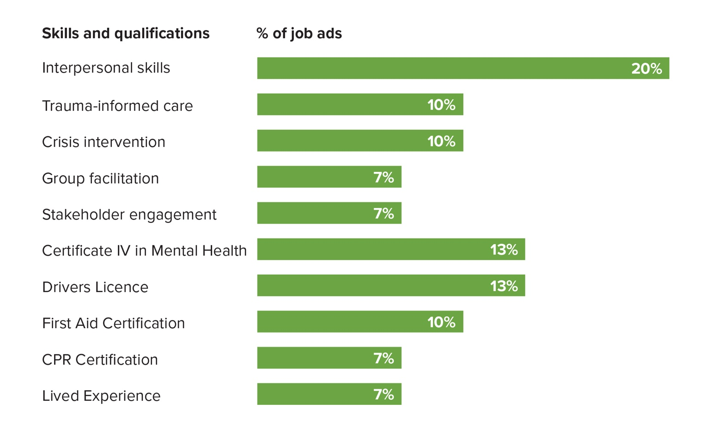The most frequently requested skills and qualifications from this sample of job advertisements are illustrated in the following charts:

*Refer Appendix 4.*

## 2.3 Training and educational pathways

### Enrolments and completions

The most popular qualifications of those within the scope of this project, according to total enrolments across Australia in 2023 are the *CHC43315 Certificate IV in Mental Health* (12,774 enrolments nation-wide) and the *CHC53315 Diploma of Mental Health* (5,063 enrolments), both showing significant growth since 2018. Skill sets such as the *CHCSS00093 Alcohol and Other Drugs Skill Set* and the *CHCSS00113 Crisis Support Skill Set* also show strong enrolment growth, particularly in 2023, with 644 and 806 enrolments, respectively.

In contrast, enrolments in the *CHC53315 Diploma of Alcohol and Other Drugs* have steadily declined, dropping from 912 in 2018 to 553 in 2023. One reason for the drop in diploma enrolments compared to certificate IV enrolments might be the "FREE TAFE" programs across various jurisdictions that encourage enrolments into some certificate IV qualifications. This makes diplomas a more expensive and less accessible option, especially when the certificate IV qualification is sufficient to secure the desired employment.

**“Free TAFE” funding by states and territories and federal schemes:**

|  |  |
| --- | --- |
| **Qualification** | **Funding States** |
| *CHC43315 Certificate IV in Mental Health* | Victoria, New South Wales, Western Australia, Queensland plus federal funding |
| *CHC43515 Certificate IV in Mental Health Peer Work* | Victoria, Queensland, Western Australia, plus federal funding |
| *CHC43215 Certificate IV in Alcohol and Other Drugs* | Victoria, New South Wales, Western Australia, plus federal funding |
| *CHC53215 Diploma of Alcohol and Other Drugs* | New South Wales |
| *CHC53315 Diploma of Mental Health* | New South Wales, Western Australia |

The average completion rate across qualifications from 2018 to 2023 is approximately 18.3%. Skill sets, however, demonstrate a significantly higher completion rate, averaging 50.2%, reflecting their shorter duration and focused content. This disparity highlights a trend where students are more likely to complete skill sets than full qualifications, which could suggest they are more accessible or align more closely with immediate employment needs.

Summary of enrolments and completions for 2022 and 2023 is below, sourced from National Centre for Vocational Education Research (NCVER), 2023. Total VET Students and Courses, 2023.[1]

Further detail relating to past years is provided in the appendices.

*Refer Appendix 5.*

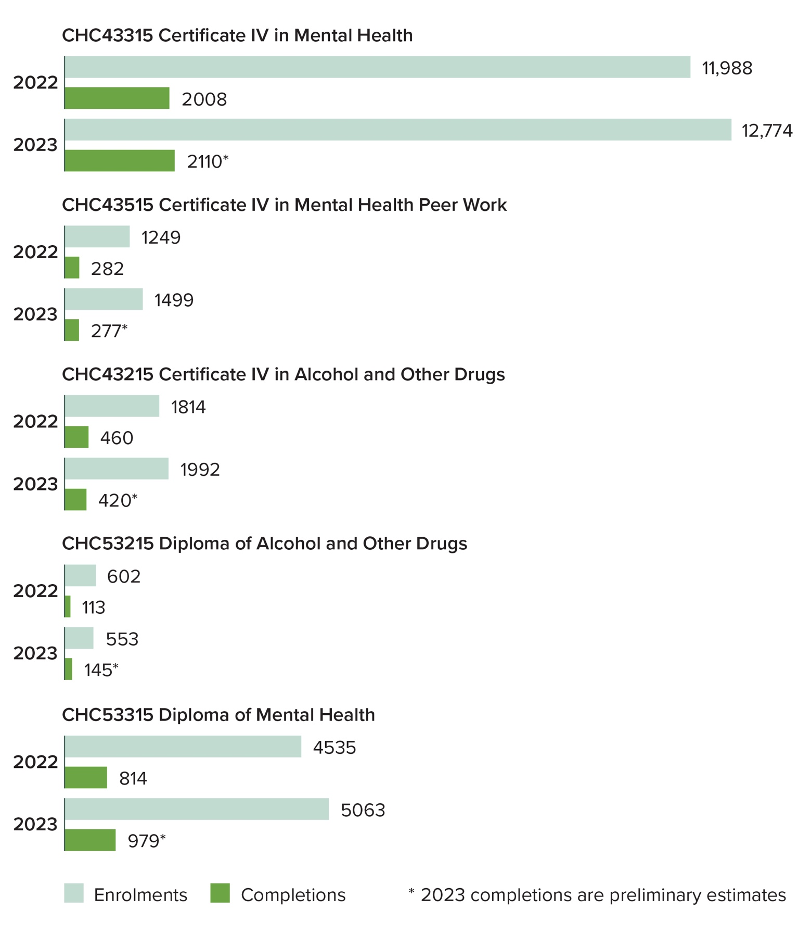**Enrolments and completions for qualifications**

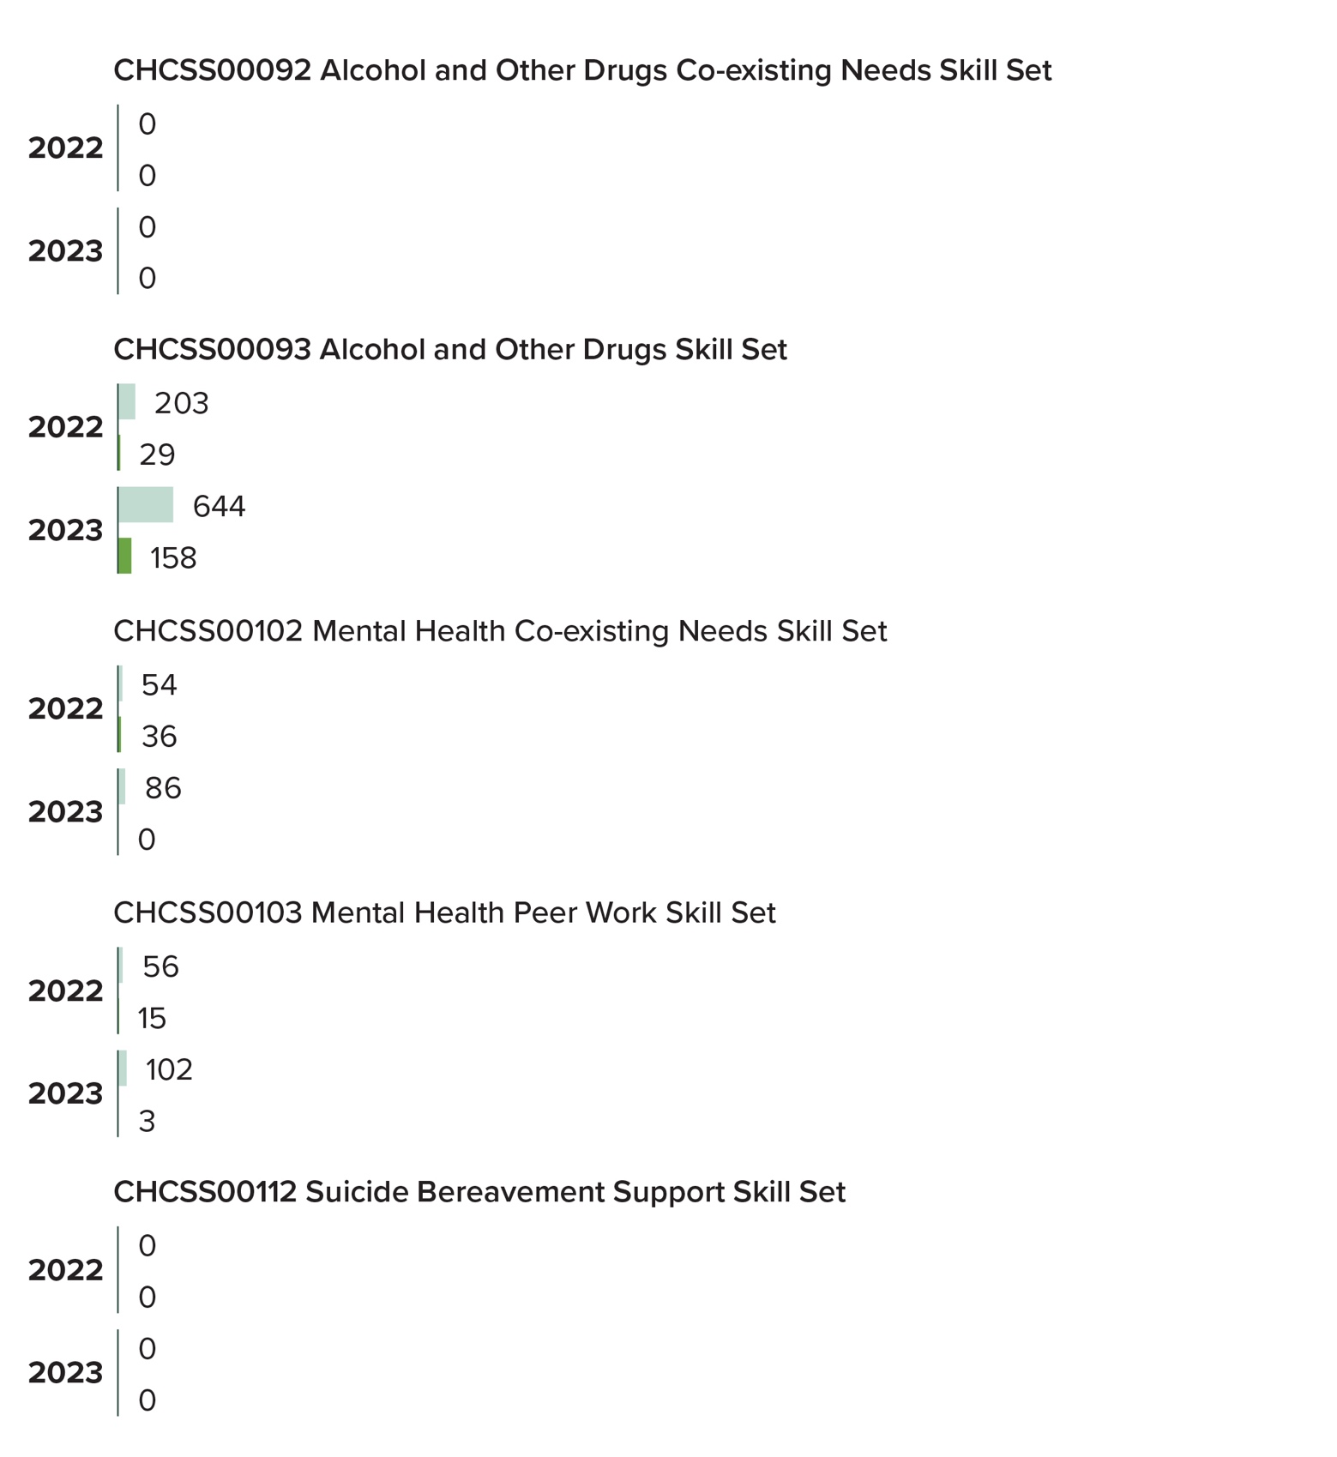**Enrolments and completions for skill sets**

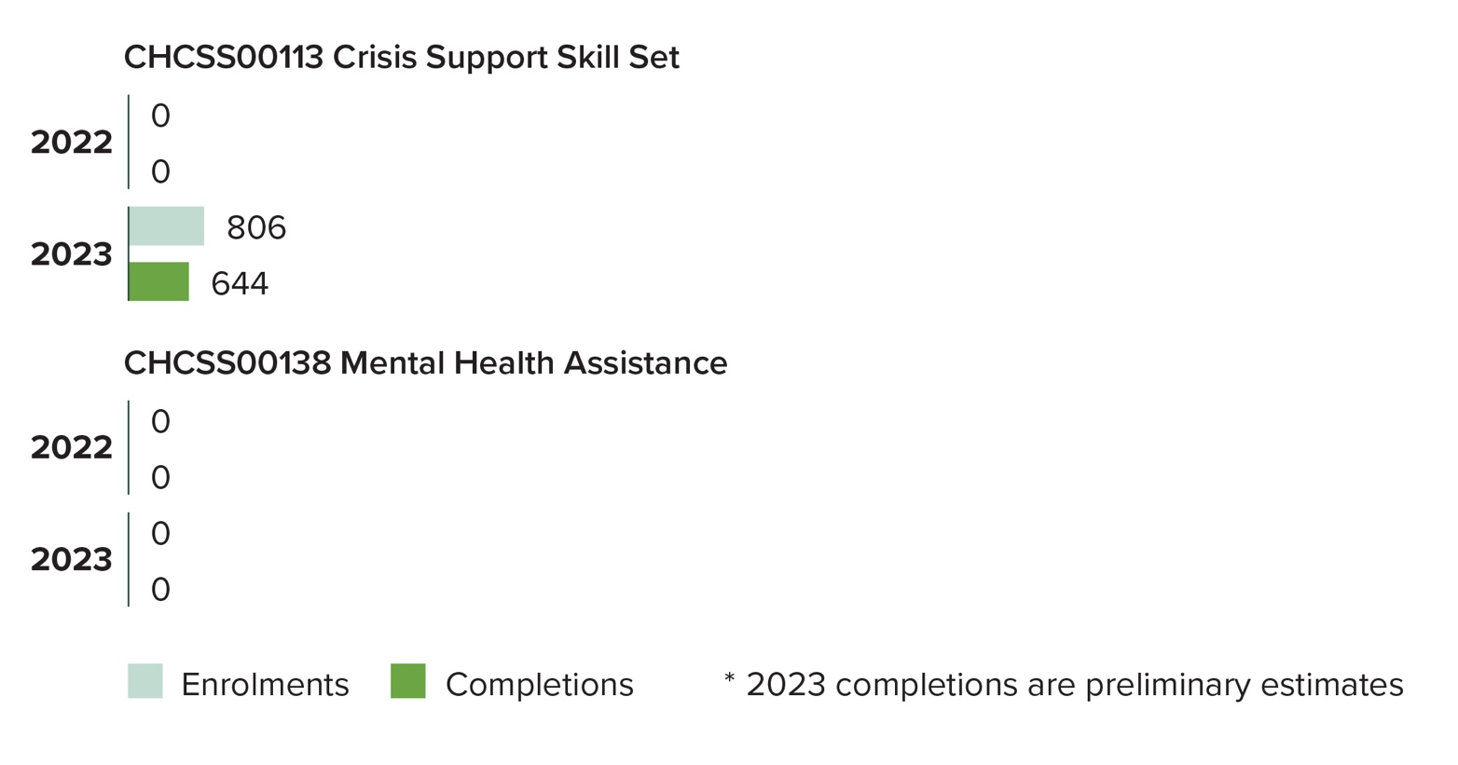

* Completion statistics provided for 2023 are considered “preliminary” and not yet fully substantiated.

### Registered Training Organisations

At the time of writing, there are 348 Registered Training Organisations across Australia registered to deliver and assess the qualifications and skill sets addressed by this review.

Although many have the capacity to deliver these qualifications and skill sets, the actual number of organisations offering them is undetermined.

*Refer Appendix 6.*

### Pathways

Interviews and desktop research were conducted to explore the educational pathways leading to certificate IV and diploma qualifications, as well as progression into Higher Education opportunities.

No formalised pathways exist that require the completion of one qualification before another can be achieved but an analysis of career pathways (see section 3.2 below) found that there are informal expectations, requirements and opportunities available for the mental health and alcohol and other drugs workforce to progress through differing levels of vocational and tertiary education programs. Some of these expectations differ from state to state. Given the complexity of Certificate IV qualifications in this field, they can present a barrier for individuals who find this level of education challenging. As a result, generic Certificate III qualifications in Community Services or Individual Support are often regarded as viable pathways for individuals seeking foundational skills and qualifications that can facilitate entry into the mental health and alcohol and other drugs sector.

## 2.4 Workforce demographics

The Mental Health (MH) and Alcohol and Other Drugs (AOD) workforce is a highly diverse and dynamic sector, encompassing a broad range of roles, from peer support workers with lived experience to advanced clinical specialists. This diversity is integral to the sector’s ability to address complex and varied community needs, particularly in rural and remote settings.

### Training and qualifications

Qualifications across the workforce range from Certificate IVs in Mental Health or Alcohol and Other Drugs to advanced diplomas and tertiary degrees. However, disparities in access to training and professional development persist:

* Rural and remote regions face acute challenges, with **35% of workers in these areas reporting difficulties accessing training opportunities**.
* Peer workers, who play a growing role in the sector, often lack formal training pathways, limiting their career progression despite the critical value of their lived experience.
* Regional disparities are significant. Workforce shortages are most pronounced in remote areas, where **vacancy rates for key roles in the MH and AOD sectors remain high,** making service delivery challenges more difficult.

### Workforce composition

#### *****Aboriginal and Torres Strait Islander peoples representation*****

Aboriginal and Torres Strait Islander workers play a critical role in providing culturally safe and sensitive care across Australia, particularly in remote and regional communities where their contributions are vital to addressing unique cultural needs. Despite this, systemic barriers, including limited access to leadership opportunities and culturally appropriate workplace support, continue to hinder their full participation in the sector. Nationally, Aboriginal and Torres Strait Islander workers represent a small but growing portion of the workforce, with higher representation in some regions, such as the Northern Territory (11%), compared to lower engagement levels in urban and other regional areas. This disparity highlights the need for targeted strategies to recruit, support, and retain First Nations workers across all parts of the country.

*"We see a high demand for First Nations workers, but systemic barriers make it hard to attract and retain them, particularly in leadership roles."*

#### *****Gender and age diversity*****

The MH and AOD workforce is predominantly female, with women making up **approximately 70%** of the sector nationally. 72% of mental health workers and 77% of mental health peer workers identify as female. (*Acil Allen Consulting*. Mental health workforce – Labour market analysis: *2023*). The workforce also skews older, with a high proportion of workers aged 45 years and over, raising concerns about succession planning and sustainability. This is consistent with broader trends in the community services sector, where women account for over 80% of the workforce according to HumanAbility’s Workforce Plan 2024 highlighting the sector’s continued reliance on female-dominated roles.

The gender distribution within the mental health and related sectors workforce shows a significantly higher representation of females across all categories. This trend is mirrored by the numbers of Aboriginal and Torres Strait Islander health workers working in these sectors.

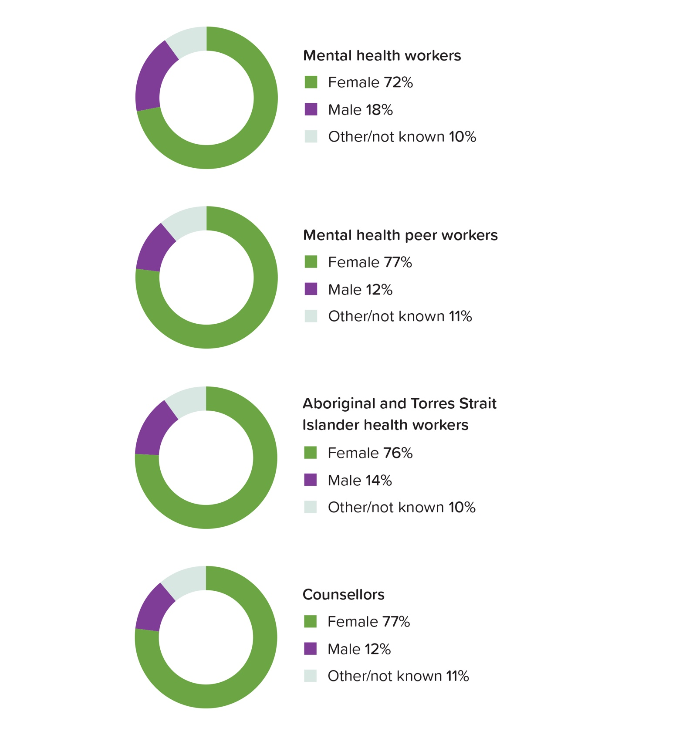*Gender representation in the Mental Health and Allied Workforce*

Women consistently form the majority of enrolments across all qualifications in mental health, peer work, and alcohol and other drugs in 2022, with percentages ranging from 63% to 75%. These statistics reflect national workforce patterns.

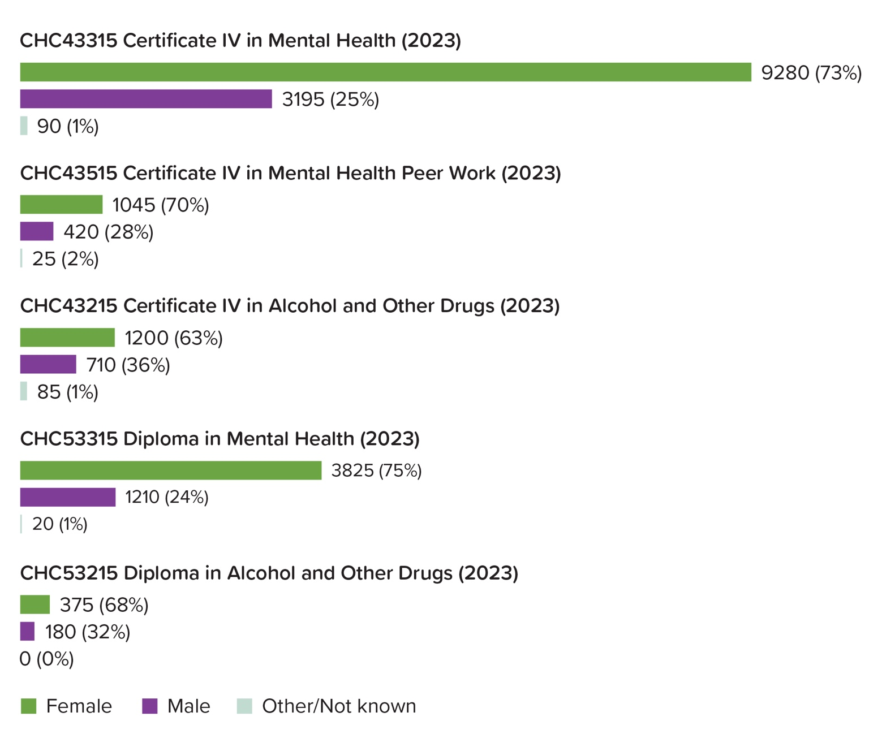*Enrolments by gender for qualifications (2023)*

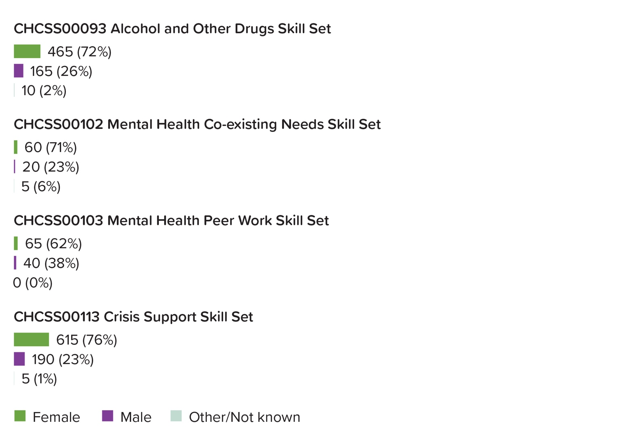*Enrolments by gender for skill sets (2023)*

## 2.5 Industry demand and growth areas

The mental health and alcohol and other drugs sectors are experiencing significant growth. The employment projections described in the *National Mental Health Workforce Strategy 2022-2032* for the Mental Health and AOD sectors highlight steady growth across key occupations. For example, welfare support workers are expected to grow from 80,300 in 2023 to 96,300 by 2033, marking a 19.9% increase over ten years. This reflects the rising demand for welfare services to address diverse community needs. Similarly, the demand for counselling services is expected to increase 15% over the next five years[2]. This growth is driven by several critical factors:

1. **Complex client needs**: The complexity of client presentations is increasing, with many individuals requiring support for both mental health and substance use concerns. This has elevated the demand for professionals with dual-diagnosis expertise, enabling them to address these intersecting issues effectively. Multidisciplinary approaches are becoming fundamental to navigating and managing such complexities, ensuring that care is holistic and tailored. Other issues that are commonly associated with mental health and alcohol and other drugs concerns include family violence, poverty, homelessness and suicide ideation.
2. **Evolving workforce roles**: Workforce expectations are shifting beyond traditional peer work to encompass roles such as policy advocacy, system navigation, and social prescribing. The latter aims to address broader social conditions by connecting clients with community-based supports that go beyond clinical settings. These evolving roles reflect a growing need for professionals who can advocate for systemic change, guide clients through complex systems, and enhance social connectedness.
3. **Regional and remote needs**: Rural and remote areas face acute workforce shortages, requiring innovative training and service delivery models. These areas experience unique challenges, such as geographic isolation and limited access to resources, which require adaptive approaches to meet community needs effectively.
4. **Integrated service models**: There is a strong push towards integrated care models where mental health and alcohol and other drugs interventions are delivered collaboratively. Such models aim to reduce fragmented service delivery, promoting seamless care and improving outcomes for clients. This approach necessitates coordination across services and disciplines, reinforcing the importance of shared knowledge and collaborative practices.
5. **Policy and regulatory developments**: The sector is increasingly shaped by policies that prioritise emerging practices such as trauma-informed care, cultural competence, and peer-led initiatives. These priorities reflect broader societal shifts, recognising the importance of culturally safe, inclusive, and client-centred care. Training and workforce development must align with these regulatory and policy-driven expectations, ensuring that practitioners are well-equipped to meet the evolving needs of their communities.

These factors underscore the necessity for training programs and qualifications to evolve, ensuring they remain relevant and responsive to the dynamic demands of the sector. Workforce development efforts must focus on fostering skills in cultural safety, trauma-informed practices, interdisciplinary collaboration, and system navigation to support a sustainable and effective workforce.

## 2.6 Licensing and regulatory requirements

The mental health and alcohol and other drugs workforce operates with minimal formal licensing and regulatory requirements. However, the majority of the workforce, including team leaders and managers at the organisations interviewed, are required to meet certain checks and hold specific certificates to perform their roles effectively. These include:

* A valid driver’s licence
* Current First Aid certification
* A national police check
* A Working with Children Check (WCCC) for those engaging directly or indirectly with individuals under 18 years old
* National Disability Insurance Scheme (NDIS) Worker Check for those interacting directly or indirectly with individuals with disabilities or working within organisations funded by the NDIS.

# Section Three: Overview of Interviews and Workshop Outcomes

## 3.1 Current workforce requirements

Interviews, focus groups, and workshops involving approximately 55 individuals, including employers, government representatives, peak bodies, coordinators, and workers in the mental health and alcohol and other drugs (MHAOD) sectors, provided rich insights into the skills and knowledge essential for workers in the industry. These discussions highlighted existing training gaps and informed recommendations for improving future qualifications to better meet sector needs.

"The Certificate IV gives a good foundation, but I don’t think it actually gives practice skills. It doesn’t give that intense practice...you cannot learn them from a book, and you need to reflect a lot on your own experiences to develop your practice."

|  |  |
| --- | --- |
| **Trauma-informed care** | **Importance**: Essential for all roles, recognising and responding to trauma appropriately across therapeutic and community settings.  **Key Elements**: Understanding trauma responses, applying compassionate inquiry, and integrating trauma awareness into every interaction. |
| **Professional boundaries and ethical practice** | **Importance**: Critical for ensuring safe and professional client-worker relationships.  **Key Challenges**: Maintaining boundaries while leveraging lived experience or working within communities that are closely connected; managing self-disclosure effectively. |
| **Crisis management and de-escalation** | **Importance**: Increasing aggression and complexity in the sector demand crisis resolution skills.  **Skills Required**: De-escalation techniques, situational awareness, and handling emergencies such as overdoses. |
| **Cultural competency and inclusivity** | **Importance**: Vital for working with Aboriginal, CALD, and other marginalised communities.  **Key Skills**: Cultural safety, historical awareness, and strategies for intersectional service delivery. |
| **Peer work and lived experience** | **Importance**: Lived experience is a cornerstone for client engagement and systemic reform.  **Key skills**: Intentional disclosure, advocacy, and navigating systemic challenges.  **Challenges**: “Peer drift” (drifting from peer support principles toward clinical or traditional roles); stigma against lived experience workers. |
| **Digital literacy and technological skills** | **Importance**: Increasing reliance on telehealth, case management systems, and AI tools.  **Training gap**: Insufficient emphasis on digital competencies in current qualifications. |
| **Group facilitation and therapeutic techniques** | **Importance**: Group-based interventions are cost-effective and widely employed.  **Skills needed**: Facilitating group dynamics, using tools like motivational interviewing, and managing educational sessions. |
| **Administrative and documentation skills** | **Importance**: Accurate record-keeping ensures compliance and continuity of care.  **Key competencies**: Writing case notes, handling client data, and adhering to governance standards. |
| **System navigation and interagency collaboration** | **Importance**: Essential for effective case management and service delivery.  **Skills needed**: Understanding justice, housing, and healthcare systems; building referral networks. |

## **Training gaps and needs**

|  |  |
| --- | --- |
| **Modernisation of core units** | Outdated qualifications fail to reflect current industry demands. |
| **Specialisation and flexibility** | **Growing need for qualifications offering electives in dual-diagnosis, Indigenous community support, and skills and knowledge in addressing a range of co-existing challenges such as domestic violence, eating disorders, perinatal mental health and addiction.** |
| **Practical training and placements** | **Current placement hours are insufficient to build competency.** |
| **Reflective practice and resilience** | **Helps prevent burnout and supports emotional well-being.** |
| **Language and terminology** | **Outdated terms perpetuate stigma.** |

### Emerging workforce needs

|  |  |
| --- | --- |
| **Integrated peer work principles** | Avoid peer drift, enhance intentional peer support, and develop systemic advocacy skills. |
| **Technology and AI integration** | Use AI-assisted tools in case management and telehealth. |
| **Comprehensive system knowledge** | Understand how mental health and AOD services intersect with justice, housing, and community systems |
| **Sustainability and retention** | **Foster resilience and establish leadership pathways to address challenges of burnout and high turnover.** |

"The qualifications give a theoretical understanding, but we’re constantly having to upskill new employees on practical things like de-escalation techniques, trauma-informed care, or navigating complex systems."

### **Recommendations for qualification redevelopment**

* Embed core competencies: Trauma-informed care, cultural competency, and harm reduction must be central to all qualifications.
* Expand placement hours: Increase structured, meaningful placement opportunities.
* Incorporate reflective practice: Include reflective and self-care practices as core training components.
* Streamline compliance units: Consolidate overlapping legislative content to create space for practical training.
* Introduce modular pathways: Allow learners to specialise in areas such as dual-diagnosis or peer leadership.
* Enhance digital literacy training: Prepare workers for emerging technologies and telehealth practices.

"If we’re serious about preparing workers, the qualifications need to include units on group facilitation, harm reduction, and navigating complex care systems."

## 3.2 Career Pathways

Interviews and desktop research were conducted to explore the career pathways leading to Certificate IV and Diploma qualifications, as well as progression into Higher Education opportunities.

Career pathways in the mental health and alcohol and other drugs sectors are diverse, offering opportunities for progression and specialisation across various roles and settings. However, these pathways are not mandatory, consistently defined, or widely recognised, which can create confusion for those entering or already working in the industry. Many entry-level workers enter these sectors without formal qualifications, with some organisations requiring only completion of mandatory courses such as the *CHCSS00093 Alcohol and Other Drugs Skill Set*, the *NDIS Introduction to Disability* or similar courses. Others may start with practical experience and on-the-job training before pursuing formal education. Some organisations set a minimum qualification requirement, such as a *Certificate III in Community Services* or similar, to ensure basic knowledge and skills alignment with organisational needs. For many workers looking to advance in the sector, the complexity of Certificate IV qualifications can be a barrier, particularly for those with limited prior education or formal study experience. As a result, some individuals opt for Certificate III qualifications in Community Services or Individual Support as a more accessible entry point before progressing to higher-level qualifications.

For those who pursue qualifications, Certificate IV or Diploma-level education can lead to roles such as support workers, peer workers, or outreach coordinators. These vocational pathways often serve as a bridge for individuals aspiring to higher education, enabling them to gain entry into university programs. Many use these qualifications as a stepping stone to become professional clinicians, such as social workers, counsellors, or other related occupations, while continuing to gain practical experience in the field. However, the lack of a nationally standardised framework for career progression often results in talented workers leaving the sector before reaching leadership roles, as they struggle to identify or access opportunities for advancement.

"The lack of clear career pathways means that many talented workers leave the sector before reaching leadership roles."

These sectors also support workers looking to specialise or advance into management, policy development, or training roles. Continuous learning is encouraged through professional development and micro-credentialing opportunities. Furthermore, with increasing demand for multidisciplinary skills, dual-sector training in mental health and AOD equips workers with the competencies needed for more complex roles, fostering career progression and adaptability within the evolving mental health and alcohol and other drugs industry.

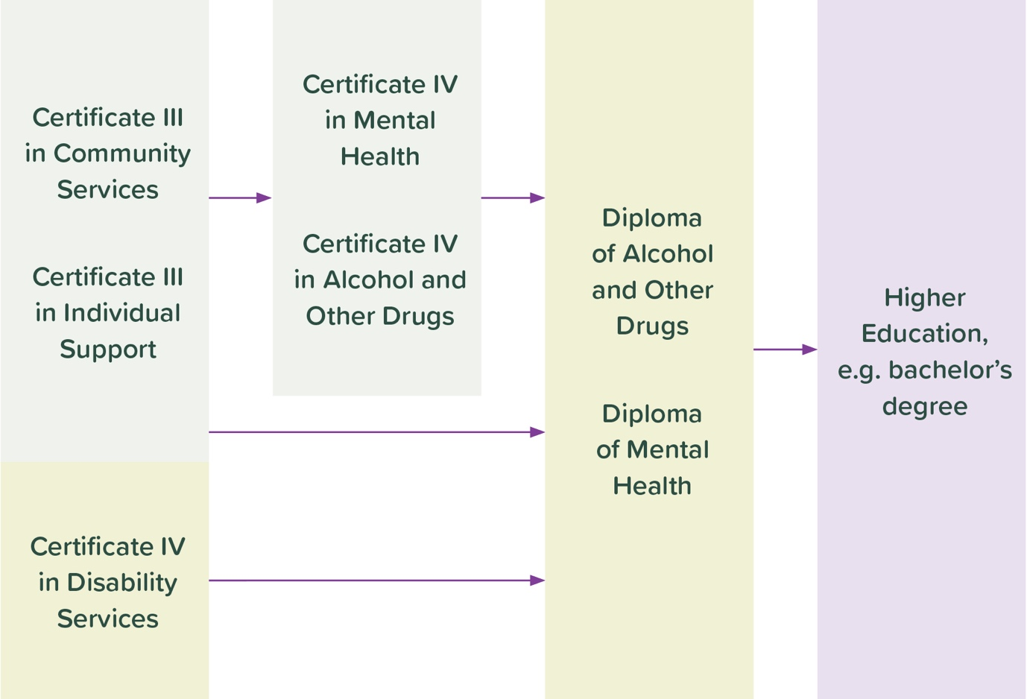

Several employers described how individuals in the industry progress through formal qualifications. This progression often begins with a Certificate III in a related field, which serves as a foundation for a *Certificate IV in Mental Health or Alcohol and Other Drugs* qualification, or in some cases, directly to a Diploma. Both pathways create opportunities for further study, including university-level qualifications. However, the *Certificate IV in Mental Health Peer Work* is less commonly associated with these pathways and is frequently pursued as a standalone qualification.

Currently, no university-level qualification is dedicated to peer work in the mental health or alcohol and other drugs sectors, which limits the upward mobility of learners in these roles. Furthermore, the *CHC43515 Certificate IV in Mental Health Peer Work* is narrowly focused on entry-level peer work positions, which restricts learners' awareness of the diverse opportunities within the lived-experience workforce. To better align with the evolving needs of the sector, the qualification should expand its scope to introduce learners to a broader range of roles and pathways, empowering them to explore advanced opportunities in areas such as policy development, management, or specialty practice.

## 3.3 Emerging trends

The mental health and alcohol and other drugs sectors are witnessing significant evolution, driven by societal changes and shifts in policy. Integration between mental health and alcohol and other drugs services has emerged as a critical trend, reflecting the high prevalence of comorbidities among clients. Dual-diagnosis capability is increasingly prioritised, with professionals expected to address both mental health and substance use issues simultaneously rather than in isolation.

Another trend is the growing importance of lived experience roles, which are transitioning from peer support-focused positions to encompass a broader range of roles, including advocacy, policy development, and leadership. This is evident in initiatives aiming to professionalise lived experience work and embed it in organisational structures.

"For peer workers, the Certificate IV in Mental Health Peer Work has been a game-changer. It validates their experience and gives them the tools to operate in professional environments."

The growth of social prescribing, which links clients to community resources for non-medical needs, reflects a shift toward holistic, client-centred care.

Given the complex and often sensitive nature of mental health and alcohol and other drugs training, delivery approaches must be carefully designed to mitigate potential emotional triggers for learners and workers. This need extends beyond peer work qualifications, requiring tailored support mechanisms and trauma-informed teaching practices to ensure a safe and effective learning environment.

## 3.4 Regional and Remote Challenges

Service delivery in regional and remote areas faces unique challenges, particularly due to workforce shortages and the lack of training infrastructure. Many rural organisations struggle to attract and retain qualified staff, exacerbated by the absence of face-to-face training options and limited placement opportunities. The transient nature of regional workforces further complicates workforce stability, impacting service continuity and client outcomes. It also affects the availability of opportunities for mandatory work placement relating to achieving qualifications in mental health and AOD, and the appropriate supervision required of learners during these placements.

"The further you go up into north Queensland, the less you have. There’s a real imbalance... and I look at what’s going on in Victoria, and they seem to be ahead of us in providing services and workforce integration."

Cultural competency is another critical issue in regional areas, especially when providing services to Aboriginal and Torres Strait Islander people and communities. Workers often lack training in culturally safe practices, creating barriers to effective engagement. Additionally, logistical challenges like vast distances between communities and available services, limited transportation options, and unreliable internet connectivity hinder both service delivery and professional development. The Social and Emotional Wellbeing (SEWB) model plays a vital role in addressing these challenges, particularly in Aboriginal and Torres Strait Islander people and communities, by integrating culturally safe, holistic support that combines mental health, cultural identity, and community wellbeing. Expanding the SEWB workforce and embedding its principles in service delivery could improve engagement, workforce retention, and health outcomes in regional and remote areas.

## 3.5 Training gaps

Employers frequently cited gaps in vocational qualifications related to practical skills and real-world applicability. Dual-diagnosis training is identified as a critical deficit, with many professionals lacking the integrated skills needed to address concurrent mental health and substance use issues. There is also a noted gap in foundational skills, such as de-escalation techniques and trauma-informed care, which are essential for managing complex client presentations.

"There’s no doubt the training is useful, but when people get into the field, they often say they weren’t fully prepared for the intensity of the work or the specific challenges of working with co-occurring conditions."

Employers also highlighted the need for training that better aligns with the diverse systems workers interact with, including justice, housing, and health services. A lack of focus on the broader systemic context in existing training products leaves workers ill-prepared to navigate these interfaces effectively. Additionally, the absence of clear vocational outcomes and role-specific competencies in certain qualifications has led to confusion and unmet workforce needs.

"We’ve seen an improvement in the general knowledge of graduates, but critical skills like cultural safety, group facilitation, and harm minimisation are often underdeveloped."

## 3.6 Specialised skills and niche roles

The workforce is increasingly required to possess specialised skills tailored to specific contexts, such as harm reduction in needle exchange programs or health-focused interventions in bloodborne virus prevention. In lived experience roles, skills in boundary-setting and professional advocacy are becoming essential as these positions expand beyond peer support into areas like research and policy-making.

Emerging niche roles include link workers in social prescribing, who connect clients with community resources to improve social determinants of health, and transitional support workers in hospital-to-home programs, who facilitate a person’s reintegration into the community after they have been discharged from other services.

The need for cultural competency in working with Aboriginal and Torres Strait Islander people and communities remains a significant focus, particularly in remote areas.

*"Trauma-informed care isn’t just a buzzword; it’s critical to understanding our clients’ needs, but the training doesn’t go far enough in equipping workers to practice this effectively."*

## 3.7 Technology and digital competencies

Digital literacy is increasingly essential across the mental health and alcohol and other drugs sectors, with workers expected to navigate client management systems, conduct virtual consultations, and manage case notes electronically. The shift to online and hybrid training models has amplified the need for trainers and students alike to be proficient in digital tools, particularly in remote areas where face-to-face training is limited.

"As we move towards more telehealth and digital case management, workers need to be trained in these platforms to stay effective."

Employers also emphasise the importance of leveraging technology to improve client engagement and service delivery. For instance, assistive technologies and digital tools are now used to support capacity-building among clients with psychosocial disabilities. Despite these advancements, inconsistent internet connectivity in regional and remote areas remains a significant barrier to adopting technology-driven solutions.

## 3.8 Sector challenges

Key challenges identified through stakeholder interviews and workshops highlight the pressing issues impacting the mental health and alcohol and other drugs workforce and their training needs.

|  |  |
| --- | --- |
| **Description** | **Challenge** |
| Regional and remote challenges | * Barriers to accessing training and professional development in isolated areas. * Higher operational costs and logistical difficulties for service delivery in remote communities. * Limited housing and other social supports, impacting both clients and workers. |
| Training and education | * Mismatch between training content and the practical skills required in the field, including co-occurring condition management and trauma-informed care. * Insufficient vocational placement hours for real-world application of skills. * Limited access to training for workers in remote areas due to infrastructure challenges * Demand for entry level qualifications at a lower and more accessible AQF level. |
| Emerging needs and trends | * Growing need for skills in digital literacy, telehealth, and social prescribing. * Demand for updated qualifications addressing integrated care for mental health and substance use challenges. * Increasing recognition of peer-led approaches and the need for specialised training for lived experience workers. * Greater utilisation of skill sets to enable time-poor staff to upskill or transition into new roles without committing to a full qualification. * Skill sets being used to build workforce capacity, providing foundational knowledge for supporting clients with mental health and AOD challenges. |
| Compliance and regulation | * Increasing complexity of compliance requirements, including heavy regulatory burdens. * Discrepancies between state-level and national-level licensing and reporting requirements. * Challenges in maintaining alignment with updated frameworks like trauma-informed and culturally safe practices. |
| Workforce attraction and retention | * Difficulties in recruiting and retaining qualified professionals, especially in regional and remote areas. * High turnover rates due to burnout, low wages, and limited career advancement opportunities. * Shortage of First Nations workers and challenges faced by culturally diverse workers in predominantly white workplaces. * Lack of flexible pathways and support for lived experience workers entering the workforce. |
| Workload and resources | * Overburdened staff, particularly in regional and remote services, where resources are scarce. * High demand for mental health and substance use services exacerbating workforce stress. |
| Funding challenges | * Strict limitations on funding usage, leading to operational constraints. * Reliance on short-term grants, limiting sustainability for long-term projects. |

# Section Four: Mapping to Qualifications

## 4.1 Functions and Subfunctions analysis

The analysis of job roles and tasks described by interviewees, job advertisements, and position descriptions shows that many of the **br**oad functions (key responsibilities or areas of work) and more specific subfunctions (component tasks or specialised activities within those areas) performed by the workforce are covered by existing units of competency. However, not all roles and tasks are fully addressed. For example, units like *CHCMHS002 Establish self-directed recovery relationships, CHCMHS003 Provide recovery oriented mental health services*, and *CHCMHS011 Assess and promote social, emotional and physical wellbeing* match tasks such as goal setting, recovery planning, and community collaboration performed by mental health recovery workers. Despite this, there are gaps and areas where the coverage is only partial. Some roles, especially those involving integrated care or practices like trauma-informed approaches, do not have strong unit alignment. In addition, some tasks may need more specific or customised units to handle challenges such as cultural sensitivity or dual-diagnosis support. There is also overlap between some units, making it difficult to distinguish between the unique tasks of different roles.

The next stage of the mental health, alcohol, and other drugs qualification review will be critical in addressing these gaps. It will focus on identifying units that need modification to better reflect the scope of practice, recognising gaps in the current units that require the development of new content, and exploring the potential restructuring of qualifications to provide clearer pathways and address industry needs. This review will ensure that training products are fit for purpose and aligned with workforce demands and national strategies, as outlined in the project's objectives and methodology.

*Refer Appendix 7.*

## 4.2 Analysis of required skills and knowledge mapped to existing training package components

The alignment of workforce needs in the mental health, alcohol, and other drugs sectors with current training package components was evaluated by analysing stakeholder feedback, job functions, and emerging trends. The following chart highlights the strengths and gaps in the existing training framework, assessing how effectively the current qualifications and skill sets equip the workforce to meet sector-specific skill requirements.

*Refer Appendix 8.*

#### Summary of Workforce Needs mapped to Training Package Components

|  |  |  |
| --- | --- | --- |
| **Trauma-informed care** | *CHCMHS007 Work effectively in trauma-informed care*  *CHCMHS005 Provide services to people with co-existing mental health and alcohol and other drugs issues* | Covers basic principles but lacks advanced practical training for complex trauma scenarios in diverse settings. |
| **Dual diagnosis skills** | *CHCMHS005 Provide services to people with co-existing mental health and alcohol and other drugs issues*  *CHCAOD004 Assess needs of clients with alcohol and other drugs issues* | Theoretical alignment is strong; practical integration of mental health and AOD care requires enhancement. |
| **Professional boundaries and ethics** | *CHCLEG001 Work legally and ethically*  *CHCMHS002 Establish self-directed recovery relationships* | Foundational coverage, but additional focus needed for challenges in peer roles and intentional disclosure practices. |
| **Cultural competency and safety** | *CHCDIV002 Promote Aboriginal and/or Torres Strait Islander cultural safety*  *CHCMHS011 Assess and promote social, emotional and physical wellbeing* | Foundational content included, practical application for Aboriginal and Torres Strait Islander peoples contexts is insufficient. |
| **Harm reduction strategies** | *CHCAOD001 Work in an alcohol and other drugs context*  *CHCAOD007 Develop strategies for alcohol and other drugs relapse prevention and management* | Provides foundational knowledge but lacks depth in harm reduction for high-risk settings like needle exchanges. |
| **Motivational interviewing** | *CHCCCS014 Provide brief interventions*  *CHCGRP002 Plan and conduct group activities* | Basic skills covered; advanced facilitation techniques and group dynamic management need more emphasis. |
| **Crisis management** | *CHCCCS019 Recognise and respond to crisis situations*  *CHCCCS003 Increase the safety of individuals at risk of suicide* | Addresses foundational crisis response but lacks advanced de-escalation strategies for volatile non-clinical contexts. |
| **Digital literacy** | *Not explicitly covered* | Significant gap in training for digital tools, case management systems, and telehealth platforms. |
| **System navigation** | *CHCMHS004 Work collaboratively with the care network and other services*  *CHCPRP001 Develop and maintain networks and collaborative partnerships* | Theoretical alignment is present; more practical tools for navigating complex systems like housing and healthcare needed. |
| **Lived experience integration** | *CHCPWK001 Apply peer work practices in the mental health sector*  *CHCPWK003 Apply lived experience in mental health peer work* | Strong foundational coverage but needs focus on peer drift, stigma management, and intentional lived experience use. “Peer worker” is a term not commonly used in the AOD sector, so units appearing in AOD qualifications could instead refer to lived experience workers or specialists |
| **Case management** | *CHCMHS002 Establish self-directed recovery relationships*  *CHCAOD006 Provide interventions for people with alcohol and other drugs issues* | Well-covered theoretically, but practical application of individualised recovery planning requires strengthening. |
| **Group facilitation** | *CHCGRP002 Plan and conduct group activities*  *CHCGRP004 Deliver structured programs* | Core skills included but insufficient focus on managing complex group dynamics in therapeutic settings. |

### Skill Sets:

* The CHCSS00092 Alcohol and Other Drugs Co-existing Needs Skill Set is underutilised, showing no completions in recent data. Expanding its relevance to include advanced dual-diagnosis skills could increase uptake and value.
* The CHCSS00103 Mental Health Peer Work Skill Set provides foundational coverage for peer work but lacks customisation for AOD contexts. Note: “peer work” could be replaced with “lived experience work” or similar for the AOD workforce.

### Completion Trends:

* Declining completions for the CHC53215 Diploma of Alcohol and Other Drugs may reflect a lack of perceived value or alignment with career progression opportunities. Consider revising to emphasise advanced practice skills.

### Placement Hours:

* The standard 80 hours for practical placements is insufficient to develop competency in the skills needed to undertake work in this sector. Expanding the placement requirements, in particular for trauma-informed care and peer work, may better support the skill development in these areas.

### Emerging Trends:

* Increased use of telehealth and digital tools highlights a critical need for units focusing on digital literacy and technology for modern service delivery.
* Expansion of peer-led roles and lived experience integration drives the demand for targeted support and leadership pathways for these workers.
* Growth in social prescribing and harm minimisation strategies underscores the need for training in these innovative approaches.
* Development of integrated care models calls for enhanced collaboration between mental health and alcohol and other drugs services.
* Increased reliance on digital literacy, telehealth, and AI tools demonstrates the need for specialised training in emerging technologies.
* Greater focus on advanced crisis management and system navigation highlights the importance of equipping workers with practical tools for complex care scenarios.

## 4.3 Vocational placement hours

Many stakeholders view placement hours as vital for ensuring practical skill development, especially in roles requiring relational and therapeutic expertise, like trauma-informed care and peer support. However, concerns were raised about the adequacy and implementation of these hours. Some argued that 80 hours is insufficient for developing the complex skills required, particularly in peer work, where practice and reflective learning are critical. Conversely, others highlighted challenges in finding suitable placements, particularly in rural areas, where opportunities are limited, and organisations often lack the resources to support trainees. Employers expressed hesitation to hire candidates without practical experience, even with formal qualifications, underscoring the importance of placements. There was also a call for more structured, supervised, and impactful placement experiences, as some placements were described as poorly aligned with the learning objectives, reducing their value.

*"The biggest issue with placements is finding meaningful opportunities. Too often, students are given administrative tasks instead of real client-facing experience."*

Only three components under review (*CHC43315 Certificate IV in Mental Health, CHC53315 Diploma of Mental Health*, and *CHCSS00102 Mental Health Co-existing Needs Skill Set*) have core units explicitly requiring minimum placement hours. However, the assessment criteria for several commonly selected elective units stipulate that learners must demonstrate skills and knowledge in a real workplace setting rather than a simulated environment. For instance, units such as CH*CCCS003 Increase the safety of individuals at risk of suicide* and *CHCCCS019 Recognise and respond to crisis situations* require practical engagement with real-world scenarios, including direct interaction with people in need. Furthermore, units like *CHC*A*OD004 Assess needs of clients with alcohol and other drugs issue*s and *CHCAOD009 Develop and review individual alcohol and other drugs treatment plans* demand evidence of applied skills, often necessitating supervised activities within a workplace.

"When placements are too short, people miss out on the chance to really build their confidence and practice what they’ve learned. It makes it harder for them to transition smoothly into the workforce."

While these requirements are not tied to specific minimum hours, they underscore the importance of real-world practice for competency. This reflects a broader need for robust placement opportunities to bridge theoretical knowledge and applied skills, highlighting systemic challenges such as securing appropriate placements, ensuring sufficient supervision, and addressing inequities in rural or regional access to suitable workplaces. These issues are particularly relevant when analysing the adequacy and consistency of practical training across these qualifications.

*Refer Appendix 9.*

## 4.4 Qualification Packaging Rules and Units

The qualifications under review reveal a varied structure in the number and nature of elective units available, which impacts their relevance to workforce needs.

|  |  |
| --- | --- |
| *CHC43315 Certificate IV in Mental Health* | 11 core and 4 elective (15 units) |
| *CHC43515 Certificate IV in Mental Health Peer Work* | 8 core and 7 elective (15 units). |
| *CHC43215 Certificate IV in Alcohol and Other Drugs* | 12 core and 5 elective (17 units) |
| *CHC53215 Diploma of Alcohol and Other Drugs* | 16 core and 6 elective (22 units). |
| *CHC53315 Diploma of Mental Health* | 15 core and 5 elective (20 units) |

Some qualifications, like the *CHC53315 Diploma of Mental Health*, offer fewer elective options that are better aligned with the industry’s needs. However, others, such as the *CHC43215 Certificate IV in Alcohol and Other Drugs,* present a wider elective bank, but stakeholders have expressed concerns about the relevance of some of these options. A focused approach to elective options may better meet industry and learner needs.

*Refer Appendix 10.*

# Section Five: Recommendations and next steps

5.1: Recommendations for qualification enhancements

This functional analysis for the mental health, alcohol, and other drugs sectors has highlighted several key themes and priorities for consideration in redeveloping the structure and content of these Training Package components.

### Key priorities for qualification redevelopment

* Trauma-responsive care
* Embed trauma-informed and trauma-aware practices in all qualifications.
* Cultural competency
* Include cultural safety, especially tailored for First Nations peoples, culturally diverse communities, and those with lived experience.
* Harm reduction
* Strengthen harm minimisation strategies across all qualifications to reflect contemporary practices.
* Reflective practice and self-care:
* Incorporate modules emphasising reflective practice and self-care as core components.
* Workplace simulations and placements:
* Expand and refine workplace simulations.
* Increase and contextualise vocational placement hours to reflect real-world scenarios.
* Specialised streams:
* Introduce distinct streams or specialisations, such as AOD lived experience specialists, and consumer-focused and carer-focused mental health peer worker pathways.
* Integrate emerging models like peer-led and lived experience-focused approaches.
* Contemporary, person-centred language:
* Replace terms like “crisis” with industry-preferred terminology.
* Use inclusive and non-stigmatising language throughout training materials.
* Skills focus:
* Emphasise dual-diagnosis capabilities, social prescribing, and integrated care models.
* Enhance skills in group facilitation, system navigation, and co-occurring condition management.
* Alignment with current practices:
* Update units like “*CHCMHS003 Provide recovery-oriented mental health services*” to core where relevant.
* Ensure practical, context-relevant delivery methods for telehealth and digital platforms.
* Diversity and inclusion:
* Ensure qualifications support workforce diversity, including Aboriginal and Torres Strait Islander peoples and those with lived experience.
* Develop resources for underrepresented groups to enhance participation in training and employment pathways.
* Professional identity:
* Reinforce the unique identity of peer workers as a distinct vocational role.
* Digital competency:
* Enhance references to skills required to work with digital platforms, including telehealth, AI-based case note systems and other digital-based recordkeeping systems

### Recommendations for changes to Qualifications, Skill Sets and Units of Competency

#### CHC43315 Certificate IV in Mental Health

|  |  |
| --- | --- |
| **Change** | **Units** |
| Expand focus on trauma-informed care and cultural safety to ensure practical and theoretical understanding | Several relevant units |
| Review placement hours to better align with real-world requirements | Where relevant |
| Review terminology for appropriateness | *CHCMHS002 Establish self-directed recovery relationships* (“promote the recovery approach”)  *CHCMHS003 Provide recovery oriented mental health services* (“deliver a range of recovery strategies”)  *CHCMHS004 Work collaboratively with the care network and other services* (“work with supporters and services”) |
| Change “client” and “individual” to “person” | All units |
| Review units to add digital skills where appropriate | Where relevant |
| Review units to ensure cultural sensitivity and trauma-informed care in supporting bereaved individuals and families | [*CHCCCS018*](https://training.gov.au/training/details/CHCCCS018) *Provide suicide bereavement support* |
| Expand performance evidence section in core units | Core units |
| Add a range of current approaches and frameworks to knowledge evidence | *CHCMHS005 Provide services to people with co-existing mental health and alcohol and other drugs issues*  *CHCMHS007 Work effectively in trauma informed care* |
| Review for inclusion of references to interpersonal and domestic violence | All units |
| Replace “issues” with “challenges” | Where relevant |
| Retitle | Several units, e.g.  *CHCMHS008 Promote and facilitate self advocacy* (suggested “develop person’s self advocacy skills”) |
| Review terminology for appropriateness | All units  e.g. *CHCMHS011 Assess and promote social, emotional and physical wellbeing* (Include references to “support” rather than “assess”) |
| Replace superseded units | Core and elective |
| Consider adding to core | *CHCPRP003 Reflect on and improve own professional practice*  [*HLTWHS006*](https://training.gov.au/Training/Details/HLTWHS006) *Manage personal stressors in the work environment* |
| Consider adding to elective bank | *CHCMHS001 Work with people with mental health issues*  *CHCPRT001 Identify and respond to children and young people at risk*  *CHCGRP002 Plan and conduct group activities*  *CHCSOH013 Work with people experiencing or at risk of homelessness* |
| Consider removing from elective bank | [*CHCAOD005*](https://training.gov.au/Training/Details/CHCAOD005) *Provide alcohol and other drugs withdrawal services*  [*CHCEDU002*](https://training.gov.au/Training/Details/CHCEDU002) *Plan health promotion and community intervention*  [*CHCEDU005*](https://training.gov.au/Training/Details/CHCEDU005) *Work with clients to identify financial literacy education needs*  [*CHCEDU007*](https://training.gov.au/Training/Details/CHCEDU007) *Provide group education on consumer credit and debt*  [*CHCEDU009*](https://training.gov.au/Training/Details/CHCEDU009) *Provide parenting, health and well-being education*  [*CHCFAM010*](https://training.gov.au/Training/Details/CHCFAM010) *Provide intervention support to families*  [*CHCMGT001*](https://training.gov.au/Training/Details/CHCMGT001) *Develop, implement and review quality framework*  [*CHCPOL001*](https://training.gov.au/Training/Details/CHCPOL001) *Contribute to the review and development of policies*  [*HLTAID013*](https://training.gov.au/Training/Details/HLTAID013) *Provide First Aid in remote or isolated site*  [*HLTAID014*](https://training.gov.au/Training/Details/HLTAID014) *Provide Advanced First Aid* |

#### CHC43515 Certificate IV in Mental Health Peer Work

|  |  |
| --- | --- |
| **Change** | **Units** |
| Expand focus on trauma-informed care and cultural safety to ensure practical and theoretical understanding | Several relevant units |
| Review placement hours to better align with real-world requirements | Where relevant |
| Explore inclusion of more advanced units on peer leadership and advocacy to support career progression | Where relevant |
| Expand focus on ethical boundaries and the use of lived experience narratives | Throughout peer work specific units |
| Explore inclusion of micro-credential options for specialisations |  |
| Review units to add digital skills | Where relevant |
| Integrate content addressing lived experience in AOD contexts alongside mental health | Where relevant |
| Separate consumer peer worker and carer peer worker skills into separate qualification streams: e.g. Certificate IV in Mental Health Peer Work (Carers) and Certificate IV in Mental Health Peer Work (Consumers) | At qualification level |
| Enhance advanced de-escalation skills | *CHCCCS019 Recognise and respond to crisis situations* |
| Review units requiring assessment of direct interaction with clients to accommodate working with digital platforms, e.g. telehealth and other services, where direct engagement skills are difficult to observe and assess | Where relevant |
| Review units for duplication and consider merging | *CHCPWK001 Apply peer work practices in the mental health sector*  *CHCPWK002 Contribute to the continuous improvement of mental health services for consumers and carers*  *CHCPWK003 Apply lived experience in mental health peer work* |
| Review terminology for appropriateness | *CHCMHS011 Assess and promote social, emotional and physical wellbeing (consider using “support” instead of “assess”*  *CHCCCS019 Recognise and respond to crisis situations (review use of “crisis”)* |
| Change “client” and “individual” to “person” | All units |
| Add a range of current approaches and frameworks to knowledge evidence | *CHCMHS007 Work effectively in trauma informed care*  *CHCPWK001 Apply peer work practices in the mental health sector* |
| Review all units for inclusion of references to interpersonal and domestic violence | All units |
| Replace “issues” with “challenges” | Where appropriate |
| Replace superseded units | Where appropriate |
| Consider adding to core | *CHCLEG001 Work legally and ethically*  *CHCPRP003 Reflect on and improve own professional practice*  *CHCMHS003 Provide recovery oriented mental health services* |
| Consider adding to elective bank | *CHCPRP001 Develop and maintain networks and collaborative partnerships*  *CHCPRP003 Reflect on and improve own professional practice*  *CHCLEG001 Work legally and ethically*  *HLTAAP001 Recognise healthy body systems* |
| Consider removing from elective bank (not used in past 5 years) | [*CHCCCS025*](https://training.gov.au/training/details/CHCCCS025) *Support relationships with carers and families*  [*CHCCCS027*](https://training.gov.au/training/details/CHCCCS027) *Visit client residence*  [*CHCCDE001*](https://training.gov.au/training/details/CHCCDE001) *Support community participation in planning processes*  [*CHCCDE002*](https://training.gov.au/training/details/CHCCDE002) *Develop and implement community programs*  [*CHCCDE004*](https://training.gov.au/training/details/CHCCDE004) *Implement participation and engagement strategies*  [*CHCCDE006*](https://training.gov.au/training/details/CHCCDE006) *Work to empower Aboriginal and/or Torres Strait Islander communities*  [*CHCCDE007*](https://training.gov.au/training/details/CHCCDE007) *Develop and provide community projects*  [*CHCCDE008*](https://training.gov.au/training/details/CHCCDE008) *Support community action*  [*CHCDEV002*](https://training.gov.au/training/details/CHCDEV002) *Analyse impacts of sociological factors on clients in community work and services*  [*CHCEDU011*](https://training.gov.au/training/details/CHCEDU011) *Work with parents or carers of very young children*  [*CHCGRP004*](https://training.gov.au/training/details/CHCGRP004) *Deliver structured programs*  [*CHCMHS006*](https://training.gov.au/training/details/CHCMHS006) *Facilitate the recovery process with the person, family and carers*  [*CHCPOL001*](https://training.gov.au/training/details/CHCPOL001) *Contribute to the review and development of policies*  [*CHCSET001*](https://training.gov.au/training/details/CHCSET001) *Work with forced migrants*  [*CHCSET002*](https://training.gov.au/training/details/CHCSET002) *Undertake bicultural work with forced migrants in Australia*  [*CHCSOH002*](https://training.gov.au/training/details/CHCSOH002) *Manage and maintain tenancy agreements and services*  [*CHCYTH011*](https://training.gov.au/training/details/CHCYTH011) *Work effectively with young people and their families*  [*BSBINM201*](https://training.gov.au/training/details/BSBINM201) *Process and maintain workplace information*  [*BSBRES401*](https://training.gov.au/training/details/BSBRES401) *Analyse and present research information* |

#### [CHC43215 Certificate IV in Alcohol and Other Drugs](https://training.gov.au/Training/Details/CHC43215)

|  |  |
| --- | --- |
| **Change** | **Units** |
| Expand focus on trauma-informed care and cultural safety to ensure practical and theoretical understanding | Where relevant |
| Review placement hours to better align with real-world requirements | Where relevant |
| Review terminology for appropriateness | All units |
| Change “client” and “individual” to “person” | Where relevant |
| Include dual-diagnosis management, including practical approaches to co-occurring mental health and substance use issues | Where relevant |
| Review units to add digital skills | Where relevant |
| Review harm minimisation strategies to ensure alignment with emerging best practices | Where relevant |
| Add a range of current approaches and frameworks to knowledge evidence | *CHCAOD001 Work in an alcohol and other drugs context* |
| Review all units for inclusion of references to interpersonal and domestic violence | All units |
| Replace “issues” with “challenges” | Where relevant |
| Replace superseded units listed in elective bank | Where relevant |
| Consider adding to core | *CHCCCS003 Increase the safety of individuals at risk of suicide*  *CHCGRP002 Plan and conduct group activities*  *CHCMHS007 Work effectively in trauma informed care*  *CHCPRP003 Reflect on and improve own professional practice* |
| Consider adding to elective bank | *CHCCSM012 Coordinate complex case requirements*  *CHCMHS011 Assess and promote social, emotional and physical wellbeing*  *HLTWHS003 Maintain work health and safety* |
| Consider removing from elective bank (not used in past 5 years) | [*CHCAGE001*](https://training.gov.au/training/details/CHCAGE001) *Facilitate the empowerment of older people*  [*CHCCCS001*](https://training.gov.au/training/details/CHCCCS001) *Address the needs of people with chronic disease*  [*CHCCCS018*](https://training.gov.au/training/details/CHCCCS018) *Provide suicide bereavement support*  [*CHCCCS023*](https://training.gov.au/training/details/CHCCCS023) *Support independence and wellbeing*  [*CHCCCS027*](https://training.gov.au/training/details/CHCCCS027) *Visit client residence*  [*CHCCDE004*](https://training.gov.au/training/details/CHCCDE004) *Implement participation and engagement strategies*  [*CHCCDE006*](https://training.gov.au/training/details/CHCCDE006) *Work to empower Aboriginal and/or Torres Strait Islander communities*  [*CHCCDE007*](https://training.gov.au/training/details/CHCCDE007) *Develop and provide community projects*  [*CHCDIS007*](https://training.gov.au/training/details/CHCDIS007) *Facilitate the empowerment of people with disability*  [*CHCDIS008*](https://training.gov.au/training/details/CHCDIS008) *Facilitate community participation and social inclusion*  [*CHCEDU001*](https://training.gov.au/training/details/CHCEDU001) *Provide community focused promotion and prevention strategies*  [*CHCEDU002*](https://training.gov.au/training/details/CHCEDU002) *Plan health promotion and community intervention*  [*CHCEDU005*](https://training.gov.au/training/details/CHCEDU005) *Work with clients to identify financial literacy education needs*  [*CHCEDU006*](https://training.gov.au/training/details/CHCEDU006) *Improve clients’ fundamental financial literacy skills*  [*CHCEDU007*](https://training.gov.au/training/details/CHCEDU007) *Provide group education on consumer credit and debt*  [*CHCEDU008*](https://training.gov.au/training/details/CHCEDU008) *Share health information*  [*CHCEDU009*](https://training.gov.au/training/details/CHCEDU009) *Provide parenting, health and well-being education*  [*CHCFAM003*](https://training.gov.au/training/details/CHCFAM003) *Support people to improve relationships*  [*CHCFAM010*](https://training.gov.au/training/details/CHCFAM010) *Provide intervention support to families*  [*CHCGRP003*](https://training.gov.au/training/details/CHCGRP003) *Plan, facilitate and review psycho-educational groups*  [*CHCGRP004*](https://training.gov.au/training/details/CHCGRP004) *Deliver structured programs*  [*CHCLLN001*](https://training.gov.au/training/details/CHCLLN001) *Respond to client language, literacy and numeracy needs*  [*CHCPRT002*](https://training.gov.au/training/details/CHCPRT002) *Support the rights and safety of children and young people*  [*CHCSET001*](https://training.gov.au/training/details/CHCSET001) *Work with forced migrants*  [*CHCSET002*](https://training.gov.au/training/details/CHCSET002) *Undertake bicultural work with forced migrants in Australia*  [*CHCYTH011*](https://training.gov.au/training/details/CHCYTH011) *Work effectively with young people and their families*  [*HLTAAP001*](https://training.gov.au/training/details/HLTAAP001) *Recognise healthy body systems*  [*HLTHPS006*](https://training.gov.au/training/details/HLTHPS006) *Assist clients with medication*  [*HLTHPS010*](https://training.gov.au/training/details/HLTHPS010) *Interpret and use information about nutrition and diet*  [*HLTOHC001*](https://training.gov.au/training/details/HLTOHC001) *Recognise and respond to oral health issues*  [*HLTOHC002*](https://training.gov.au/training/details/HLTOHC002) *Inform and support patients and groups about oral health*  [*HLTOHC003*](https://training.gov.au/training/details/HLTOHC003) *Apply and manage use of basic oral health products*  [*HLTOHC004*](https://training.gov.au/training/details/HLTOHC004) *Provide or assist with oral hygiene*  [*BSBINM201*](https://training.gov.au/training/details/BSBINM201) *Process and maintain workplace information* |

#### [CHC53215 Diploma of Alcohol and Other Drugs](https://training.gov.au/Training/Details/CHC53215)

|  |  |
| --- | --- |
| **Change** | **Units** |
| Expand focus on trauma-informed care and cultural safety to ensure practical and theoretical understanding | Where relevant |
| Review placement hours to better align with real-world requirements | Where relevant |
| Ensure unit requiring placement hours have practical skill application requirements | Where relevant |
| Increase focus on group facilitation and social prescribing approaches | Where relevant |
| Review terminology for appropriateness | All units |
| Change “client” and “individual” to “person” | All units |
| Add current approaches and frameworks to knowledge evidence | Where relevant |
| Review all units for inclusion of references to interpersonal and domestic violence | Where relevant |
| Replace “issues” with “challenges” | All units |
| Review units to add digital skills | Where relevant |
| Replace superseded units | Where relevant |
| Consider adding to core | [*CHCMHS013*](https://training.gov.au/training/details/CHCMHS013) *Implement trauma informed care* |
| Consider removing from core | *HLTAID011 Provide first aid* |
| Consider adding to elective bank | *CHCCCS019 Recognise and respond to crisis situations*  *HLTAID011 Provide first aid* |
| Consider removing from elective bank | [*CHCCDE006*](https://training.gov.au/training/details/CHCCDE006) *Work to empower Aboriginal and/or Torres Strait Islander communities*  [*CHCINM001*](https://training.gov.au/training/details/CHCINM001) *Meet statutory and organisation information requirements*  [*CHCLLN001*](https://training.gov.au/training/details/CHCLLN001) *Respond to client language, literacy and numeracy needs*  [*CHCMGT001*](https://training.gov.au/training/details/CHCMGT001) *Develop, implement and review quality framework*  [*CHCMGT002*](https://training.gov.au/training/details/CHCMGT002) *Manage partnership agreements with service providers*  [*CHCMHS004*](https://training.gov.au/training/details/CHCMHS004) *Work collaboratively with the care network and other services*  [*CHCMHS012*](https://training.gov.au/training/details/CHCMHS012) *Provide support to develop wellness plans and advanced directives*  [*CHCSOH002*](https://training.gov.au/training/details/CHCSOH002) *Manage and maintain tenancy agreements and services*  [*CHCSOH008*](https://training.gov.au/training/details/CHCSOH008) *Manage head lease*  [*CHCSOH009*](https://training.gov.au/training/details/CHCSOH009) *Develop quality systems in line with registration standards*  [*CHCVOL003*](https://training.gov.au/training/details/CHCVOL003) *Recruit, induct and support volunteers*  [*HLTAID014*](https://training.gov.au/training/details/HLTAID014) *Provide advanced first aid*  [*HLTHPS006*](https://training.gov.au/training/details/HLTHPS006) *Assist clients with medication*  [*HLTHPS010*](https://training.gov.au/training/details/HLTHPS010) *Interpret and use information about nutrition and diet*  [*HLTOHC001*](https://training.gov.au/training/details/HLTOHC001) *Recognise and respond to oral health issues*  [*HLTOHC002*](https://training.gov.au/training/details/HLTOHC002) *Inform and support patients and groups about oral health*  [*HLTOHC003*](https://training.gov.au/training/details/HLTOHC003) *Apply and manage use of basic oral health products*  [*HLTOHC004*](https://training.gov.au/training/details/HLTOHC004) *Provide or assist with oral hygiene*  [*BSBFIM501*](https://training.gov.au/training/details/BSBFIM501) *Manage budgets and financial plans* |

#### [CHC53315 Diploma of Mental Health](https://training.gov.au/Training/Details/CHC53315)

|  |  |
| --- | --- |
| **Change** | **Units** |
| Expand focus on trauma-informed care and cultural safety to ensure practical and theoretical understanding | Where relevant |
| Add focus on system navigation | Where relevant |
| Review placement hours to better align with real-world requirements | Where relevant |
| Review terminology for appropriateness | All units |
| Change “client” and “individual” to “person” | All units |
| Review units to add digital skills | Where relevant |
| Add current approaches and frameworks to knowledge evidence of several units, including motivational interviewing, complex care coordination, acceptance commitment therapy | Where relevant |
| Review all units for inclusion of references to interpersonal and domestic violence | All units |
| Replace “issues” with “challenges” | All units |
| Replace superseded units | Where relevant |
| Consider adding to core (issues raised by employers) | *CHCMHS007 Work effectively in trauma informed care* |
| Consider adding to elective bank (often delivered as part of this qualification) | *CHCCCS003 Increase the safety of individuals at risk of suicide*  *CHCCSM005 Develop, facilitate and review all aspects of case management*  *CHCDEV001 Confirm client developmental status*  *CHCLEG001 Work legally and ethically*  *CHCMHS001 Work with people with mental health issues*  *CHCPRP001 Develop and maintain networks and collaborative partnerships*  *HLTENN009 Implement and monitor care for a person with mental health conditions* |
| Consider adding to elective bank (to meet stated needs of employers) | *Peer work units* |
| Consider removing from elective bank (not used in past 5 years) | *CHCAOD003 Provide needle and syringe services*  *CHCINM001 Meet statutory and organisation information requirements*  *BSBFIM501 Manage budgets and financial plans*  *CHCSOH002 Manage and maintain tenancy agreements and services*  *CHCSOH008 Manage head lease*  [*CHCSOH009*](https://training.gov.au/training/details/CHCSOH009) *Develop quality systems in line with registration standards*  [*CHCVOL003*](https://training.gov.au/training/details/CHCVOL003) *Recruit, induct and support volunteers* |

#### [CHCSS00092 Alcohol and Other Drugs Co-existing Needs Skill Set](https://aus01.safelinks.protection.outlook.com/?url=https%3A%2F%2Ftraining.gov.au%2Ftraining%2Fdetails%2FCHCSS00092%2Fskillsetdetails&data=05%7C02%7Ckate.declercq%40humanability.com.au%7C56297e558a8949f5922a08dcfe1b481b%7C970f60a909fa47bbbd6455acf3f6729f%7C0%7C0%7C638664640375405405%7CUnknown%7CTWFpbGZsb3d8eyJFbXB0eU1hcGkiOnRydWUsIlYiOiIwLjAuMDAwMCIsIlAiOiJXaW4zMiIsIkFOIjoiTWFpbCIsIldUIjoyfQ%3D%3D%7C0%7C%7C%7C&sdata=h%2FxnIt5wxqFKUjPXosGVu%2Bw0W0ch04uN7cn2ZUOaot4%3D&reserved=0)

* Has not been used for the past 5 years
* All 4 units are current
* Language and terminology in all units will be reviewed
* Industry will be consulted to determine whether to delete
* If not to delete, include trauma informed and dual diagnosis skills

#### [CHCSS00093 Alcohol and Other Drugs Skill Set](https://aus01.safelinks.protection.outlook.com/?url=https%3A%2F%2Ftraining.gov.au%2Ftraining%2Fdetails%2FCHCSS00093%2Fskillsetdetails&data=05%7C02%7Ckate.declercq%40humanability.com.au%7C56297e558a8949f5922a08dcfe1b481b%7C970f60a909fa47bbbd6455acf3f6729f%7C0%7C0%7C638664640375421828%7CUnknown%7CTWFpbGZsb3d8eyJFbXB0eU1hcGkiOnRydWUsIlYiOiIwLjAuMDAwMCIsIlAiOiJXaW4zMiIsIkFOIjoiTWFpbCIsIldUIjoyfQ%3D%3D%7C0%7C%7C%7C&sdata=Wms5%2Fi2BGxgYYZH2XNQQ5nZadNc0ms%2BgYOe3NW92%2BaQ%3D&reserved=0)

* 1,840 enrolments in 2023
* Listed by Victorian government as a minimum requirement for the AOD workforce
* All 4 units are current
* Introduce practical harm minimisation techniques and the role of peer support in AOD settings
* Language and terminology in all units will be reviewed.

#### [CHCSS00102 Mental Health Co-existing Needs Skill Set](https://aus01.safelinks.protection.outlook.com/?url=https%3A%2F%2Ftraining.gov.au%2Ftraining%2Fdetails%2FCHCSS00102%2Fskillsetdetails&data=05%7C02%7Ckate.declercq%40humanability.com.au%7C56297e558a8949f5922a08dcfe1b481b%7C970f60a909fa47bbbd6455acf3f6729f%7C0%7C0%7C638664640375370630%7CUnknown%7CTWFpbGZsb3d8eyJFbXB0eU1hcGkiOnRydWUsIlYiOiIwLjAuMDAwMCIsIlAiOiJXaW4zMiIsIkFOIjoiTWFpbCIsIldUIjoyfQ%3D%3D%7C0%7C%7C%7C&sdata=m40U9CFQcGV5LB2d86TwW17iEJYluDK3hrHIxM%2F29Yo%3D&reserved=0)

* 260 enrolments in 2023
* All 4 units are current
* Language and terminology in all units will be reviewed
* CHCMHS011 Assess and promote social, emotional and physical wellbeing is expected to be modified to replace the term “assess” with “support”
* Include guidance on culturally safe practices for working with Aboriginal and Torres Strait Islander people

#### [CHCSS00103 Mental Health Peer Work Skill Set](https://aus01.safelinks.protection.outlook.com/?url=https%3A%2F%2Ftraining.gov.au%2Ftraining%2Fdetails%2FCHCSS00103%2Fskillsetdetails&data=05%7C02%7Ckate.declercq%40humanability.com.au%7C56297e558a8949f5922a08dcfe1b481b%7C970f60a909fa47bbbd6455acf3f6729f%7C0%7C0%7C638664640375388887%7CUnknown%7CTWFpbGZsb3d8eyJFbXB0eU1hcGkiOnRydWUsIlYiOiIwLjAuMDAwMCIsIlAiOiJXaW4zMiIsIkFOIjoiTWFpbCIsIldUIjoyfQ%3D%3D%7C0%7C%7C%7C&sdata=VeuQSk6x3Xn7cpOWHPErOmsILlk9SupXcm%2FYpxFxV50%3D&reserved=0)

* 150 enrolments in 2023
* All 3 units are current
* Language and terminology in all units will be reviewed
* Expand focus on ethical boundaries and the use of lived experience narratives

#### [CHCSS00112 Suicide Bereavement Support Skill Set](https://aus01.safelinks.protection.outlook.com/?url=https%3A%2F%2Ftraining.gov.au%2Ftraining%2Fdetails%2FCHCSS00113%2Fskillsetdetails&data=05%7C02%7Ckate.declercq%40humanability.com.au%7C56297e558a8949f5922a08dcfe1b481b%7C970f60a909fa47bbbd6455acf3f6729f%7C0%7C0%7C638664640375455288%7CUnknown%7CTWFpbGZsb3d8eyJFbXB0eU1hcGkiOnRydWUsIlYiOiIwLjAuMDAwMCIsIlAiOiJXaW4zMiIsIkFOIjoiTWFpbCIsIldUIjoyfQ%3D%3D%7C0%7C%7C%7C&sdata=XM%2BdHCMXW92KkLb8glWJWRrMdE20nQdd9N8H9Ba%2BrG4%3D&reserved=0)

* Has not been used for the past 5 years
* All 4 units are current
* Language and terminology in all units will be reviewed if this skill set is to remain within the Training Package.
* Industry will be consulted to determine whether to delete
* If not deleting, ensure integration of cultural sensitivity and trauma-informed care in supporting bereaved individuals and families.

#### [CHCSS00113 Crisis Support Skill Set](https://aus01.safelinks.protection.outlook.com/?url=https%3A%2F%2Ftraining.gov.au%2Ftraining%2Fdetails%2FCHCSS00113%2Fskillsetdetails&data=05%7C02%7Ckate.declercq%40humanability.com.au%7C56297e558a8949f5922a08dcfe1b481b%7C970f60a909fa47bbbd6455acf3f6729f%7C0%7C0%7C638664640375437854%7CUnknown%7CTWFpbGZsb3d8eyJFbXB0eU1hcGkiOnRydWUsIlYiOiIwLjAuMDAwMCIsIlAiOiJXaW4zMiIsIkFOIjoiTWFpbCIsIldUIjoyfQ%3D%3D%7C0%7C%7C%7C&sdata=MOCMYz66rxJe85X8eXmPigyIPukGIOymA4S1%2BZM55M4%3D&reserved=0)

* 805 enrolments in 2023
* All 3 units are current
* Language and terminology in all units will be reviewed
* Strengthen practical crisis intervention techniques, with specific attention to suicide prevention and de-escalation

#### [CHCSS00138 Mental Health Assistance](https://aus01.safelinks.protection.outlook.com/?url=https%3A%2F%2Ftraining.gov.au%2Ftraining%2Fdetails%2FCHCSS00138%2Fskillsetdetails&data=05%7C02%7Ckate.declercq%40humanability.com.au%7C56297e558a8949f5922a08dcfe1b481b%7C970f60a909fa47bbbd6455acf3f6729f%7C0%7C0%7C638664640375352305%7CUnknown%7CTWFpbGZsb3d8eyJFbXB0eU1hcGkiOnRydWUsIlYiOiIwLjAuMDAwMCIsIlAiOiJXaW4zMiIsIkFOIjoiTWFpbCIsIldUIjoyfQ%3D%3D%7C0%7C%7C%7C&sdata=VMzCLbPxB%2FABIyXahr14dVpKaCXgxpKsGKPcqmAH6tA%3D&reserved=0)

* Has not been used for the past 5 years
* Both units are current
* Language and terminology in all units will be reviewed if this skill set is to remain within this Training Package
* Industry will be consulted to determine whether to delete

#### Companion Volume Implementation Guide

Include explanation and examples where assessment of skills appearing in several units within the one qualification or skill set can be mapped to avoid having to deliver and reassess the same skills and knowledge several times.

5.2 Next steps

The next phase involves targeted consultations with Registered Training Organisations to refine proposed qualification changes and ensure their practical deliverability. Insights gathered through workshops, virtual forums and industry surveys have been integral in shaping the approach to finalising qualifications, skill sets and units of competency.

Importantly, validation by the technical committee overseeing this review will be required before the suggested revisions are made public. The committee's feedback will guide the drafting of the revised training products, ensuring alignment with sector needs and strategic priorities. Professional development workshops will be designed to upskill trainers and assessors on new content, emphasising the need to integrate lived experience frameworks and flexible delivery modes to address the needs of regional and remote workforces. These steps will result in a comprehensive submission for Skills Ministers' endorsement, paving the way for the updated qualifications to be implemented across Australia.

# Appendices

## Appendix 1: Training Package Components

#### Qualifications

* [CHC43315 Certificate IV in Mental Health](https://training.gov.au/Training/Details/CHC43315)
* [CHC43515 Certificate IV in Mental Health Peer Work](https://training.gov.au/Training/Details/CHC43515)
* [CHC43215 Certificate IV in Alcohol and Other Drugs](https://training.gov.au/Training/Details/CHC43215)
* [CHC53215 Diploma of Alcohol and Other Drugs](https://training.gov.au/Training/Details/CHC53215)
* [CHC53315 Diploma of Mental Health](https://training.gov.au/Training/Details/CHC53315)

#### Skill sets

* [CHCSS00092 Alcohol and Other Drugs Co-existing Needs Skill Set](https://aus01.safelinks.protection.outlook.com/?url=https%3A%2F%2Ftraining.gov.au%2Ftraining%2Fdetails%2FCHCSS00092%2Fskillsetdetails&data=05%7C02%7Ckate.declercq%40humanability.com.au%7C56297e558a8949f5922a08dcfe1b481b%7C970f60a909fa47bbbd6455acf3f6729f%7C0%7C0%7C638664640375405405%7CUnknown%7CTWFpbGZsb3d8eyJFbXB0eU1hcGkiOnRydWUsIlYiOiIwLjAuMDAwMCIsIlAiOiJXaW4zMiIsIkFOIjoiTWFpbCIsIldUIjoyfQ%3D%3D%7C0%7C%7C%7C&sdata=h%2FxnIt5wxqFKUjPXosGVu%2Bw0W0ch04uN7cn2ZUOaot4%3D&reserved=0)
* [CHCSS00093 Alcohol and Other Drugs Skill Set](https://aus01.safelinks.protection.outlook.com/?url=https%3A%2F%2Ftraining.gov.au%2Ftraining%2Fdetails%2FCHCSS00093%2Fskillsetdetails&data=05%7C02%7Ckate.declercq%40humanability.com.au%7C56297e558a8949f5922a08dcfe1b481b%7C970f60a909fa47bbbd6455acf3f6729f%7C0%7C0%7C638664640375421828%7CUnknown%7CTWFpbGZsb3d8eyJFbXB0eU1hcGkiOnRydWUsIlYiOiIwLjAuMDAwMCIsIlAiOiJXaW4zMiIsIkFOIjoiTWFpbCIsIldUIjoyfQ%3D%3D%7C0%7C%7C%7C&sdata=Wms5%2Fi2BGxgYYZH2XNQQ5nZadNc0ms%2BgYOe3NW92%2BaQ%3D&reserved=0)
* [CHCSS00102 Mental Health Co-existing Needs Skill Set](https://aus01.safelinks.protection.outlook.com/?url=https%3A%2F%2Ftraining.gov.au%2Ftraining%2Fdetails%2FCHCSS00102%2Fskillsetdetails&data=05%7C02%7Ckate.declercq%40humanability.com.au%7C56297e558a8949f5922a08dcfe1b481b%7C970f60a909fa47bbbd6455acf3f6729f%7C0%7C0%7C638664640375370630%7CUnknown%7CTWFpbGZsb3d8eyJFbXB0eU1hcGkiOnRydWUsIlYiOiIwLjAuMDAwMCIsIlAiOiJXaW4zMiIsIkFOIjoiTWFpbCIsIldUIjoyfQ%3D%3D%7C0%7C%7C%7C&sdata=m40U9CFQcGV5LB2d86TwW17iEJYluDK3hrHIxM%2F29Yo%3D&reserved=0)
* [CHCSS00103 Mental Health Peer Work Skill Set](https://aus01.safelinks.protection.outlook.com/?url=https%3A%2F%2Ftraining.gov.au%2Ftraining%2Fdetails%2FCHCSS00103%2Fskillsetdetails&data=05%7C02%7Ckate.declercq%40humanability.com.au%7C56297e558a8949f5922a08dcfe1b481b%7C970f60a909fa47bbbd6455acf3f6729f%7C0%7C0%7C638664640375388887%7CUnknown%7CTWFpbGZsb3d8eyJFbXB0eU1hcGkiOnRydWUsIlYiOiIwLjAuMDAwMCIsIlAiOiJXaW4zMiIsIkFOIjoiTWFpbCIsIldUIjoyfQ%3D%3D%7C0%7C%7C%7C&sdata=VeuQSk6x3Xn7cpOWHPErOmsILlk9SupXcm%2FYpxFxV50%3D&reserved=0)
* [CHCSS00112 Suicide Bereavement Support Skill Set](https://training.gov.au/training/details/CHCSS00112/skillsetdetails)
* [CHCSS00113 Crisis Support Skill Set](https://aus01.safelinks.protection.outlook.com/?url=https%3A%2F%2Ftraining.gov.au%2Ftraining%2Fdetails%2FCHCSS00113%2Fskillsetdetails&data=05%7C02%7Ckate.declercq%40humanability.com.au%7C56297e558a8949f5922a08dcfe1b481b%7C970f60a909fa47bbbd6455acf3f6729f%7C0%7C0%7C638664640375437854%7CUnknown%7CTWFpbGZsb3d8eyJFbXB0eU1hcGkiOnRydWUsIlYiOiIwLjAuMDAwMCIsIlAiOiJXaW4zMiIsIkFOIjoiTWFpbCIsIldUIjoyfQ%3D%3D%7C0%7C%7C%7C&sdata=MOCMYz66rxJe85X8eXmPigyIPukGIOymA4S1%2BZM55M4%3D&reserved=0)
* [CHCSS00138 Mental Health Assistance](https://aus01.safelinks.protection.outlook.com/?url=https%3A%2F%2Ftraining.gov.au%2Ftraining%2Fdetails%2FCHCSS00138%2Fskillsetdetails&data=05%7C02%7Ckate.declercq%40humanability.com.au%7C56297e558a8949f5922a08dcfe1b481b%7C970f60a909fa47bbbd6455acf3f6729f%7C0%7C0%7C638664640375352305%7CUnknown%7CTWFpbGZsb3d8eyJFbXB0eU1hcGkiOnRydWUsIlYiOiIwLjAuMDAwMCIsIlAiOiJXaW4zMiIsIkFOIjoiTWFpbCIsIldUIjoyfQ%3D%3D%7C0%7C%7C%7C&sdata=VMzCLbPxB%2FABIyXahr14dVpKaCXgxpKsGKPcqmAH6tA%3D&reserved=0)

#### Units of competency

* [CHCAOD001 Work in an alcohol and other drugs context](https://training.gov.au/Training/Details/CHCAOD001)
* [CHCAOD002 Work with clients who are intoxicated](https://training.gov.au/Training/Details/CHCAOD002)
* [CHCAOD003 Provide needle and syringe services](https://training.gov.au/Training/Details/CHCAOD003)
* [CHCAOD004 Assess needs of clients with alcohol and other drugs issues](https://training.gov.au/Training/Details/CHCAOD004)
* [CHCAOD005  Provide alcohol and other drugs withdrawal services](https://training.gov.au/Training/Details/CHCAOD005)
* [CHCAOD006 Provide interventions for people with alcohol and other drugs issues](https://training.gov.au/Training/Details/CHCAOD006)
* [CHCAOD007  Develop strategies for alcohol and other drugs relapse prevention and management](https://training.gov.au/Training/Details/CHCAOD007#:~:text=CHCAOD007%20-%20Develop%20strategies%20for%20alcohol%20and%20other%20drugs)
* [CHCAOD008  Provide advanced interventions to meet the needs of clients with alcohol and other drugs issues](https://training.gov.au/Training/Details/CHCAOD008)
* [CHCAOD009  Develop and review individual alcohol and other drugs treatment plans](https://training.gov.au/Training/Details/CHCAOD009)
* [CHCCCS003  Increase the safety of individuals at risk of suicide](https://training.gov.au/Training/Details/CHCCCS003)
* CHCCCS014 Provide brief interventions
* [CHCCCS017  Provide loss and grief support](https://training.gov.au/Training/Details/CHCCCS017)
* [CHCCCS018 Provide suicide bereavement support](https://training.gov.au/Training/Details/CHCCCS018)
* [CHCCCS019 Recognise and respond to crisis situations](https://training.gov.au/Training/Details/CHCCCS019)
* [CHCCCS028 Provide client-centred support to people in crisis](https://training.gov.au/Training/Details/CHCCCS028)
* [CHCCOM006 Establish and manage client relationships](https://training.gov.au/Training/Details/CHCCOM006)
* [CHCEDU001 Provide community focused health promotion and prevention strategies](https://training.gov.au/Training/Details/CHCEDU001)
* [CHCEDU008 Share health information](https://training.gov.au/Training/Details/CHCEDU008)
* [CHCMHS001  Work with people with mental health issues](https://training.gov.au/Training/Details/CHCMHS001)
* [CHCMHS002 Establish self-directed recovery relationships](https://training.gov.au/Training/Details/CHCMHS002)
* [CHCMHS003  Provide recovery oriented mental health services](https://training.gov.au/Training/Details/CHCMHS003)
* [CHCMHS004  Work collaboratively with the care network and other services](https://training.gov.au/Training/Details/CHCMHS004)
* [CHCMHS005  Provide services to people with co-existing mental health and alcohol and other drugs issues](https://training.gov.au/Training/Details/CHCMHS005)
* [CHCMHS006  Facilitate the recovery process with the person, family and carers](https://training.gov.au/Training/Details/CHCMHS006)
* [CHCMHS007  Work effectively in trauma informed care](https://training.gov.au/Training/Details/CHCMHS007)
* [CHCMHS008  Promote and facilitate self advocacy](https://training.gov.au/Training/Details/CHCMHS009)
* [CHCMHS009 Provide early intervention, health prevention and promotion programs](https://training.gov.au/Training/Details/CHCMHS009)
* [CHCMHS010  Implement recovery oriented approaches to complexity](https://training.gov.au/Training/Details/CHCMHS010)
* [CHCMHS011  Assess and promote social, emotional and physical wellbeing](https://training.gov.au/Training/Details/CHCMHS011)
* [CHCMHS012 Provide support to develop wellness plans and advanced directives](https://training.gov.au/Training/Details/CHCMHS012)
* [CHCMHS013  Implement trauma informed care](https://training.gov.au/Training/Details/CHCMHS013)
* [CHCPRP002 Collaborate in professional practice](https://training.gov.au/Training/Details/CHCPRP002)
* [CHCPWK001 Apply peer work practices in the mental health sector](https://training.gov.au/Training/Details/CHCPWK001)
* [CHCPWK002 Contribute to the continuous improvement of mental health services](https://training.gov.au/Training/Details/CHCPWK002)
* [CHCPWK003 Apply lived experience in mental health peer work](https://training.gov.au/Training/Details/CHCPWK003)
* [CHCPWK004 Work effectively in consumer mental health peer work](https://training.gov.au/Training/Details/CHCPWK004)
* [CHCPWK005 Work effectively with carers as a mental health peer worker](https://training.gov.au/Training/Details/CHCPWK005)
* [CHCPWK006 Promote and conduct mental health peer work](https://training.gov.au/Training/Details/CHCPWK006)

## Appendix 2: Organisations interviewed

Arches Foundation (QLD)

CAAPS Aboriginal Corporation (NT)

Carbal Medical Services (QLD)

Charles Darwin University (NT)

Communify (QLD)

Consumers of Mental Health WA (WA)

Cyrenian House (WA)

Department of Health Mental Health, Alcohol and Other Drugs Branch (NT)

Drug and Alcohol Services SA (SA)

Employee at Hire Up (VIC)

GenU (VIC)

Goldbridge (QLD)

Hawkeye Consultancy (QLD)

Insight: Centre for Alcohol and Other Drug Training and Workforce Development (QLD)

LaTrobe Community Health Service (VIC)

Life Without Barriers (SA)

Life Without Barriers (VIC)

Lived Experience Australia (NSW)

Lives Lived Well (QLD)

Mental Health First Aid International (VIC)

Mind Australia (SA)

Mulgrave Complete Care (QLD)

Odyssey House (VIC)

Orygen (VIC)

Palmerston (WA)

Primary & Community Care Services Ltd (QLD)

Queensland Centre for Mental Health Learning (QLD)

Queensland Network of Alcohol and Other Drugs Agencies (QNADA) (QLD)

Reach Out (NSW)

RUAH Community Services (WA)

Salvation Army (WA)

Self Help Addiction Resource Centre (VIC)

St Vincent de Paul Society QLD (QLD)

Substance Misuse Limestone Coast (SA)

Sunrise Coordination Services (SA)

Turning Point (VIC)

Wesley Mission Queensland (QLD)

WHOS Treatment Services (QLD)

#### Government and Peak Body Consultation

An information and discussion session was conducted to gather information from State, Territory, and Federal Government Departments and State and Territory Mental Health Commissions

Tasmanian Department of Health (TAS)

Mental Health Commission of NSW (NSW)

Mental Health Commission of WA (WA)

Office for Mental Health and Wellbeing ACT (ACT)

Queensland Mental Health Commission (QLD)

Tasmanian Centre for Mental Health Service Innovation (TAS)

## Appendix 3: List of Services and Sectors

### Mental Health Services

* **Community Mental Health Services**:
* Psychosocial support
* Counselling
* Case management
* Community outreach
* **Residential Mental Health Services**:
* Transitional care
* Supported accommodation
* Long-term care for individuals with complex mental health needs
* **Hospital-Based Mental Health Services**:
* Mental health inpatient units
* Discharge planning and post-hospitalisation support
* **Peer Support Services**:
* Mental health peer work in inpatient and community settings
* Peer advocacy and support groups

### Alcohol and Other Drugs (AOD) Services

* **Rehabilitation and Withdrawal Services**:
* Residential rehabilitation centres
* Non-residential detox and withdrawal programs
* **Counselling and Support**:
* Outpatient counselling
* Brief intervention and harm reduction programs
* **Needle and Syringe Programs (NSP)**:
* Harm minimisation services
* Education on safe substance use practices
* **Court Diversion and Justice Programs**:
* Supporting individuals through alternative sentencing programs
* Counselling and rehabilitation for drug-related offenders

### Family and Domestic Violence Support

* **Crisis and Emergency Accommodation**:
* Support for individuals and families escaping violence
* Trauma-informed care in shelters and crisis centres
* **Counselling and Advocacy Services**:
* Addressing co-occurring mental health and AOD issues

### Youth Services

* **Youth Outreach Programs**:
* Addressing AOD issues in young people
* Mental health support for at-risk youth
* **Youth Residential Services**:
* Support for homeless or at-risk youth with mental health and AOD challenges

### Indigenous and Culturally Specific Services

* **Aboriginal and Torres Strait Islander Health Services**:
* Social and emotional wellbeing programs
* Culturally informed AOD and mental health support
* **Multicultural and CALD Services**:
* Support tailored to culturally and linguistically diverse communities

### Homelessness and Housing Support

* **Homelessness Outreach Services**:
* Crisis intervention
* Long-term housing solutions with mental health and AOD support
* **Housing Stability Programs**:
* Supporting tenants to maintain housing
* Addressing barriers like mental health or substance use

### Education and Prevention Programs

* **Community Education Initiatives**:
* Public awareness campaigns on mental health and AOD issues
* Training for community leaders and organisations
* **School-Based Programs**:
* Education on substance use and mental health for students and teachers

### Employment and Vocational Support

* **Job Placement and Training Programs**:
* Support for individuals recovering from AOD or mental health issues to find employment
* **Social Enterprises**:
* Opportunities in community-led businesses that support recovery and well-being

### Specialist Services

* **Dual Diagnosis Programs**:
* Integrated care for co-occurring mental health and substance use disorders
* **Family Support Services**:
* Support for families affected by a loved one’s mental health or AOD issues

### Advocacy and Systemic Reform

* **Policy and Advocacy Organisations**:
* Lived experience advisory roles
* Contributions to policy development and systemic change
* **Consumer and Carer Representation**:
* Ensuring the voices of service users inform organisational practices and policies

## Appendix 4: Job Advertisements

Sample of advertisements and job descriptions relating to mental health work, mental health peer work and alcohol and other drugs work.

|  |  |  |  |  |
| --- | --- | --- | --- | --- |
| **Job Title** | **Employer** | **Job Functions/Tasks** | **Key Skills Required** | **Qualifications/ Licences/ Certifications** |
| **Mental health support worker** | Anglicare | Participate in programs to develop daily living skills, facilitate integration into the community, liaise with families and external providers. | Empathy, interpersonal skills | *Certificate IV in Mental Health*, Disability, or Individual Support; First Aid |
| **Mental health recovery worker** | Anglicare | Provide psychosocial rehabilitation and recovery planning, assist with transitioning clients to independent living, maintain client-centred support. | Case management skills, interpersonal skills | Tertiary qualifications in Psychology, Social Work, or Nursing; *Certificate IV in Mental Health* |
| **Support worker mental health** | Agency Representing Various Organisations | Provide care for individuals with disabilities and mental health conditions, manage de-escalation, assist with daily living activities. | Behavioural management skills, flexible availability | First Aid, CPR |
| **Mental health support worker** | Autistic Vision Australia | Assist with life management tasks, support daily routines, provide emotional and practical support, manage documentation. | Organisational skills, communication skills, experience in residential support | First Aid, ABN |
| **Mental health support worker** | Brave Mind Social Services | Provide person-centred support, assist with NDIS goals, deliver case notes, emotional and practical support. | Understanding of NDIS goals, interpersonal skills | Tertiary qualifications or relevant experience; First Aid, CPR |
| **Peer wellbeing navigator** | Wellways Australia Limited | Offer peer support and care planning, facilitate group sessions, support engagement with clinical services. | Lived experience, interpersonal skills, group facilitation | Certificate IV/Diploma in Mental Health or AOD; driver’s licence |
| **Alcohol and other drugs support worker** | Carbal Medical Services | Assist individuals with addiction issues, deliver culturally sensitive services, provide referrals and maintain records. | Cultural sensitivity, strong communication skills | Certificate III/IV in Aboriginal Primary Health Care or AOD |
| **Alcohol and other drugs worker residential** | Ted Noffs Foundation | Support young people in a residential drug and alcohol program, supervise daily activities, facilitate group sessions. | Experience with youth in AOD settings, interpersonal skills | NSW Working with Children Check, First Aid |
| **Mental health support worker** | Primacy Care Australia | Support participants in accessing the community, maintain relationships, and manage appointments. | Time management, interpersonal skills | NDIS worker Screening Check, First Aid/CPR, driver’s licence |
| **Team leader lived experience workforce** | South West Healthcare | Ensure lived experience perspectives are central to operations, engage stakeholders, develop workforce strategies. | Stakeholder engagement, leadership, communication | Lived experience, understanding of peer work principles |
| **Aod/drug & alcohol counsellor** | International Health and Medical Services | Assess and manage substance use clients, deliver individual counselling, and facilitate SMART recovery groups. | Counselling, SMART recovery facilitation, communication skills | Counselling, SMART recovery facilitation, communication skills |
| **Support worker** | Drug and Alcohol Services Australia Ltd | Deliver care in a therapeutic community, support treatment plans, facilitate daily living tasks. | Therapeutic care, treatment plan implementation, daily living support | Therapeutic care, treatment plan implementation, daily living support |
| **Peer support worker** | Neami National Limited | Provide intentional peer support and promote empowerment, handle intake interviews, conduct partnership work. | Interpersonal skills, lived experience, advocacy | Certificate IV in Mental Health, driver’s licence |
| **Peer worker – alcohol and other drugs** | EACH | Facilitate AOD recovery groups, provide one-on-one support, mentor peer trainees, contribute to program culture. | Trauma-informed care, mentoring, group facilitation | Trauma-informed care, mentoring, group facilitation |
| **Mental health and disability support workers** | Epic Support Services | Provide support for people with brain disorders, assist with daily tasks, capacity building, community access. | Experience with Autism Spectrum Disorder, capacity-building skills | Certificate IV in Mental Health or Disability Support |
| **Mental health support worker** | Insight Mental Health | Deliver essential services for individuals with disabilities, align services with NDIS goals, provide tailored consultation. | Strong interpersonal skills, service coordination | Tertiary qualifications in Social Sciences or relevant experience |
| **Mental health support workers** | Alacrity Health | Offer trauma-informed 1:1 support, build independent living skills, maintain case notes, and participate in development activities. | Trauma-informed care, independent living skill development | *Certificate IV in Mental Health*, AOD, or Peer Support; NDIS Worker Screening Check |
| **Aod support worker** | Uniting | Provide counselling for AOD withdrawal, assist with individual treatment plans, facilitate group work. | Group facilitation, harm minimisation knowledge | Certificate IV in Alcohol and Other Drugs |
| **Aboriginal mental health worker** | Broome Regional Aboriginal Medical Services | Deliver SEWB programs, provide counselling and case management, culturally sensitive service delivery. | Experience in SEWB programs, cultural competence | Certificate IV in Aboriginal Primary Health Care; AHPRA registration |
| **Prevention officer** | Hope Community Services | Advance AOD prevention strategies, liaise with stakeholders, maintain records, and develop promotional strategies. | Stakeholder engagement, report writing, communication skills | Experience in AOD prevention; First Aid certification |
| **Aod tenancy and support worker** | Self-Help Addiction Resource Centre | Support day-to-day operations of recovery housing, conduct intake assessments, manage tenancy tasks. | Tenancy management, intake assessment | Tertiary qualifications in health or social sciences (preferred) |
| **Aod community service worker** | WHOS | Assess clients for residential treatment services, deliver therapeutic interventions, support group facilitation. | Group facilitation, therapeutic intervention skills | Certificate IV in AOD or higher |
| **Mental health support worker** | Magnus Health Pty Ltd | Assist participants with high-intensity needs, provide personal care, medication management, and implement behaviour strategies. | Crisis intervention, medication management, behavioural strategies | *Certificate III in Individual Support*; Blue Card; NDIS Worker Screening Check |
| **Family/carer peer worker older persons mental health service** | Langford Support Services | Support families in mental health recovery through trauma-informed principles and human rights awareness. | Crisis intervention, flexibility, strong communication | *Certificate III in Individual Support*; trauma-informed care; National Police Check |
| **Complex support worker** | Langford Support Services | Provide individualised and flexible support to people with complex needs, handle crisis intervention. | Crisis intervention, flexibility, strong communication | *Certificate III in Individual Support*; trauma-informed care; National Police Check |
| **Mental health support worker** | Melbourne Health and Care Services | Deliver high-quality support to participants with diverse mental health conditions, assist with daily living. | Interpersonal skills, time management | Experience in mental health support, driver’s licence |
| **Female mental health support worker** | Conscious Care Group | Support NDIS participants with mental health conditions, manage medication and behaviour strategies. | Medication management, trauma-informed care | Certificate IV in Mental Health, driver’s licence |
| **Mental health support worker** | Richmond Futures, Hobart | Provide high-quality care to participants with psychosocial disabilities, build independent living skills. | Experience with NDIS, skill-building | Certificate IV in Mental Health or Disability Support |
| **Support worker** | Interact Australia | Assist with community participation, skill-building, vocational preparation, and record-keeping. | Communication, vocational preparation skills | *Certificate IV in Mental Health* or Disability; understanding of NDIS principles |
| **Mental health and disability support worker (female support staff)** | Hope Circle, Perth | Collaborate with staff to enhance participant goals, assist with community and social engagement. | Leadership, stakeholder engagement, communication | Lived experience, program management |

Appendix 5: Enrolment and Completion data

|  |  |  |  |  |  |  |
| --- | --- | --- | --- | --- | --- | --- |
| **Qualifications enrolments** | **2018** | **2019** | **2020** | **2021** | **2022** | **2023** |
| CHC43315 Certificate IV in Mental Health | 6204 | 7527 | 9634 | 12410 | 11988 | 12774 |
| CHC43515 Certificate IV in Mental Health Peer Work | 703 | 718 | 1057 | 1222 | 1249 | 1499 |
| CHC43215 Certificate IV in Alcohol and Other Drugs | 1939 | 1726 | 1619 | 1906 | 1814 | 1992 |
| CHC53215 Diploma of Alcohol and Other Drugs | 912 | 865 | 772 | 706 | 602 | 553 |
| CHC53315 Diploma of Mental Health | 2266 | 2703 | 2812 | 4000 | 4535 | 5063 |
| **Skill Sets – enrolments** | **2018** | **2019** | **2020** | **2021** | **2022** | **2023** |
| CHCSS00092 Alcohol and Other Drugs Co-existing Needs Skill Set | 2 | 0 | 0 | 0 | 0 | 0 |
| CHCSS00093 Alcohol and Other Drugs Skill Set | 8 | 44 | 2 | 0 | 203 | 644 |
| [CHCSS00102 Mental Health Co-existing Needs Skill Set](https://aus01.safelinks.protection.outlook.com/?url=https%3A%2F%2Ftraining.gov.au%2Ftraining%2Fdetails%2FCHCSS00102%2Fskillsetdetails&data=05%7C02%7Ckate.declercq%40humanability.com.au%7C56297e558a8949f5922a08dcfe1b481b%7C970f60a909fa47bbbd6455acf3f6729f%7C0%7C0%7C638664640375370630%7CUnknown%7CTWFpbGZsb3d8eyJFbXB0eU1hcGkiOnRydWUsIlYiOiIwLjAuMDAwMCIsIlAiOiJXaW4zMiIsIkFOIjoiTWFpbCIsIldUIjoyfQ%3D%3D%7C0%7C%7C%7C&sdata=m40U9CFQcGV5LB2d86TwW17iEJYluDK3hrHIxM%2F29Yo%3D&reserved=0) | 12 | 20 | 1 | 52 | 54 | 86 |
| [CHCSS00103 Mental Health Peer Work Skill Set](https://aus01.safelinks.protection.outlook.com/?url=https%3A%2F%2Ftraining.gov.au%2Ftraining%2Fdetails%2FCHCSS00103%2Fskillsetdetails&data=05%7C02%7Ckate.declercq%40humanability.com.au%7C56297e558a8949f5922a08dcfe1b481b%7C970f60a909fa47bbbd6455acf3f6729f%7C0%7C0%7C638664640375388887%7CUnknown%7CTWFpbGZsb3d8eyJFbXB0eU1hcGkiOnRydWUsIlYiOiIwLjAuMDAwMCIsIlAiOiJXaW4zMiIsIkFOIjoiTWFpbCIsIldUIjoyfQ%3D%3D%7C0%7C%7C%7C&sdata=VeuQSk6x3Xn7cpOWHPErOmsILlk9SupXcm%2FYpxFxV50%3D&reserved=0) | 1 | 0 | 30 | 76 | 56 | 102 |
| [CHCSS00112 Suicide Bereavement Support Skill Set](https://aus01.safelinks.protection.outlook.com/?url=https%3A%2F%2Ftraining.gov.au%2Ftraining%2Fdetails%2FCHCSS00113%2Fskillsetdetails&data=05%7C02%7Ckate.declercq%40humanability.com.au%7C56297e558a8949f5922a08dcfe1b481b%7C970f60a909fa47bbbd6455acf3f6729f%7C0%7C0%7C638664640375455288%7CUnknown%7CTWFpbGZsb3d8eyJFbXB0eU1hcGkiOnRydWUsIlYiOiIwLjAuMDAwMCIsIlAiOiJXaW4zMiIsIkFOIjoiTWFpbCIsIldUIjoyfQ%3D%3D%7C0%7C%7C%7C&sdata=XM%2BdHCMXW92KkLb8glWJWRrMdE20nQdd9N8H9Ba%2BrG4%3D&reserved=0) | 0 | 0 | 0 | 0 | 0 | 0 |
| [CHCSS00113 Crisis Support Skill Set](https://aus01.safelinks.protection.outlook.com/?url=https%3A%2F%2Ftraining.gov.au%2Ftraining%2Fdetails%2FCHCSS00113%2Fskillsetdetails&data=05%7C02%7Ckate.declercq%40humanability.com.au%7C56297e558a8949f5922a08dcfe1b481b%7C970f60a909fa47bbbd6455acf3f6729f%7C0%7C0%7C638664640375437854%7CUnknown%7CTWFpbGZsb3d8eyJFbXB0eU1hcGkiOnRydWUsIlYiOiIwLjAuMDAwMCIsIlAiOiJXaW4zMiIsIkFOIjoiTWFpbCIsIldUIjoyfQ%3D%3D%7C0%7C%7C%7C&sdata=MOCMYz66rxJe85X8eXmPigyIPukGIOymA4S1%2BZM55M4%3D&reserved=0) | 0 | 0 | 0 | 0 | 0 | 806 |
| [CHCSS00138 Mental Health Assistance](https://aus01.safelinks.protection.outlook.com/?url=https%3A%2F%2Ftraining.gov.au%2Ftraining%2Fdetails%2FCHCSS00138%2Fskillsetdetails&data=05%7C02%7Ckate.declercq%40humanability.com.au%7C56297e558a8949f5922a08dcfe1b481b%7C970f60a909fa47bbbd6455acf3f6729f%7C0%7C0%7C638664640375352305%7CUnknown%7CTWFpbGZsb3d8eyJFbXB0eU1hcGkiOnRydWUsIlYiOiIwLjAuMDAwMCIsIlAiOiJXaW4zMiIsIkFOIjoiTWFpbCIsIldUIjoyfQ%3D%3D%7C0%7C%7C%7C&sdata=VMzCLbPxB%2FABIyXahr14dVpKaCXgxpKsGKPcqmAH6tA%3D&reserved=0) | 0 | 0 | 0 | 0 | 0 | 0 |
| **Qualifications – Completions** | **2018** | **2019** | **2020** | **2021** | **2022** | **2023** |
| CHC43315 Certificate IV in Mental Health | 1219 | 1347 | 1047 | 1696 | 2008 | 2110 |
| CHC43515 Certificate IV in Mental Health Peer Work | 171 | 167 | 180 | 238 | 282 | 277 |
| CHC43215 Certificate IV in Alcohol and Other Drugs | 542 | 458 | 364 | 472 | 460 | 420 |
| CHC53215 Diploma of Alcohol and Other Drugs | 130 | 134 | 98 | 103 | 113 | 145 |
| CHC53315 Diploma of Mental Health | 287 | 326 | 317 | 558 | 814 | 979 |
| **Skill Sets – Completions** | **2018** | **2019** | **2020** | **2021** | **2022** | **2023** |
| [CHCSS00092 Alcohol and Other Drugs Co-existing Needs Skill Set](https://aus01.safelinks.protection.outlook.com/?url=https%3A%2F%2Ftraining.gov.au%2Ftraining%2Fdetails%2FCHCSS00092%2Fskillsetdetails&data=05%7C02%7Ckate.declercq%40humanability.com.au%7C56297e558a8949f5922a08dcfe1b481b%7C970f60a909fa47bbbd6455acf3f6729f%7C0%7C0%7C638664640375405405%7CUnknown%7CTWFpbGZsb3d8eyJFbXB0eU1hcGkiOnRydWUsIlYiOiIwLjAuMDAwMCIsIlAiOiJXaW4zMiIsIkFOIjoiTWFpbCIsIldUIjoyfQ%3D%3D%7C0%7C%7C%7C&sdata=h%2FxnIt5wxqFKUjPXosGVu%2Bw0W0ch04uN7cn2ZUOaot4%3D&reserved=0) | 2 | 0 | 0 | 0 | 0 | 0 |
| [CHCSS00093 Alcohol and Other Drugs Skill Set](https://aus01.safelinks.protection.outlook.com/?url=https%3A%2F%2Ftraining.gov.au%2Ftraining%2Fdetails%2FCHCSS00093%2Fskillsetdetails&data=05%7C02%7Ckate.declercq%40humanability.com.au%7C56297e558a8949f5922a08dcfe1b481b%7C970f60a909fa47bbbd6455acf3f6729f%7C0%7C0%7C638664640375421828%7CUnknown%7CTWFpbGZsb3d8eyJFbXB0eU1hcGkiOnRydWUsIlYiOiIwLjAuMDAwMCIsIlAiOiJXaW4zMiIsIkFOIjoiTWFpbCIsIldUIjoyfQ%3D%3D%7C0%7C%7C%7C&sdata=Wms5%2Fi2BGxgYYZH2XNQQ5nZadNc0ms%2BgYOe3NW92%2BaQ%3D&reserved=0) | 10 | 30 | 0 | 0 | 29 | 158 |
| CHCSS00102 Mental Health Co-existing Needs Skill Set | 13 | 16 | 0 | 4 | 36 | 0 |
| [CHCSS00112 Suicide Bereavement Support Skill Set](https://aus01.safelinks.protection.outlook.com/?url=https%3A%2F%2Ftraining.gov.au%2Ftraining%2Fdetails%2FCHCSS00113%2Fskillsetdetails&data=05%7C02%7Ckate.declercq%40humanability.com.au%7C56297e558a8949f5922a08dcfe1b481b%7C970f60a909fa47bbbd6455acf3f6729f%7C0%7C0%7C638664640375455288%7CUnknown%7CTWFpbGZsb3d8eyJFbXB0eU1hcGkiOnRydWUsIlYiOiIwLjAuMDAwMCIsIlAiOiJXaW4zMiIsIkFOIjoiTWFpbCIsIldUIjoyfQ%3D%3D%7C0%7C%7C%7C&sdata=XM%2BdHCMXW92KkLb8glWJWRrMdE20nQdd9N8H9Ba%2BrG4%3D&reserved=0) | 0 | 0 | 0 | 0 | 0 | 0 |
| [CHCSS00103 Mental Health Peer Work Skill Set](https://aus01.safelinks.protection.outlook.com/?url=https%3A%2F%2Ftraining.gov.au%2Ftraining%2Fdetails%2FCHCSS00103%2Fskillsetdetails&data=05%7C02%7Ckate.declercq%40humanability.com.au%7C56297e558a8949f5922a08dcfe1b481b%7C970f60a909fa47bbbd6455acf3f6729f%7C0%7C0%7C638664640375388887%7CUnknown%7CTWFpbGZsb3d8eyJFbXB0eU1hcGkiOnRydWUsIlYiOiIwLjAuMDAwMCIsIlAiOiJXaW4zMiIsIkFOIjoiTWFpbCIsIldUIjoyfQ%3D%3D%7C0%7C%7C%7C&sdata=VeuQSk6x3Xn7cpOWHPErOmsILlk9SupXcm%2FYpxFxV50%3D&reserved=0) | 4 | 0 | 49 | 62 | 15 | 3 |
| [CHCSS00113 Crisis Support Skill Set](https://aus01.safelinks.protection.outlook.com/?url=https%3A%2F%2Ftraining.gov.au%2Ftraining%2Fdetails%2FCHCSS00113%2Fskillsetdetails&data=05%7C02%7Ckate.declercq%40humanability.com.au%7C56297e558a8949f5922a08dcfe1b481b%7C970f60a909fa47bbbd6455acf3f6729f%7C0%7C0%7C638664640375437854%7CUnknown%7CTWFpbGZsb3d8eyJFbXB0eU1hcGkiOnRydWUsIlYiOiIwLjAuMDAwMCIsIlAiOiJXaW4zMiIsIkFOIjoiTWFpbCIsIldUIjoyfQ%3D%3D%7C0%7C%7C%7C&sdata=MOCMYz66rxJe85X8eXmPigyIPukGIOymA4S1%2BZM55M4%3D&reserved=0) | 0 | 0 | 0 | 0 | 0 | 664 |
| [CHCSS00138 Mental Health Assistance](https://aus01.safelinks.protection.outlook.com/?url=https%3A%2F%2Ftraining.gov.au%2Ftraining%2Fdetails%2FCHCSS00138%2Fskillsetdetails&data=05%7C02%7Ckate.declercq%40humanability.com.au%7C56297e558a8949f5922a08dcfe1b481b%7C970f60a909fa47bbbd6455acf3f6729f%7C0%7C0%7C638664640375352305%7CUnknown%7CTWFpbGZsb3d8eyJFbXB0eU1hcGkiOnRydWUsIlYiOiIwLjAuMDAwMCIsIlAiOiJXaW4zMiIsIkFOIjoiTWFpbCIsIldUIjoyfQ%3D%3D%7C0%7C%7C%7C&sdata=VMzCLbPxB%2FABIyXahr14dVpKaCXgxpKsGKPcqmAH6tA%3D&reserved=0) | 0 | 0 | 0 | 0 | 0 | 0 |

Note: Completion statistics provided for 2023 are considered “preliminary” and not yet fully substantiated. (National Centre for Vocational Education Research (NCVER), 2023. Total VET Students and Courses, 2023. Available at: <https://www.ncver.edu.au/research-and-statistics/publications/all-publications/total-vet-students-and-courses-2023>)

## Appendix 6: Registered Training Organisations

Registered Training Organisations with the Mental Health and Alcohol and Other Drugs qualifications on their scope of registration.

|  |  |  |  |  |  |  |  |  |  |
| --- | --- | --- | --- | --- | --- | --- | --- | --- | --- |
| **Qualification** | **Total** | **NSW** | **VIC** | **QLD** | **SA** | **WA** | **TAS** | **NT** | **ACT** |
| [*CHC43315 Certificate IV in Mental Health*](https://training.gov.au/Training/Details/CHC43315) | 47 | 7 | 27 | 5 | 0 | 4 | 1 | 2 | 1 |
| [*CHC43515 Certificate IV in Mental Health Peer Work*](https://training.gov.au/Training/Details/CHC43515) | 285 | 98 | 95 | 47 | 16 | 12 | 7 | 5 | 5 |
| [*CHC43215 Certificate IV in Alcohol and Other Drugs*](https://training.gov.au/Training/Details/CHC43215) | 38 | 6 | 14 | 8 | 3 | 4 | 1 | 2 | 0 |
| [*CHC53215 Diploma of Alcohol and Other Drugs*](https://training.gov.au/Training/Details/CHC53215) | 22 | 3 | 11 | 3 | 0 | 2 | 1 | 1 | 1 |
| [*CHC53315 Diploma of Mental Health*](https://training.gov.au/Training/Details/CHC53315) | 68 | 20 | 30 | 9 | 3 | 6 | 0 | 0 | 0 |
| Total | | 134 | 177 | 72 | 22 | 28 | 10 | 10 | 7 |

## Appendix 7: Key job roles, functions and sub functions

These job titles and related job functions reflect the variety of roles available within the Mental Health and Alcohol and Other Drugs sectors, ranging from direct client support to specialist clinical and advocacy positions. This list focusses on roles that relate to the qualifications and skill sets reviewed in this project and are generally undertaken by people with a vocational education, skill set or no formal qualification in this field.

| **Roles** | **Function performed** | **Sub functions** | **Relevant units of competency** |
| --- | --- | --- | --- |
| **Mental Health** | | | |
| Mental health recovery worker | Support individuals with severe mental illness in recovery and rehabilitation | Goal setting, recovery planning, life skills development, community participation, medication management, crisis management, maintaining safe environments, accurate record-keeping, collaborating with other service providers. | *CHCMHS002 Establish self-directed recovery relationships CHCMHS003 Provide recovery oriented mental health services CHCMHS004 Work collaboratively with the care network and other services CHCMHS008 Promote and facilitate self-advocacy CHCMHS011 Assess and promote social emotional and physical wellbeing* |
| Mental health support worker | Assist clients with psychosocial disabilities in achieving daily living and personal goals | Personal care, community access, meal preparation, transport, support plan implementation, medication management, liaison with families and providers, accurate record-keeping. | *CHCMHS001 Work with people with mental health issues CHCMHS003 Provide recovery oriented mental health services CHCMHS008 Promote and facilitate self-advocacy CHCMHS011 Assess and promote social emotional and physical wellbeing HLTWHS001 Participate in workplace health and safety* |
| Peer wellbeing navigator | Provide peer support and guidance for mental health recovery | Intentional peer support, service navigation, care planning, group facilitation, capacity building, engagement with clinical supports, fostering empowerment. | *CHCPWK001 Apply peer work practices in the mental health sector CHCPWK003 Apply lived experience in mental health peer work CHCMHS008 Promote and facilitate self-advocacy CHCMHS011 Assess and promote social emotional and physical wellbeing CHCMHS007 Work effectively in trauma informed care* |
| Mental health case manager | Coordinate care and support for mental health clients | Developing individualised care plans, connecting clients with resources, monitoring progress, and collaborating with stakeholders. | *CHCMHS002 Establish self-directed recovery relationships CHCMHS004 Work collaboratively with the care network and other services CHCMHS005 Provide services to people with co-existing mental health and alcohol and other drugs issues CHCPRP001 Develop and maintain networks and collaborative partnerships* |
| Psychosocial support worker | Provide tailored psychosocial support for mental health recovery | Assisting with daily tasks, managing social interactions, and building life skills. | *CHCMHS003 Provide recovery oriented mental health services CHCMHS008 Promote and facilitate self-advocacy CHCMHS011 Assess and promote social emotional and physical wellbeing CHCADV001 Facilitate the interests and rights of clients CHCMHS007 Work effectively in trauma informed care* |
| Social and emotional wellbeing worker | Provides mental health, cultural identify and wellbeing support, in Aboriginal and/or Torres Strait Islander people and communities | Supporting people with mental health issues, grief and trauma recovery, facilitating community wellbeing programs, connecting people to services, advocating for culturally responsive care, delivering mental health education | *CHCMHS011 Assess and promote social, emotional, and physical wellbeing CHCDIV002 Promote Aboriginal and/or Torres Strait Islander cultural safety CHCLEG001 Work legally and ethically CHCMHS002 Establish self-directed recovery relationships CHCMHS004 Work collaboratively with the care network and other services CHCMHS005 Provide services to people with co-existing mental health and alcohol and other drugs issues CHCMHS007 Work effectively in trauma informed care* |
| Aboriginal community liaison officer | Bridge service delivery to Aboriginal communities | Case management, cultural advocacy, community engagement, referral pathways, and cultural sensitivity. | *CHCDIV002 Promote Aboriginal and/or Torres Strait Islander cultural safety CHCMHS004 Work collaboratively with the care network and other services CHCMHS006 Facilitate the recovery process with the person, family and carers CHCMHS007 Work effectively in trauma informed care* |
| Mental health outreach worker | Deliver mental health services directly in the community | Home visits, crisis intervention, connecting clients to services, advocacy, and support for daily activities. | *CHCMHS004 Work collaboratively with the care network and other services CHCMHS007 Work effectively in trauma informed care CHCMHS011 Assess and promote social emotional and physical wellbeing CHCCCS019 Recognise and respond to crisis situations* |
| Lived experience workforce lead | Coordinate and lead peer workforce initiatives | Mentorship, professional development for peers, integrating lived experience perspectives in service delivery. | *CHCPWK001 Apply peer work practices in the mental health sector CHCPWK003 Apply lived experience in mental health peer work CHCPWK005 Work effectively with carers as a mental health peer worker CHCPOL001 Contribute to the review and development of policies* |
| Cultural support worker | Provide culturally tailored support services | Advocacy, education, community engagement, and direct support. | *CHCDIV002 Promote Aboriginal and/or Torres Strait Islander cultural safety CHCMHS006 Facilitate the recovery process with the person family and carers CHCMHS008 Promote and facilitate self-advocacy* |

| **Roles** | **Function performed** | **Sub functions** | **Relevant units of competency** |
| --- | --- | --- | --- |
| **Alcohol and Other Drugs (AOD)** | | | |
| AOD support worker | Provide assistance for individuals with substance use disorders | Assisting with harm reduction strategies, referrals, practical support, education, and counselling. | *CHCAOD001 Work in an alcohol and other drugs context CHCAOD002 Work with clients who are intoxicated CHCAOD004 Assess needs of clients with alcohol and other drugs issues CHCAOD006 Provide interventions for people with alcohol and other drugs issues* |
| AOD case manager | Coordinate treatment plans and monitor progress for clients with AOD challenges | Assessment, treatment planning, referrals, and case note management. | *CHCAOD004 Assess needs of clients with alcohol and other drugs issues CHCAOD006 Provide interventions for people with alcohol and other drugs issues CHCMHS005 Provide services to people with co-existing mental health and alcohol and other drugs issues CHCMGT001 Develop implement and review quality framework* |
| Needle exchange program coordinator (or harm reduction coordinator) | Oversee harm reduction efforts through needle exchange services | Distribution of clean supplies, harm reduction education, and community outreach. | *CHCAOD001 Work in an alcohol and other drugs context CHCAOD008 Provide advanced interventions to meet the needs of clients with alcohol and other drugs issues CHCAOD009 Develop and review individual alcohol and other drugs treatment plans* |
| Sobering up unit support worker | Provide a safe space for individuals recovering from intoxication | Monitoring health, ensuring safety, providing basic care, and supporting transitions to further care. | *CHCAOD002 Work with clients who are intoxicated CHCAOD005 Provide alcohol and other drugs withdrawal services HLTWHS001 Participate in workplace health and safety* |
| Residential rehabilitation worker (or residential support worker) | Support individuals in recovery-focused residential settings | Group facilitation, daily task supervision, therapeutic interventions, household management. | *CHCMHS003 Provide recovery oriented mental health services CHCAOD006 Provide interventions for people with alcohol and other drugs issues CHCMHS007 Work effectively in trauma informed care CHCADV001 Facilitate the interests and rights of clients* |
| AOD counsellor | Provide specialised support and interventions for individuals with alcohol and other drug-related challenges. | Counselling, developing treatment plans, relapse prevention strategies, harm reduction education, and facilitating individual or group therapy sessions. | *CHCAOD001 Work in an alcohol and other drugs context CHCAOD006 Provide interventions for people with alcohol and other drugs issues CHCAOD008 Provide advanced interventions to meet the needs of clients with alcohol and other drugs issues CHCCSL001 Establish and confirm the counselling relationship* |

| **Roles** | **Function performed** | **Sub functions** | **Relevant units of competency** |
| --- | --- | --- | --- |
| **Combined Roles (Mental Health and AOD)** | | | |
| Dual diagnosis clinician/specialist | Address co-occurring mental health and substance use disorders | Assessment, integrated care planning, therapeutic interventions, case management. | *CHCMHS005 Provide services to people with co-existing mental health and alcohol and other drugs issues CHCMHS007 Work effectively in trauma informed care CHCAOD006 Provide interventions for people with alcohol and other drugs issues CHCCCS004 Assess co-existing needs* |
| Community AOD and mental health worker | Provide holistic care for individuals with both AOD and mental health challenges | Supporting harm reduction, mental health interventions, community referrals, and client engagement. | *CHCMHS005 Provide services to people with co-existing mental health and alcohol and other drugs issues CHCMHS011 Assess and promote social emotional and physical wellbeing CHCAOD006 Provide interventions for people with alcohol and other drugs issues CHCMHS004 Work collaboratively with the care network and other services* |
| Social prescribing link worker (or social connection worker) | Connect clients with non-clinical resources to improve overall wellbeing | Referrals to community programs, social activities, and support networks. | *CHCMHS011 Assess and promote social emotional and physical wellbeing CHCEDU001 Provide community focused health promotion and prevention strategies CHCCCS004 Assess co-existing needs* |
| Counsellor | |  | | --- | | Provide therapeutic and emotional support | | |  | | --- | | Provide therapeutic and emotional support | | *CHCCSL001 Establish and confirm the counselling relationship CHCCSL002 Apply specialist interpersonal and counselling interview skills CHCCSL003 Facilitate the counselling relationship and process CHCCCS017 Provide loss and grief support CHCMHS011 Assess and promote social, emotional, and physical wellbeing CHCAOD006 Provide interventions for people with alcohol and other drugs issues CHCCCS004 Assess co-existing needs CHCAOD008 Provide advanced interventions to meet the needs of clients with alcohol and other drugs issues* |
| **Broader or Related Roles** | | | |
| Community mental health worker | Support clients in community settings to achieve mental health goals | Case management, advocacy, community engagement, and group work facilitation. | *CHCMHS001 Work with people with mental health issues CHCMHS004 Work collaboratively with the care network and other services CHCCCS004 Assess co-existing needs* |
| Family support worker (AOD and gambling) | Provide support to families impacted by AOD and gambling | Counselling, educational sessions, family mediation, and support planning. | *CHCAOD005 Provide alcohol and other drugs withdrawal services CHCCCS004 Assess co-existing needs CHCCSL001 Establish and confirm the counselling relationship* |
| Youth mental health worker | Support young people with mental health needs | Crisis intervention, skills development, peer support, and advocacy. | *CHCMHS003 Provide recovery oriented mental health services CHCMHS011 Assess and promote social emotional and physical wellbeing CHCCCS019 Recognise and respond to crisis situations CHCMHS008 Promote and facilitate self-advocacy* |
| Forensic AOD and mental health worker | Work with clients involved in the justice system to address AOD and mental health challenges | Risk assessment, treatment planning, harm reduction, and advocacy. | *CHCMHS005 Provide services to people with co-existing mental health and alcohol and other drugs issues CHCAOD004 Assess needs of clients with alcohol and other drugs issues CHCMHS007 Work effectively in trauma informed care CHCCCS020 Respond effectively to behaviours of concern* |
| Policy and advocacy specialist (lived experience) | Advocate for systemic change using lived experience insights | Policy development, stakeholder engagement, public speaking, and mentorship. | *CHCPOL001 Contribute to the review and development of policies CHCADV005 Provide systems advocacy services CHCCOM003 Develop workplace communication strategies CHCPWK002 Contribute to the continuous improvement of mental health services for consumers and carers* |
| Volunteer coordinator | Manage peer and volunteer staff | Recruitment, training, mentorship, and resource allocation. | *CHCGRP001 Support group activities CHCGRP002 Plan and conduct group activities CHCPRP001 Develop and maintain networks and collaborative partnerships CHCMGT001 Develop implement and review quality framework* |
| **Lived Experience and Peer Roles** | | | |
| Peer worker (peer support worker) | Provide peer-based advocacy and support | Group facilitation, recovery sharing, fostering empowerment. | *CHCPWK001 Apply peer work practices in the mental health sector CHCPWK003 Apply lived experience in mental health peer work CHCMHS008 Promote and facilitate self-advocacy* |
| Cultural support worker (Aboriginal community liaison officer) | Bridge service delivery to Aboriginal communities | Advocacy, cultural sensitivity, community engagement. | *CHCDIV002 Promote Aboriginal and/or Torres Strait Islander cultural safety CHCMHS006 Facilitate the recovery process with the person family and carers CHCMHS008 Promote and facilitate self-advocacy* |
| Peer wellbeing navigator (lived experience educator) | Mentor and educate others using personal recovery experience | Capacity building, care navigation, group facilitation. | *CHCPWK001 Apply peer work practices in the mental health sector CHCPWK003 Apply lived experience in mental health peer work CHCMHS011 Assess and promote social emotional and physical wellbeing CHCPWK002 Contribute to the continuous improvement of mental health services for consumers and carers* |
| **Specialised/Leadership Roles** | | | |
| Training and development coordinator (lived experience) | Design and implement training programs for peer workers | Curriculum development, facilitation, and capacity building. | *CHCPRP003 Reflect on and improve own professional practice CHCPOL001 Contribute to the review and development of policies CHCCOM003 Develop workplace communication strategies CHCPWK005 Work effectively with carers as a mental health peer worker* |
| Peer workforce coordinator | Oversee and support the peer workforce within an organisation. | Oversee and support the peer workforce within an organisation. | *CHCPWK004 Work effectively in consumer mental health peer work CHCPWK005 Work effectively with carers as a mental health peer worker CHCMGT001 Develop implement and review quality framework* |
| Harm reduction coordinator (harm reduction officer) | Oversee harm reduction initiatives | Distribution of supplies, harm reduction education, community outreach. | *CHCAOD001 Work in an alcohol and other drugs context CHCAOD008 Provide advanced interventions to meet the needs of clients with alcohol and other drugs issues CHCCCS020 Respond effectively to behaviours of concern* |
| Harm reduction specialist (needle and syringe program worker) | Provide support through needle exchange programs | Clean supply distribution, harm minimisation, overdose response education. | *CHCAOD001 Work in an alcohol and other drugs context CHCAOD009 Develop and review individual alcohol and other drugs treatment plans CHCAOD006 Provide interventions for people with alcohol and other drugs issues* |
| Family support worker (family and carer support worker) | Support families impacted by mental health or substance use | Counselling, family mediation, educational sessions. | *CHCCCS004 Assess co-existing needs CHCCCS017 Provide loss and grief support CHCADV001 Facilitate the interests and rights of clients* |

| **Roles** | **Function performed** | **Sub functions** | **Relevant units of competency** |
| --- | --- | --- | --- |
| **Administrative and Supportive Roles** | | | |
| Intake and assessment worker (intake and assessment officer) | Assess and coordinate client intake | Screening, initial assessment, service referrals | *CHCCCS004 Assess co-existing needs CHCMHS004 Work collaboratively with the care network and other services CHCAOD004 Assess needs of clients with alcohol and other drugs issues* |
| Administration coordinator (client services coordinator) | Manage service-related administrative tasks | Data entry, client tracking, staff scheduling | *CHCCOM003 Develop workplace communication strategies CHCLEG001 Work legally and ethically CHCGRP001 Support group activities* |

## Appendix 8: Workforce Skills Aligned to Existing Training Package Components

|  |  |  |
| --- | --- | --- |
| **Workforce Needs** | **Related Units/Skill Sets** | **Comments on Gaps or Alignment** |
| Trauma-informed care | *CHCMHS007 Work effectively in trauma-informed care CHCMHS005 Provide services to people with co-existing mental health and AOD issues* | Well-represented in foundational concepts but lacks depth in practical, case-based trauma response strategies. Relevant to recovery workers and peer roles, especially those supporting clients with complex trauma histories. Needs integration of advanced trauma-informed frameworks tailored to diverse settings. |
| Dual diagnosis skills | *CHCMHS005 Provide services to people with co-existing mental health and AOD issues CHCAOD004 Assess needs of clients with AOD issues* | Adequate coverage of co-existing needs in theory, but practical examples for managing integrated care are limited. Highly relevant for dual-diagnosis specialists and clinicians handling both mental health and AOD issues. Additional cross-disciplinary scenarios needed to address the intersectionality of client challenges. |
| Professional boundaries and ethics | *CHCLEG001 Work legally and ethically CHCMHS002 Establish self-directed recovery relationships* | Core units provide foundational knowledge, but specific challenges in peer work (e.g., managing boundaries while sharing lived experience) require additional practical application. These skills are crucial for peer support roles and other client-facing roles that navigate sensitive personal disclosures. |
| Cultural competency (first nations) | *CHCDIV002 Promote Aboriginal and/or Torres Strait Islander peoples cultural safety CHCMHS011 Assess and promote social, emotional, and physical wellbeing* | Aligns with foundational principles but lacks practical applications such as creating culturally tailored care plans. Relevant for roles engaging with Aboriginal and Torres Strait Islander people and communities. Enhanced focus on culturally specific tools and practices is required. |
| Harm reduction strategies | *CHCAOD001 Work in an AOD context CHCAOD007 Develop strategies for AOD relapse prevention and management* | Includes fundamental harm reduction concepts, but deeper training in high-risk settings like needle exchange programs is needed. Relevant for harm reduction workers and coordinators working in outreach or crisis intervention contexts. |
| Motivational interviewing and facilitation | *CHCCCS014 Provide brief interventions CHCGRP002 Plan and conduct group activities* | Provides a base for motivational interviewing and group facilitation but lacks advanced facilitation training for managing group dynamics in therapeutic or high-risk settings. Crucial for counsellors, group facilitators, and roles in residential rehabilitation environments. |
| Crisis management and de-escalation | *CHCCCS019 Recognise and respond to crisis situations CHCCCS003 Increase the safety of individuals at risk of suicide* | Foundational crisis response skills are well-covered, but advanced de-escalation techniques, especially for volatile non-clinical settings, are missing. Highly relevant for crisis support workers and residential rehabilitation staff managing high-pressure situations. |
| Digital literacy and technology | *No dedicated unit identified* | Not represented in the current training package, creating a significant gap. Skills in case management software, telehealth tools, and digital documentation are increasingly critical. These gaps impact case managers, outreach workers, and others using technology for service delivery. |
| System navigation and collaboration | *CHCMHS004 Work collaboratively with the care network and other services CHCPRP001 Develop and maintain networks and collaborative partnerships* | Aligns well with theoretical knowledge but lacks practical tools for navigating complex systems like housing, healthcare, and justice. Relevant for outreach workers and case managers who support clients through system complexities. Practical simulation exercises or case studies could enhance competency. |
| Lived experience integration | *CHCPWK001 Apply peer work practices in the mental health sector CHCPWK003 Apply lived experience in mental health peer work* | Peer roles are supported but require more emphasis on challenges such as "peer drift," intentional disclosure, and stigma management. Relevant to peer work roles in both mental health and AOD contexts. Expanded training on using lived experience intentionally and ethically is needed. |
| Case management and recovery planning | *CHCMHS002 Establish self-directed recovery relationships CHCAOD006 Provide interventions for people with AOD issues* | Theoretical frameworks are strong, but graduates often lack consistency in practical application. Relevant for case managers and recovery-focused roles, where tailored client care plans are essential. Increased focus on implementing individualised recovery plans is recommended. |
| Group dynamics and facilitation | *CHCGRP002 Plan and conduct group activities CHCGRP004 Deliver structured programs* | Training on group facilitation is present but does not adequately address managing complex group dynamics, particularly in therapeutic settings. Relevant for facilitators in residential programs or community settings. Advanced training in facilitation strategies would strengthen workforce readiness. |

## Appendix 9: Placement Hours

#### A list of placement hours for each relevant unit within this review and how these mandate placements for each qualification and skill set

|  |  |
| --- | --- |
| **Units with mandatory placement hours** | **Hours** |
| *CHCCCS028 Provide client-centred support to people in crisis* | 50 |
| *CHCCSM013 Facilitate and review case management* | 100 |
| *CHCDEV005 Analyse impacts of sociological factors on people in community work and services* | 100 |
| *CHCMHS002 Establish self-directed recovery relationships* | 80 |
| *CHCMHS003 Provide recovery oriented mental health services* | 80 |
| *CHCMHS004 Work collaboratively with the care network and other services* | 80 |
| *CHCMHS010 Implement recovery oriented approaches to complexity* | 160 |
| *CHCPAS004 Provide pastoral and spiritual care* | 100 |
| *CHCPRT027 Work collaboratively to maintain an environment safe for children and young people* | 120 |
| *CHCVOL001 Be an effective volunteer* | 20 |
| *CHCVOL002 Lead volunteer teams* | 30 |

### Qualifications and skill sets with core units that have mandatory placement hours

#### CHC43315 Certificate IV in Mental Health

* **CHCMHS002 Establish self-directed recovery relationships**: 80 hours
* **CHCMHS003 Provide recovery oriented mental health services**: 80 hours
* **CHCMHS004 Work collaboratively with the care network and other services**: 80 hours

#### CHC53315 Diploma of Mental Health

* **CHCMHS002 Establish self-directed recovery relationships**: 80 hours
* **CHCMHS003 Provide recovery oriented mental health services**: 80 hours
* **CHCMHS004 Work collaboratively with the care network and other services**: 80 hours
* **CHCMHS010 Implement recovery oriented approaches to complexity**: 160 hours

#### CHCSS00102 Mental Health Co-existing Needs Skill Set

* **CHCMHS004 Work collaboratively with the care network and other services**: 80 hours
* **CHCMHS010 Implement recovery oriented approaches to complexity**: 160 hours

## Appendix 10: Qualification Packaging Rules and Units

Full qualification rules are available on [training.gov.au](http://www.training.gov.au/). The following table presents the core and available elective units in each qualification and skill set (to determine previously established essential skills).

|  |  |
| --- | --- |
| **Qualification /  Skill Set** | **Units** |
| [*CHC43315 Certificate IV in Mental Health*](https://training.gov.au/Training/Details/CHC43315) | 11 core and 4 elective units.  Core units are:   * CHCDIV001 Work with diverse people * CHCDIV002 Promote Aboriginal and/or Torres Strait Islander cultural safety * CHCLEG001 Work legally and ethically * CHCMHS002 Establish self-directed recovery relationships * CHCMHS003 Provide recovery oriented mental health services * CHCMHS004 Work collaboratively with the care network and other services * CHCMHS005 Provide services to people with co-existing mental health and alcohol and other drugs issues * CHCMHS007 Work effectively in trauma informed care * CHCMHS008 Promote and facilitate self advocacy * CHCMHS011 Assess and promote social, emotional and physical wellbeing * HLTWHS001 Participate in workplace health and safety   Elective units are:   * [CHCADV001](https://training.gov.au/Training/Details/CHCADV001) Facilitate the interests and rights of clients * [CHCAOD001](https://training.gov.au/Training/Details/CHCAOD001) Work in an alcohol and other drugs context * [CHCAOD002](https://training.gov.au/Training/Details/CHCAOD002) Work with clients who are intoxicated * [CHCAOD004](https://training.gov.au/Training/Details/CHCAOD004) Assess needs of clients with alcohol and other drugs issues * [CHCAOD005](https://training.gov.au/Training/Details/CHCAOD005) Provide alcohol and other drugs withdrawal services * [CHCAOD006](https://training.gov.au/Training/Details/CHCAOD006) Provide interventions for people with alcohol and other drugs issues * [CHCCCS003](https://training.gov.au/Training/Details/CHCCCS003) Increase the safety of individuals at risk of suicide * [CHCCCS004](https://training.gov.au/Training/Details/CHCCCS004) Assess co-existing needs * [CHCCCS007](https://training.gov.au/Training/Details/CHCCCS007) Develop and implement service programs * [CHCCCS009](https://training.gov.au/Training/Details/CHCCCS009) Facilitate responsible behaviour * [CHCCCS014](https://training.gov.au/Training/Details/CHCCCS014) Provide brief interventions * [CHCCCS017](https://training.gov.au/Training/Details/CHCCCS017) Provide loss and grief support * [CHCCCS018](https://training.gov.au/Training/Details/CHCCCS018) Provide suicide bereavement support * [CHCCCS019](https://training.gov.au/Training/Details/CHCCCS019) Recognise and respond to crisis situations * [CHCCCS020](https://training.gov.au/Training/Details/CHCCCS020) Respond effectively to behaviours of concern * [CHCCOM002](https://training.gov.au/Training/Details/CHCCOM002) Use communication to build relationships * [CHCDFV001](https://training.gov.au/Training/Details/CHCDFV001) Recognise and respond appropriately to domestic and family violence * [CHCEDU001](https://training.gov.au/Training/Details/CHCEDU001) Provide community focused health promotion and prevention strategies * [CHCEDU002](https://training.gov.au/Training/Details/CHCEDU002) Plan health promotion and community intervention * [CHCEDU005](https://training.gov.au/Training/Details/CHCEDU005) Work with clients to identify financial literacy education needs * [CHCEDU006](https://training.gov.au/Training/Details/CHCEDU006) Improve clients' fundamental financial literacy skills * [CHCEDU007](https://training.gov.au/Training/Details/CHCEDU007) Provide group education on consumer credit and debt * [CHCEDU008](https://training.gov.au/Training/Details/CHCEDU008) Share health information * [CHCEDU009](https://training.gov.au/Training/Details/CHCEDU009) Provide parenting, health and well-being education * [CHCFAM010](https://training.gov.au/Training/Details/CHCFAM010) Provide intervention support to families * [CHCMGT001](https://training.gov.au/Training/Details/CHCMGT001) Develop, implement and review quality framework * [CHCMHS006](https://training.gov.au/Training/Details/CHCMHS006) Facilitate the recovery process with the person, family and carers * [CHCPOL001](https://training.gov.au/Training/Details/CHCPOL001) Contribute to the review and development of policies * [CHCPRP001](https://training.gov.au/Training/Details/CHCPRP001) Develop and maintain networks and collaborative partnerships * [CHCPRP003](https://training.gov.au/Training/Details/CHCPRP003) Reflect on and improve own professional practice * [HLTAAP001](https://training.gov.au/Training/Details/HLTAAP001) Recognise healthy body systems * [HLTAID011](https://training.gov.au/Training/Details/HLTAID011) Provide First Aid * [HLTAID013](https://training.gov.au/Training/Details/HLTAID013) Provide First Aid in remote or isolated site * [HLTAID014](https://training.gov.au/Training/Details/HLTAID014) Provide Advanced First Aid * [HLTHPS006](https://training.gov.au/Training/Details/HLTHPS006) Assist clients with medication * [HLTHPS010](https://training.gov.au/Training/Details/HLTHPS010) Interpret and use information about nutrition and diet * [HLTOHC004](https://training.gov.au/Training/Details/HLTOHC004) Provide or assist with oral hygiene * [HLTWHS006](https://training.gov.au/Training/Details/HLTWHS006) Manage personal stressors in the work environment |
| [*CHC43515 Certificate IV in Mental Health Peer Work*](https://training.gov.au/Training/Details/CHC43515) | 8 core and 7 elective units.  Core units are:   * CHCDIV001 Work with diverse people * CHCMHS007 Work effectively in trauma informed care * CHCMHS008 Promote and facilitate self advocacy * CHCMHS011 Assess and promote social, emotional and physical wellbeing * CHCPWK001 Apply peer work practices in the mental health sector * CHCPWK002 Contribute to the continuous improvement of mental health services * CHCPWK003 Apply lived experience in mental health peer work * HLTWHS001 Participate in workplace health and safety   Elective units are:   * [CHCPWK004](https://training.gov.au/training/details/CHCPWK004) Work effectively in consumer mental health peer work * [CHCPWK005](https://training.gov.au/training/details/CHCPWK005) Work effectively with carers as a mental health peer worker * [CHCADV001](https://training.gov.au/training/details/CHCADV001) Facilitate the interests and rights of clients * [CHCADV002](https://training.gov.au/training/details/CHCADV002) Provide advocacy and representation services * [CHCADV005](https://training.gov.au/training/details/CHCADV005) Provide systems advocacy services * [CHCAGE001](https://training.gov.au/training/details/CHCAGE001) Facilitate the empowerment of older people * [CHCAGE005](https://training.gov.au/training/details/CHCAGE005) Provide support to people living with dementia * [CHCAOD001](https://training.gov.au/training/details/CHCAOD001) Work in an alcohol and other drugs context * [CHCCCS001](https://training.gov.au/training/details/CHCCCS001) Address the needs of people with chronic disease * [CHCCCS003](https://training.gov.au/training/details/CHCCCS003) Increase the safety of individuals at risk of suicide * [CHCCCS017](https://training.gov.au/training/details/CHCCCS017) Provide loss and grief support * [CHCCCS019](https://training.gov.au/training/details/CHCCCS019) Recognise and respond to crisis situations * [CHCCCS020](https://training.gov.au/training/details/CHCCCS020) Respond effectively to behaviours of concern * [CHCCCS023](https://training.gov.au/training/details/CHCCCS023) Support independence and wellbeing * [CHCCCS025](https://training.gov.au/training/details/CHCCCS025) Support relationships with carers and families * [CHCCCS027](https://training.gov.au/training/details/CHCCCS027) Visit client residence * [CHCCDE001](https://training.gov.au/training/details/CHCCDE001) Support community participation in planning processes * [CHCCDE002](https://training.gov.au/training/details/CHCCDE002) Develop and implement community programs * [CHCCDE004](https://training.gov.au/training/details/CHCCDE004) Implement participation and engagement strategies * [CHCCDE006](https://training.gov.au/training/details/CHCCDE006) Work to empower Aboriginal and/or Torres Strait Islander communities * [CHCCDE007](https://training.gov.au/training/details/CHCCDE007) Develop and provide community projects * [CHCCDE008](https://training.gov.au/training/details/CHCCDE008) Support community action * [CHCDEV002](https://training.gov.au/training/details/CHCDEV002) Analyse impacts of sociological factors on clients in community work and services * [CHCDIS007](https://training.gov.au/training/details/CHCDIS007) Facilitate the empowerment of people with disability * [CHCDIS008](https://training.gov.au/training/details/CHCDIS008) Facilitate community participation and social inclusion * [CHCDIV002](https://training.gov.au/training/details/CHCDIV002) Promote Aboriginal and/or Torres Strait Islander cultural safety * [CHCEDU011](https://training.gov.au/training/details/CHCEDU011) Work with parents or carers of very young children * [CHCGRP001](https://training.gov.au/training/details/CHCGRP001) Support group activities * [CHCGRP002](https://training.gov.au/training/details/CHCGRP002) Plan and conduct group activities * [CHCGRP004](https://training.gov.au/training/details/CHCGRP004) Deliver structured programs * [CHCLEG001](https://training.gov.au/training/details/CHCLEG001) Work legally and ethically * [CHCMHS002](https://training.gov.au/training/details/CHCMHS002) Establish self-directed recovery relationships * [CHCMHS003](https://training.gov.au/training/details/CHCMHS003) Provide recovery oriented mental health services * [CHCMHS004](https://training.gov.au/training/details/CHCMHS004) Work collaboratively with the care network and other services * [CHCMHS005](https://training.gov.au/training/details/CHCMHS005) Provide services to people with co-existing mental health and alcohol and other drugs issues * [CHCMHS006](https://training.gov.au/training/details/CHCMHS006) Facilitate the recovery process with the person, family and carers * [CHCPOL001](https://training.gov.au/training/details/CHCPOL001) Contribute to the review and development of policies * [CHCPRP001](https://training.gov.au/training/details/CHCPRP001) Develop and maintain networks and collaborative partnerships * [CHCSET001](https://training.gov.au/training/details/CHCSET001) Work with forced migrants * [CHCSET002](https://training.gov.au/training/details/CHCSET002) Undertake bicultural work with forced migrants in Australia * [CHCSOH001](https://training.gov.au/training/details/CHCSOH001) Work with people experiencing or at risk of homelessness * [CHCSOH002](https://training.gov.au/training/details/CHCSOH002) Manage and maintain tenancy agreements and services * [CHCYTH003](https://training.gov.au/training/details/CHCYTH003) Support young people to create opportunities in their lives * [CHCYTH011](https://training.gov.au/training/details/CHCYTH011) Work effectively with young people and their families * [HLTWHS006](https://training.gov.au/training/details/HLTWHS006) Manage personal stressors in the work environment * [BSBCMM401](https://training.gov.au/training/details/BSBCMM401) Make a presentation * [BSBINM201](https://training.gov.au/training/details/BSBINM201) Process and maintain workplace information * [BSBRES401](https://training.gov.au/training/details/BSBRES401) Analyse and present research information * [BSBWOR204](https://training.gov.au/training/details/BSBWOR204) Use business technology * [TAEDEL401A](https://training.gov.au/training/details/TAEDEL401A) Plan, organise and deliver group-based learning * [TAEDEL402A](https://training.gov.au/training/details/TAEDEL402A) Plan, organise and facilitate learning in the workplace * [TAEDES401A](https://training.gov.au/training/details/TAEDES401A) Design and develop learning programs |
| [*CHC43215 Certificate IV in Alcohol and Other Drugs*](https://training.gov.au/Training/Details/CHC43215) | 12 core and 5 elective units.  Core units are:   * CHCAOD001 Work in an alcohol and other drugs context * CHCAOD004 Assess needs of clients with alcohol and other drugs issues * CHCAOD006 Provide interventions for people with alcohol and other drugs issues * CHCAOD009 Develop and review individual alcohol and other drugs treatment plans * CHCCCS004 Assess co-existing needs * CHCCCS014 Provide brief interventions * CHCCOM002 Use communication to build relationships * CHCDIV001 Work with diverse people * CHCLEG001 Work legally and ethically * CHCMHS001 Work with people with mental health issues * CHCPRP001 Develop and maintain networks and collaborative partnerships * HLTAID011 Provide first aid   Elective units are:   * [CHCADV001](https://training.gov.au/training/details/CHCADV001) Facilitate the interests and rights of clients * [CHCAGE001](https://training.gov.au/training/details/CHCAGE001) Facilitate the empowerment of older people * [CHCAOD002](https://training.gov.au/training/details/CHCAOD002) Work with clients who are intoxicated * [CHCAOD003](https://training.gov.au/training/details/CHCAOD003) Provide needle and syringe services * [CHCAOD005](https://training.gov.au/training/details/CHCAOD005) Provide alcohol and other drugs withdrawal services * [CHCCCS001](https://training.gov.au/training/details/CHCCCS001) Address the needs of people with chronic disease * [CHCCCS003](https://training.gov.au/training/details/CHCCCS003) Increase the safety of individuals at risk of suicide * [CHCCCS006](https://training.gov.au/training/details/CHCCCS006) Facilitate individual service planning and delivery * [CHCCCS009](https://training.gov.au/training/details/CHCCCS009) Facilitate responsible behaviour * [CHCCCS017](https://training.gov.au/training/details/CHCCCS017) Provide loss and grief support * [CHCCCS018](https://training.gov.au/training/details/CHCCCS018) Provide suicide bereavement support * [CHCCCS019](https://training.gov.au/training/details/CHCCCS019) Recognise and respond to crisis situations * [CHCCCS023](https://training.gov.au/training/details/CHCCCS023) Support independence and wellbeing * [CHCCCS027](https://training.gov.au/training/details/CHCCCS027) Visit client residence * [CHCCDE002](https://training.gov.au/training/details/CHCCDE002) Develop and implement community programs * [CHCCDE004](https://training.gov.au/training/details/CHCCDE004) Implement participation and engagement strategies * [CHCCDE006](https://training.gov.au/training/details/CHCCDE006) Work to empower Aboriginal and/or Torres Strait Islander communities * [CHCCDE007](https://training.gov.au/training/details/CHCCDE007) Develop and provide community projects * [CHCCSM004](https://training.gov.au/training/details/CHCCSM004) Coordinate complex case requirements * [CHCDFV001](https://training.gov.au/training/details/CHCDFV001) Recognise and respond appropriately to domestic and family violence * [CHCDIS007](https://training.gov.au/training/details/CHCDIS007) Facilitate the empowerment of people with disability * [CHCDIS008](https://training.gov.au/training/details/CHCDIS008) Facilitate community participation and social inclusion * [CHCDIV002](https://training.gov.au/training/details/CHCDIV002) Promote Aboriginal and/or Torres Strait Islander cultural safety * [CHCEDU001](https://training.gov.au/training/details/CHCEDU001) Provide community focused promotion and prevention strategies * [CHCEDU002](https://training.gov.au/training/details/CHCEDU002) Plan health promotion and community intervention * [CHCEDU005](https://training.gov.au/training/details/CHCEDU005) Work with clients to identify financial literacy education needs * [CHCEDU006](https://training.gov.au/training/details/CHCEDU006) Improve clients’ fundamental financial literacy skills * [CHCEDU007](https://training.gov.au/training/details/CHCEDU007) Provide group education on consumer credit and debt * [CHCEDU008](https://training.gov.au/training/details/CHCEDU008) Share health information * [CHCEDU009](https://training.gov.au/training/details/CHCEDU009) Provide parenting, health and well-being education * [CHCFAM003](https://training.gov.au/training/details/CHCFAM003) Support people to improve relationships * [CHCFAM010](https://training.gov.au/training/details/CHCFAM010) Provide intervention support to families * [CHCGRP002](https://training.gov.au/training/details/CHCGRP002) Plan and conduct group activities * [CHCGRP003](https://training.gov.au/training/details/CHCGRP003) Plan, facilitate and review psycho-educational groups * [CHCGRP004](https://training.gov.au/training/details/CHCGRP004) Deliver structured programs * [CHCLLN001](https://training.gov.au/training/details/CHCLLN001) Respond to client language, literacy and numeracy needs * [CHCMHS002](https://training.gov.au/training/details/CHCMHS002) Establish self-directed recovery relationships * [CHCMHS003](https://training.gov.au/training/details/CHCMHS003) Provide recovery oriented mental health services * [CHCMHS004](https://training.gov.au/training/details/CHCMHS004) Work collaboratively with the care network and other services * [CHCMHS005](https://training.gov.au/training/details/CHCMHS005) Provide services to people with co-existing mental health and alcohol and other drugs issues * [CHCMHS006](https://training.gov.au/training/details/CHCMHS006) Facilitate the recovery process with the person, family and carers * [CHCPRP003](https://training.gov.au/training/details/CHCPRP003) Reflect on and improve own professional practice * [CHCPRT001](https://training.gov.au/training/details/CHCPRT001) Identify and respond to children and young people at risk * [CHCPRT002](https://training.gov.au/training/details/CHCPRT002) Support the rights and safety of children and young people * [CHCSET001](https://training.gov.au/training/details/CHCSET001) Work with forced migrants * [CHCSET002](https://training.gov.au/training/details/CHCSET002) Undertake bicultural work with forced migrants in Australia * [CHCSOH001](https://training.gov.au/training/details/CHCSOH001) Work with people experiencing or at risk of homelessness * [CHCYTH011](https://training.gov.au/training/details/CHCYTH011) Work effectively with young people and their families * [HLTAAP001](https://training.gov.au/training/details/HLTAAP001) Recognise healthy body systems * [HLTHPS006](https://training.gov.au/training/details/HLTHPS006) Assist clients with medication * [HLTHPS010](https://training.gov.au/training/details/HLTHPS010) Interpret and use information about nutrition and diet * [HLTOHC001](https://training.gov.au/training/details/HLTOHC001) Recognise and respond to oral health issues * [HLTOHC002](https://training.gov.au/training/details/HLTOHC002) Inform and support patients and groups about oral health * [HLTOHC003](https://training.gov.au/training/details/HLTOHC003) Apply and manage use of basic oral health products * [HLTOHC004](https://training.gov.au/training/details/HLTOHC004) Provide or assist with oral hygiene * [HLTWHS006](https://training.gov.au/training/details/HLTWHS006) Manage personal stressors in the work environment * [BSBINM201](https://training.gov.au/training/details/BSBINM201) Process and maintain workplace information |
| [*CHC53215 Diploma of Alcohol and Other Drugs*](https://training.gov.au/Training/Details/CHC53215) | 16 core and 6 elective units. Core units are:   * CHCADV005 Provide systems advocacy services * CHCAOD001 Work in an alcohol and other drugs context * CHCAOD004 Assess needs of clients with alcohol and other drugs issues * CHCAOD006 Provide interventions for people with alcohol and other drugs issues * CHCAOD007 Develop strategies for alcohol and other drugs relapse prevention and management * CHCAOD008 Provide advanced interventions to meet the needs of clients with alcohol and other drug issues * CHCAOD009 Develop and review individual alcohol and other drugs treatment plans * CHCCCS004 Assess co-existing needs * CHCCOM006 Establish and manage client relationships * CHCDIV001 Work with diverse people * CHCMHS005 Provide services to people with co-existing mental health and alcohol and other drugs issues * CHCMHS007 Work effectively in trauma informed care * CHCPOL003 Research and apply evidence to practice * CHCPRP002 Collaborate in professional practice * CHCPRP003 Reflect on and improve own professional practice * HLTAID011 Provide first aid   Elective units are:   * [CHCAOD002](https://training.gov.au/Training/Details/CHCAOD002) Work with clients who are intoxicated * [CHCAOD003](https://training.gov.au/Training/Details/CHCAOD003) Provide needle and syringe services * [CHCAOD005](https://training.gov.au/Training/Details/CHCAOD005) Provide alcohol and other drugs withdrawal services * [CHCCCS007](https://training.gov.au/Training/Details/CHCCCS007) Develop and implement service programs * [CHCCCS017](https://training.gov.au/Training/Details/CHCCCS017) Provide loss and grief support * [CHCCCS018](https://training.gov.au/Training/Details/CHCCCS018) Provide suicide bereavement support * [CHCCSL001](https://training.gov.au/Training/Details/CHCCSL001) Establish and confirm the counselling relationship * [CHCCSL002](https://training.gov.au/Training/Details/CHCCSL002) Apply specialist interpersonal and counselling interview skills * [CHCCSL003](https://training.gov.au/Training/Details/CHCCSL003) Facilitate the counselling relationship and process * [CHCCSL007](https://training.gov.au/Training/Details/CHCCSL007) Support counselling clients in decision-making processes * [CHCDFV006](https://training.gov.au/Training/Details/CHCDFV006) Counsel clients affected by domestic and family violence * [CHCDIV002](https://training.gov.au/Training/Details/CHCDIV002) Promote Aboriginal and/or Torres Strait Islander cultural safety * [CHCEDU001](https://training.gov.au/Training/Details/CHCEDU001) Provide community focused health promotion and prevention strategies * [CHCGMB001](https://training.gov.au/Training/Details/CHCGMB001) Assess the needs of clients with problem gambling issues * [CHCGMB002](https://training.gov.au/Training/Details/CHCGMB002) Provide counselling for clients with problem gambling issues * [CHCINM001](https://training.gov.au/Training/Details/CHCINM001) Meet statutory and organisation information requirements * [CHCLLN001](https://training.gov.au/Training/Details/CHCLLN001) Respond to client language, literacy and numeracy needs * [CHCMGT001](https://training.gov.au/Training/Details/CHCMGT001) Develop, implement and review quality framework * [CHCMGT002](https://training.gov.au/Training/Details/CHCMGT002) Manage partnership agreements with service providers * [CHCMHS002](https://training.gov.au/Training/Details/CHCMHS002) Establish self-directed recovery relationships * [CHCMHS003](https://training.gov.au/Training/Details/CHCMHS003) Provide recovery oriented mental health services * [CHCMHS004](https://training.gov.au/Training/Details/CHCMHS004) Work collaboratively with the care network and other services * [CHCMHS006](https://training.gov.au/Training/Details/CHCMHS006) Facilitate the recovery process with the person, family and carers * [CHCMHS009](https://training.gov.au/Training/Details/CHCMHS009) Provide early intervention, health prevention and promotion programs * [CHCMHS010](https://training.gov.au/Training/Details/CHCMHS010) Implement recovery oriented approaches to complexity * [CHCMHS011](https://training.gov.au/Training/Details/CHCMHS011) Assess and promote social, emotional and physical wellbeing * [CHCMHS012](https://training.gov.au/Training/Details/CHCMHS012) Provide support to develop wellness plans and advanced directives * [CHCMHS013](https://training.gov.au/Training/Details/CHCMHS013) Implement trauma informed care * [CHCVOL003](https://training.gov.au/Training/Details/CHCVOL003) Recruit, induct and support volunteers * [HLTAAP001](https://training.gov.au/Training/Details/HLTAAP001) Recognise healthy body systems * [HLTAID009](https://training.gov.au/Training/Details/HLTAID009) Provide cardiopulmonary resuscitation * [HLTAID014](https://training.gov.au/Training/Details/HLTAID014) Provide Advanced First Aid * [HLTHPS006](https://training.gov.au/Training/Details/HLTHPS006) Assist clients with medication * [HLTHPS010](https://training.gov.au/Training/Details/HLTHPS010) Interpret and use information about nutrition and diet * [HLTOHC004](https://training.gov.au/Training/Details/HLTOHC004) Provide or assist with oral hygiene * [HLTWHS006](https://training.gov.au/Training/Details/HLTWHS006) Manage personal stressors in the work environment |
| [*CHC53315 Diploma of Mental Health*](https://training.gov.au/Training/Details/CHC53315) | 15 core and 5 elective units.  Core units are:   * CHCADV005 Provide systems advocacy services * CHCDIV001 Work with diverse people * CHCDIV002 Promote Aboriginal and/or Torres Strait Islander cultural safety * CHCMHS002 Establish self-directed recovery relationships * CHCMHS003 Provide recovery oriented mental health services * CHCMHS004 Work collaboratively with the care network and other services * CHCMHS005 Provide services to people with co-existing mental health and alcohol and other drugs issues * CHCMHS009 Provide early intervention, health prevention and promotion programs * CHCMHS010 Implement recovery oriented approaches to complexity * CHCMHS011 Assess and promote social, emotional and physical wellbeing * CHCMHS012 Provide support to develop wellness plans and advanced directives * CHCMHS013 Implement trauma informed care * CHCPOL003 Research and apply evidence to practice * CHCPRP003 Reflect on and improve own professional practice * HLTWHS004 Manage work health and safety   Elective units are:   * [CHCAOD001](https://training.gov.au/Training/Details/CHCAOD001) Work in an alcohol and other drugs context * [CHCAOD002](https://training.gov.au/Training/Details/CHCAOD002) Work with clients who are intoxicated * [CHCAOD003](https://training.gov.au/Training/Details/CHCAOD003) Provide needle and syringe services * [CHCAOD004](https://training.gov.au/Training/Details/CHCAOD004) Assess needs of clients with alcohol and other drugs issues * [CHCAOD005](https://training.gov.au/Training/Details/CHCAOD005) Provide alcohol and other drugs withdrawal services * [CHCAOD006](https://training.gov.au/Training/Details/CHCAOD006) Provide interventions for people with alcohol and other drugs issues * [CHCAOD007](https://training.gov.au/Training/Details/CHCAOD007) Develop strategies for alcohol and other drugs relapse prevention and management * [CHCAOD008](https://training.gov.au/Training/Details/CHCAOD008) Provide advanced interventions to meet the needs of clients with alcohol and other drugs issues * [CHCAOD009](https://training.gov.au/Training/Details/CHCAOD009) Develop and review individual alcohol and other drugs treatment plans * [CHCCCS017](https://training.gov.au/Training/Details/CHCCCS017) Provide loss and grief support * [CHCCSL001](https://training.gov.au/Training/Details/CHCCSL001) Establish and confirm the counselling relationship * [CHCCSL003](https://training.gov.au/Training/Details/CHCCSL003) Facilitate the counselling relationship and process * [CHCCSL007](https://training.gov.au/Training/Details/CHCCSL007) Support counselling clients in decision-making processes * [CHCDFV006](https://training.gov.au/Training/Details/CHCDFV006) Counsel clients affected by domestic and family violence * [CHCEDU001](https://training.gov.au/Training/Details/CHCEDU001) Provide community focused health promotion and prevention strategies * [CHCGMB001](https://training.gov.au/Training/Details/CHCGMB001) Assess the needs of clients with problem gambling issues * [CHCGMB002](https://training.gov.au/Training/Details/CHCGMB002) Provide counselling for clients with problem gambling issues * [CHCINM001](https://training.gov.au/Training/Details/CHCINM001) Meet statutory and organisation information requirements * [CHCLLN001](https://training.gov.au/Training/Details/CHCLLN001) Respond to client language, literacy and numeracy needs * [CHCMGT001](https://training.gov.au/Training/Details/CHCMGT001) Develop, implement and review quality framework * [CHCMGT002](https://training.gov.au/Training/Details/CHCMGT002) Manage partnership agreements with service providers * [CHCMHS006](https://training.gov.au/Training/Details/CHCMHS006) Facilitate the recovery process with the person, family and carers * [CHCPRP001](https://training.gov.au/Training/Details/CHCPRP001) Develop and maintain networks and collaborative partnerships * [CHCPWK006](https://training.gov.au/Training/Details/CHCPWK006) Promote and conduct mental health peer work * [CHCVOL003](https://training.gov.au/Training/Details/CHCVOL003) Recruit, induct and support volunteers * [HLTAAP001](https://training.gov.au/Training/Details/HLTAAP001) Recognise healthy body systems * [HLTHPS006](https://training.gov.au/Training/Details/HLTHPS006) Assist clients with medication * [HLTHPS010](https://training.gov.au/Training/Details/HLTHPS010) Interpret and use information about nutrition and diet * [HLTWHS006](https://training.gov.au/Training/Details/HLTWHS006) Manage personal stressors in the work environment |
| [*CHCSS00092 Alcohol and Other Drugs Co-existing Needs Skill Set*](https://aus01.safelinks.protection.outlook.com/?url=https%3A%2F%2Ftraining.gov.au%2Ftraining%2Fdetails%2FCHCSS00092%2Fskillsetdetails&data=05%7C02%7Ckate.declercq%40humanability.com.au%7C56297e558a8949f5922a08dcfe1b481b%7C970f60a909fa47bbbd6455acf3f6729f%7C0%7C0%7C638664640375405405%7CUnknown%7CTWFpbGZsb3d8eyJFbXB0eU1hcGkiOnRydWUsIlYiOiIwLjAuMDAwMCIsIlAiOiJXaW4zMiIsIkFOIjoiTWFpbCIsIldUIjoyfQ%3D%3D%7C0%7C%7C%7C&sdata=h%2FxnIt5wxqFKUjPXosGVu%2Bw0W0ch04uN7cn2ZUOaot4%3D&reserved=0) | * [CHCAOD007 Develop strategies for alcohol and other drugs relapse prevention and management](https://training.gov.au/training/details/CHCAOD007) * [CHCAOD008 Provide advanced interventions to meet the needs of clients with alcohol and other drugs issues](https://training.gov.au/training/details/CHCAOD008) * [CHCCCS004 Assess co-existing needs](https://training.gov.au/training/details/CHCCCS004) * [CHCMHS005 Provide services to people with co-existing mental health and alcohol and other drugs issues](https://training.gov.au/training/details/CHCMHS005) |
| [*CHCSS00093 Alcohol and Other Drugs Skill Set*](https://aus01.safelinks.protection.outlook.com/?url=https%3A%2F%2Ftraining.gov.au%2Ftraining%2Fdetails%2FCHCSS00093%2Fskillsetdetails&data=05%7C02%7Ckate.declercq%40humanability.com.au%7C56297e558a8949f5922a08dcfe1b481b%7C970f60a909fa47bbbd6455acf3f6729f%7C0%7C0%7C638664640375421828%7CUnknown%7CTWFpbGZsb3d8eyJFbXB0eU1hcGkiOnRydWUsIlYiOiIwLjAuMDAwMCIsIlAiOiJXaW4zMiIsIkFOIjoiTWFpbCIsIldUIjoyfQ%3D%3D%7C0%7C%7C%7C&sdata=Wms5%2Fi2BGxgYYZH2XNQQ5nZadNc0ms%2BgYOe3NW92%2BaQ%3D&reserved=0) | * [CHCAOD001 Work in an alcohol and other drugs context](https://training.gov.au/training/details/CHCAOD001) * [CHCAOD004 Assess needs of clients with alcohol and other drugs issues](https://training.gov.au/training/details/CHCAOD004) * [CHCAOD006 Provide interventions for people with alcohol and other drugs issues](https://training.gov.au/training/details/CHCAOD006) * [CHCAOD009 Develop and review individual alcohol and other drugs treatment plans](https://training.gov.au/training/details/CHCAOD009) |
| [*CHCSS00102 Mental Health Co-existing Needs Skill Set*](https://aus01.safelinks.protection.outlook.com/?url=https%3A%2F%2Ftraining.gov.au%2Ftraining%2Fdetails%2FCHCSS00102%2Fskillsetdetails&data=05%7C02%7Ckate.declercq%40humanability.com.au%7C56297e558a8949f5922a08dcfe1b481b%7C970f60a909fa47bbbd6455acf3f6729f%7C0%7C0%7C638664640375370630%7CUnknown%7CTWFpbGZsb3d8eyJFbXB0eU1hcGkiOnRydWUsIlYiOiIwLjAuMDAwMCIsIlAiOiJXaW4zMiIsIkFOIjoiTWFpbCIsIldUIjoyfQ%3D%3D%7C0%7C%7C%7C&sdata=m40U9CFQcGV5LB2d86TwW17iEJYluDK3hrHIxM%2F29Yo%3D&reserved=0) | * [CHCMHS004 Work collaboratively with the care network and other services](https://training.gov.au/training/details/CHCMHS004) * [CHCMHS005 Provide services to people with co-existing mental health and alcohol and other drugs issues](https://training.gov.au/training/details/CHCMHS005) * [CHCMHS010 Implement recovery oriented approaches to complexity](https://training.gov.au/training/details/CHCMHS010) * [CHCMHS011 Assess and promote social, emotional and physical wellbeing](https://training.gov.au/training/details/CHCMHS011) |
| [*CHCSS00103 Mental Health Peer Work Skill Set*](https://aus01.safelinks.protection.outlook.com/?url=https%3A%2F%2Ftraining.gov.au%2Ftraining%2Fdetails%2FCHCSS00103%2Fskillsetdetails&data=05%7C02%7Ckate.declercq%40humanability.com.au%7C56297e558a8949f5922a08dcfe1b481b%7C970f60a909fa47bbbd6455acf3f6729f%7C0%7C0%7C638664640375388887%7CUnknown%7CTWFpbGZsb3d8eyJFbXB0eU1hcGkiOnRydWUsIlYiOiIwLjAuMDAwMCIsIlAiOiJXaW4zMiIsIkFOIjoiTWFpbCIsIldUIjoyfQ%3D%3D%7C0%7C%7C%7C&sdata=VeuQSk6x3Xn7cpOWHPErOmsILlk9SupXcm%2FYpxFxV50%3D&reserved=0) | * [CHCLEG001 Work legally and ethically](https://training.gov.au/training/details/CHCLEG001) * [CHCPWK001 Apply peer work practices in the mental health sector](https://training.gov.au/training/details/CHCPWK001) * [CHCPWK003 Apply lived experience in mental health peer work](https://training.gov.au/training/details/CHCPWK003) |
| [*CHCSS00112 Suicide Bereavement Support Skill Set*](https://aus01.safelinks.protection.outlook.com/?url=https%3A%2F%2Ftraining.gov.au%2Ftraining%2Fdetails%2FCHCSS00113%2Fskillsetdetails&data=05%7C02%7Ckate.declercq%40humanability.com.au%7C56297e558a8949f5922a08dcfe1b481b%7C970f60a909fa47bbbd6455acf3f6729f%7C0%7C0%7C638664640375455288%7CUnknown%7CTWFpbGZsb3d8eyJFbXB0eU1hcGkiOnRydWUsIlYiOiIwLjAuMDAwMCIsIlAiOiJXaW4zMiIsIkFOIjoiTWFpbCIsIldUIjoyfQ%3D%3D%7C0%7C%7C%7C&sdata=XM%2BdHCMXW92KkLb8glWJWRrMdE20nQdd9N8H9Ba%2BrG4%3D&reserved=0) | * [CHCCOM002 Use communication to build relationships](https://training.gov.au/training/details/CHCCOM002/unitdetails) * [CHCCCS003 Increase the safety of individuals at risk of suicide](https://training.gov.au/training/details/CHCCCS003/unitdetails) * [CHCCCS017 Provide loss and grief support](https://training.gov.au/training/details/CHCCCS017/unitdetails) * [CHCCCS018 Provide suicide bereavement support CHCGRP002 Plan  and conduct group activities](https://training.gov.au/training/details/CHCCCS018/unitdetails) |
| [*CHCSS00113 Crisis Support Skill Set*](https://aus01.safelinks.protection.outlook.com/?url=https%3A%2F%2Ftraining.gov.au%2Ftraining%2Fdetails%2FCHCSS00113%2Fskillsetdetails&data=05%7C02%7Ckate.declercq%40humanability.com.au%7C56297e558a8949f5922a08dcfe1b481b%7C970f60a909fa47bbbd6455acf3f6729f%7C0%7C0%7C638664640375437854%7CUnknown%7CTWFpbGZsb3d8eyJFbXB0eU1hcGkiOnRydWUsIlYiOiIwLjAuMDAwMCIsIlAiOiJXaW4zMiIsIkFOIjoiTWFpbCIsIldUIjoyfQ%3D%3D%7C0%7C%7C%7C&sdata=MOCMYz66rxJe85X8eXmPigyIPukGIOymA4S1%2BZM55M4%3D&reserved=0) | * [CHCCCS003 Increase the safety of individuals at risk of suicide](https://training.gov.au/training/details/CHCCCS003) * [CHCCCS019 Recognise and respond to crisis situations](https://training.gov.au/training/details/CHCCCS019) * [CHCCCS028 Provide client-centred support to people in crisis](https://training.gov.au/training/details/CHCCCS028) |
| [*CHCSS00138 Mental Health Assistance*](https://aus01.safelinks.protection.outlook.com/?url=https%3A%2F%2Ftraining.gov.au%2Ftraining%2Fdetails%2FCHCSS00138%2Fskillsetdetails&data=05%7C02%7Ckate.declercq%40humanability.com.au%7C56297e558a8949f5922a08dcfe1b481b%7C970f60a909fa47bbbd6455acf3f6729f%7C0%7C0%7C638664640375352305%7CUnknown%7CTWFpbGZsb3d8eyJFbXB0eU1hcGkiOnRydWUsIlYiOiIwLjAuMDAwMCIsIlAiOiJXaW4zMiIsIkFOIjoiTWFpbCIsIldUIjoyfQ%3D%3D%7C0%7C%7C%7C&sdata=VMzCLbPxB%2FABIyXahr14dVpKaCXgxpKsGKPcqmAH6tA%3D&reserved=0) | * [CHCMHS001 Work with people with mental health issues](https://training.gov.au/training/details/CHCMHS001) * [CHCMHS004 Work collaboratively with the care network and other services](https://training.gov.au/training/details/CHCMHS004) |

1. <https://www.ncver.edu.au/research-and-statistics/publications/all-publications/total-vet-students-and-courses-2023>
2. *National Mental Health Workforce Strategy 2022-2032*